Women & Gender Lesson Plan
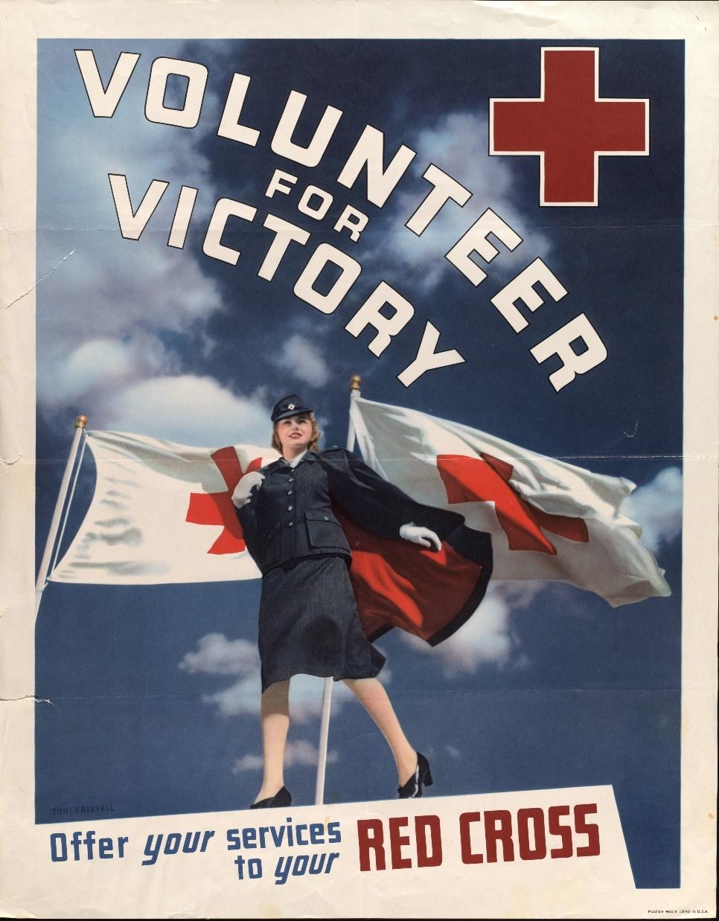
Introduction
During World War II, women served in a variety of positions. Whether on the homefront, as nurses, Women Army Corps members, or Red Cross members, they were integral to the war effort. Many of these women were surveyed during the war; men were offered the opportunity to anonymously write their opinions on women and other topics in a collection of surveys given by the Research Branch. These handwritten opinions sat largely untouched for decades until digitized and transcribed by The American Soldier in World War II project. This lesson plan utilizes a selection of these transcriptions to help students critically analyze primary sources to better understand the reality of women’s lives during World War II.

Students will also have the opportunity to use the SCIM-C Method. This method of analysis has been created to help students develop the knowledge and skills necessary to interpret historical primary sources and investigate meaningful historical questions.
Grade Level
High School/College Introductory (Age 16+)
Time Requirement
1 class period
Materials
- Copies of Women & Gender Overview Essay
- Copies of Women & Gender Responses for each group of students
- Copies of Student Worksheet for each student
Objectives
Students will analyze both primary and secondary sources related to the experiences of the American soldier during World War II. They will revise their historical interpretation after reading each source, recognizing that by synthesizing information from multiple perspectives they can develop a richer, more accurate summary of the past.
Key Terms
Primary sources: textual or visual materials created during the historical moment you are studying, such as letters, diary entries, photographs, posters, and newspaper articles
Secondary sources: materials created well after the events they discuss by someone who did not experience them firsthand. Books, journal articles, encyclopedia entries, and documentaries are good examples.
Procedures
- Begin by either having students read the overview essay, “Women & Gender,” to themselves or reading it together as a class. Once students have finished reading the essay, have them take a moment to write down some notes summarizing the experience of American WACs based on what they read. Ask a few students to share their ideas, noting cases where students interpreted the essay differently or chose different aspects of the text to emphasize. Ask students to identify the following about this text:
    - Identify 3 important details about women’s experiences detailed in the essay.
    - Identify 2 ways in which these experiences are still relevant to life in America today.
    - Identify 1 question you have or 1 source you would need to better understand these experiences. (15 minutes)
- Review the key terms listed above.
- Ask students whether the essay they just read is a primary or secondary source and how they can tell. Ask them what kinds of primary sources might be useful for learning more about what it was like to be a woman in World War II (e.g., letters, diary entries, oral histories, maps or photographs of a training camp, a training manual, etc.). (5 minutes)
- Explain that students will now have the opportunity to build on their historical summaries of women and gender during the war by reading actual survey responses that soldiers wrote about women during World War II. You may choose for students to complete the activity individually or in groups of three or four. Distribute copies of the primary source responses and the Student Worksheet to each student or group.
- Instruct students to start by analyzing just one of the letters—any one they like, or you may specify one. Have them complete Part I of the Student Worksheet once they finish reading. (10 minutes)
- Have students read as many of the additional letters as they have time for, revising their historical summary each time and answering the questions on the Student Worksheet. (20 minutes)
- Return to the whole class to debrief. The object is for students to realize that while each primary source is a useful tool, the best historical interpretations will synthesize information from multiple perspectives. Here are some possible discussion questions: (10 minutes)
    - How did your historical summary change after you read the first response?
    - Did any of your responses contradict one another? How did you handle that in writing your summary?
    - Was there any one response that helped you the most in developing your summary? If so, why was it so helpful?
    - What details do you wish you knew more about before writing this summary?
    - What kinds of sources might help you find that information?
Assessment
You will be able to assess students’ ability to analyze individual primary sources based on the historical summaries they write, as well as the answers they provide on the Student Worksheet. You will be able to assess their ability to synthesize information from multiple sources and recognize the value of that process based on their historical summaries and the answers they give in discussion.
Recommended Resources
American Women During World War II (Video)
Women in World War II (Article)
History at a Glance (Article)
Extension/Enrichment
- Have students visit The American Soldier in World War II website and search for keywords surrounding the experiences of women. Ask students to revise their historical summary after taking the information they find into account, and have them explain how the new source(s) helped enhance their understanding of what it was like for women and WACs during World War II.
Potential Keywords: women, WAC, WAVE, girl, nurse, Red Cross

- Have students choose their favorite response out of the ones they read and do a “deep analysis,” extracting as much information as possible about the writer—what he liked or disliked, where he was from, his strengths and weaknesses, etc.—and build a profile of that person. The objective here is for students to practice extracting data from the text, both the expressly written data and information they can infer by interpreting the details.
Education Standards
COMMON CORE STANDARDS
CCSS.ELA-LITERACY.RH.6-8.2 - Determine the central ideas or information of a primary or secondary source; provide an accurate summary of the source distinct from prior knowledge or opinions.
CCSS.ELA-LITERACY.RH.6-8.9 - Analyze the relationship between a primary and secondary source on the same topic.
CCSS.ELA-LITERACY.RH.9-10.1 - Cite specific textual evidence to support analysis of primary and secondary sources, attending to such features as the date and origin of the information.
CCSS.ELA-LITERACY.RH.9-10.2 - Determine the central ideas or information of a primary or secondary source; provide an accurate summary of how key events or ideas develop over the course of the text.
CCSS.ELA-LITERACY.RH.9-10.9 - Compare and contrast treatments of the same topic in several primary and secondary sources.
CCSS.ELA-LITERACY.RH.11-12.9 - Integrate information from diverse sources, both primary and secondary, into a coherent understanding of an idea or event, noting discrepancies among sources.
NATIONAL STANDARDS FOR HISTORY
HISTORICAL CONTENT ERA 8, STANDARD 3B
The student understands World War II and how the Allies prevailed.
HISTORICAL CONTENT ERA 8, STANDARD 3C
The student understands the impacts of World War II at home.
HISTORICAL THINKING STANDARD 2
The student is able to appreciate historical perspectives by demonstrating the ability to
(a) describe the past on its own terms, through the eyes and experiences of those who were there, as revealed
through their literature, diaries, letters, debates, arts, artifacts, and the like;
(b) consider the historical context in which the event unfolded–the values, outlook, options, and contingencies of that time and place; and
(c) avoid “present-mindedness,” and not judging the past solely in terms of present-day norms and values.
HISTORICAL THINKING STANDARD 4
The student is able to support interpretations with historical evidence in order to construct closely-reasoned arguments rather than facile opinions.

Image Credit: Hennepin County Library

Women & Gender Responses
Documents A, B & C provide positive views of women by soldiers.
Documents D, E & F provide negative views of women by soldiers.

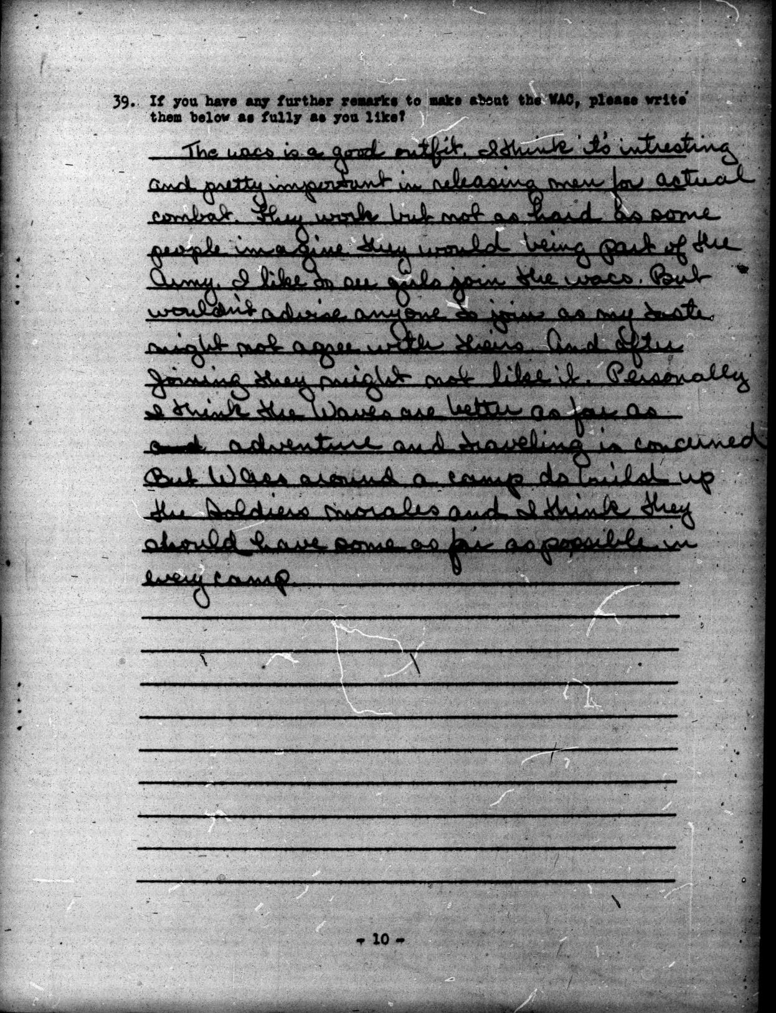
Document A (Survey 90, November-December 1943, 20-0008):
The wacs is a good outfit. I think it's intresting and pretty important in releasing men for actual combat. They work but not as hard as some people imagine they would being part of the Army. I like to see girls join the wacs. But wouldn't advise anyone to join as my taste might not agree with theirs. And after joining they might not like it. Personally I think the Waves are better as far as [deletion]and[deletion] adventure and traveling is concerned. But Wacs around a camp do build up the soldiers morales and I think they should have some as far as possible in every camp.

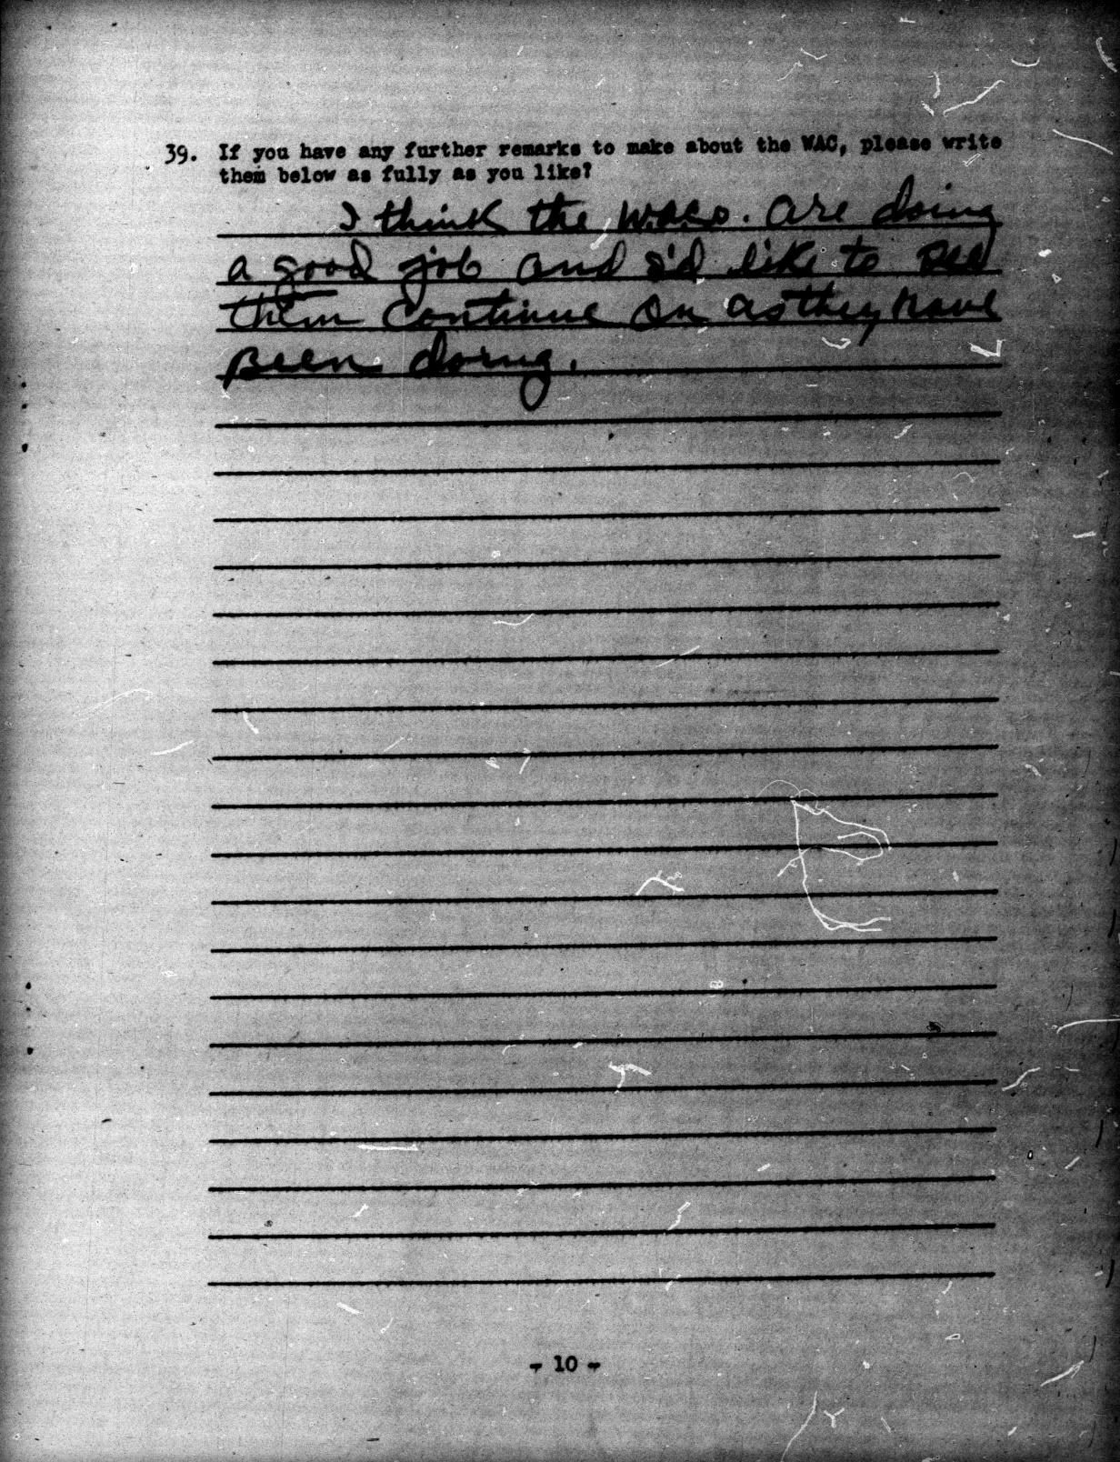

Document B (Survey 90, November-December 1943, 20-1057):
I think the W.A.C.s are doing a good job and I'd like to see them continue on as they have been doing.

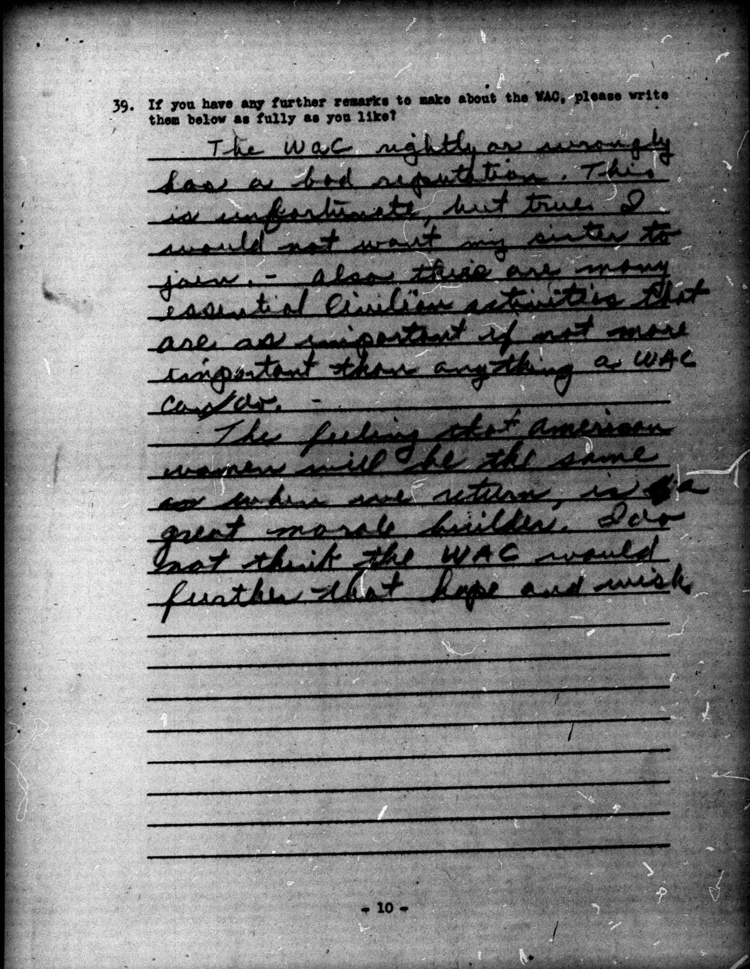

Document C (Survey 90, November-December 1943, 20-1163):
The wac rightly or wrongly has a bad reputation. This is unfortunate, but true. I would not want my sister to join. - also there are many essential civilian activities that are as important if not more important than anything a WAC can do.
The feeling that American women will be the same when we return, is a great morale builder. I do not think the WAC would further that hope and wish.

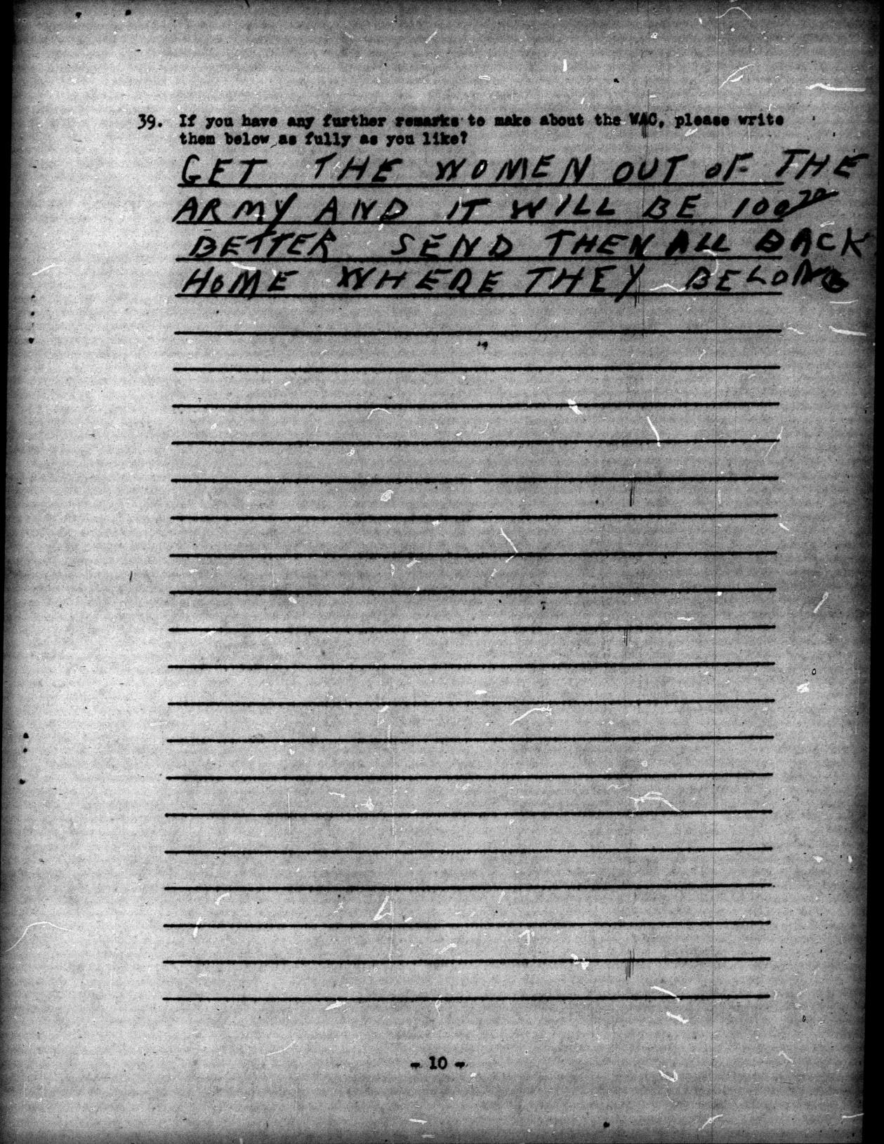

Document D (Survey 90, November-December 1943, 20-0249):
GET THE WOMEN OUT OF THE ARMY AND IT WILL BE 100% BETTER. SEND THEM ALL BACK HOME WHERE THEY BELONG.

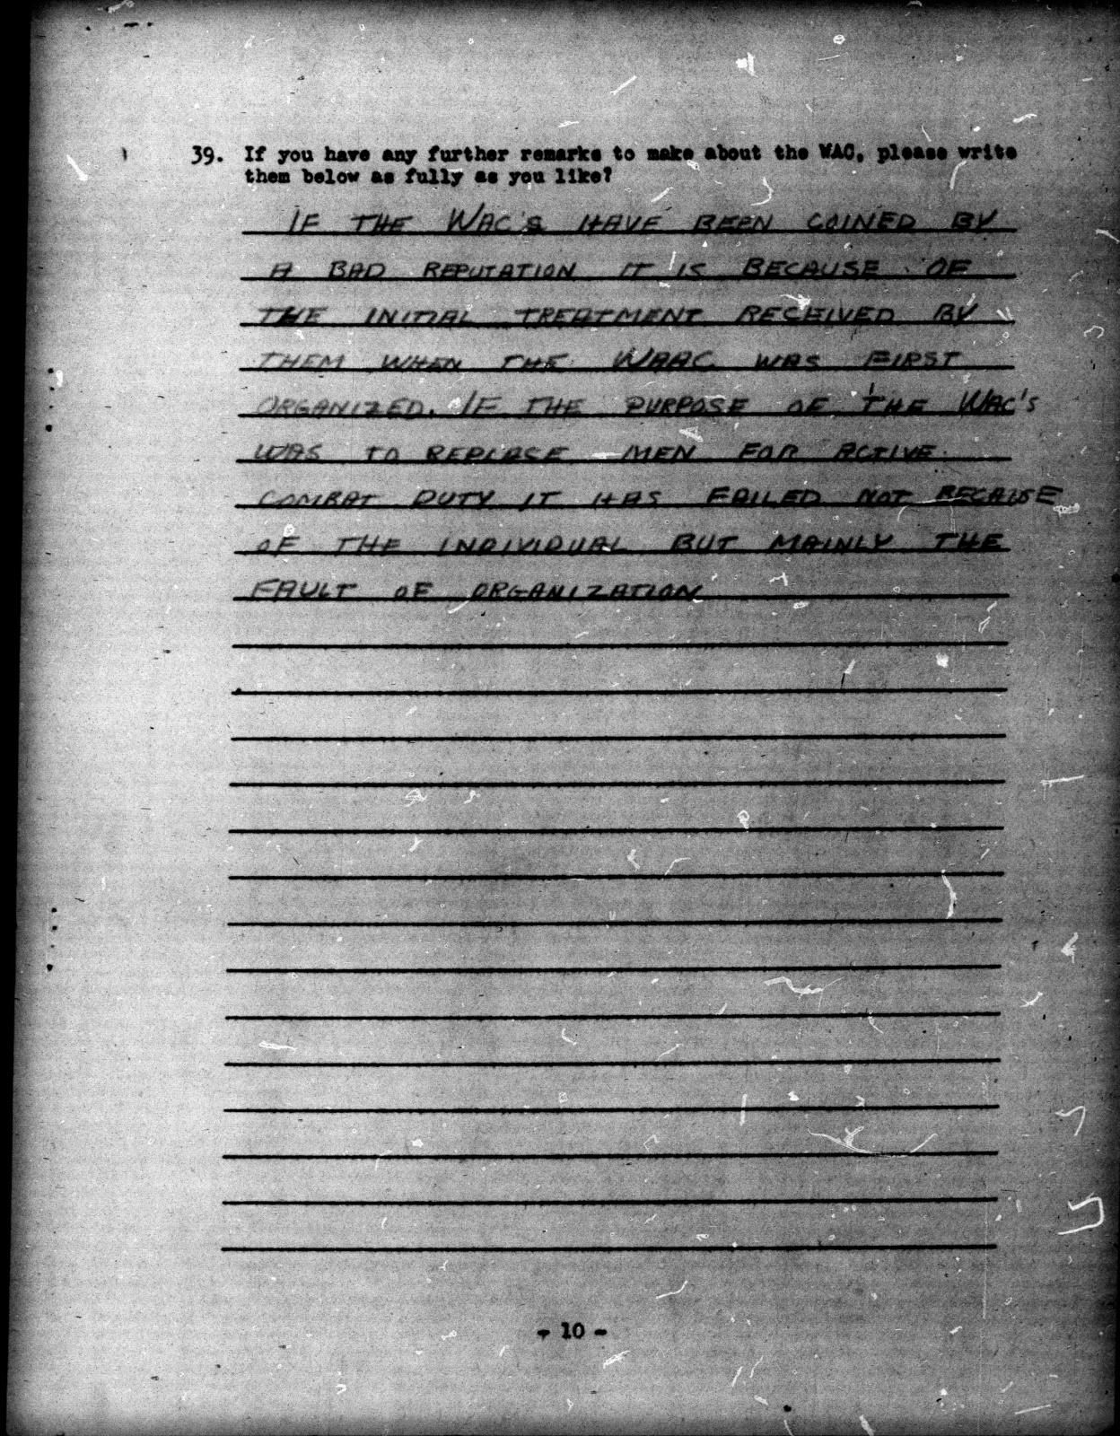

Document E (Survey 90, November-December 1943, 20-0661):
IF THE WAC'S HAVE BEEN COINED BY A BAD REPUTATION IT IS BECAUSE OF THE INITIAL TREATMENT RECEIVED BY THEM WHEN THE WAAC WAS FIRST ORGANIZED. IF THE PURPOSE OF THE WAC'S WAS TO REPLACE MEN FOR ACTIVE COMBAT DUTY IT HAS FAILED NOT BECAUSE OF THE INDIVIDUAL BUT MAINLY THE FAULT OF THE ORGANIZATION.

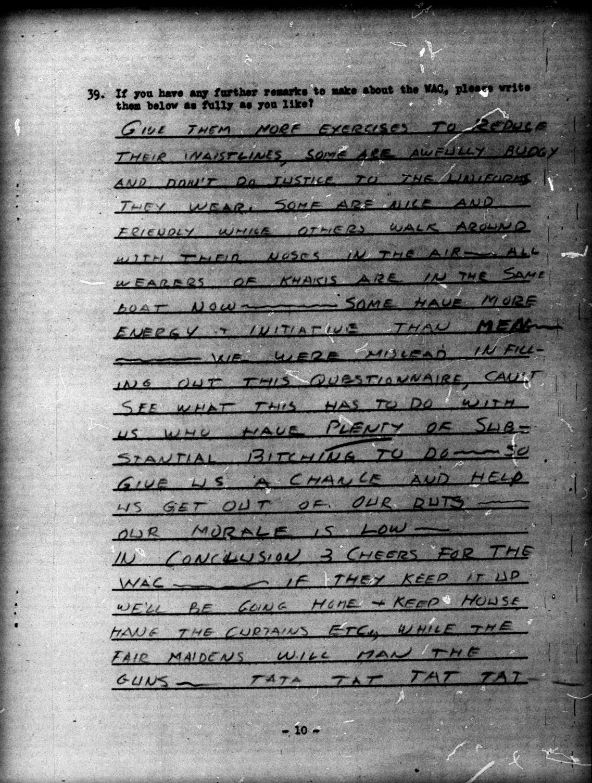

Document F (Survey 90, November-December 1943, 20-1045):
GIVE THEM MORE EXERCISES TO REDUCE THEIR WAISTLINES, SOME ARE AWFULLY BUDGY AND DON'T DO JUSTICE TO THE UNIFORMS THEY WEAR. SOME ARE NICE AND FRIENDLY WHILE OTHERS WALK AROUND WITH THEIR NOSES IN THE AIR. ALL WEARERS OF KHAKIS ARE IN THE SAME BOAT NOW. SOME HAVE MORE ENERGY AND INITIATIVE THAN MEN. WE WERE MISLEAD IN FILLING OUT THIS QUESTIONNAIRE, CAN'T SEE WHAT THIS HAS TO DO WITH US WHO HAVE PLENTY OF SUBSTANTIAL BITCHING TO DO. SO GIVE US A CHANCE AND HELP US GET OUT OF OUR RUTS. OUR MORALE IS LOW. IN CONCLUSION 3 CHEERS FOR THE WAC. IF THEY KEEP IT UP WE'LL BE GOING HOME AND KEEP HOUSE, HANG THE CURTAINS ETC., WHILE THE FAIR MAIDENS WILL MAN THE GUNS - TATA TAT TAT TAT

