Race & Ethnicity Lesson Plan
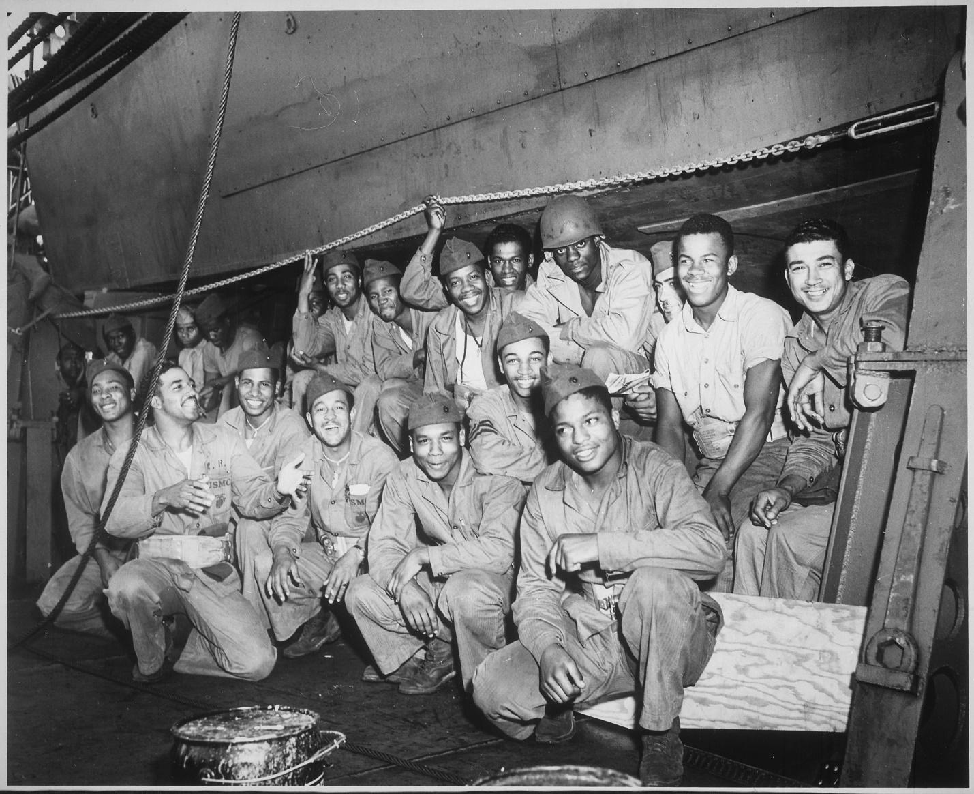
Introduction
During World War II, approximately 16 million Americans served in the military. Over half a million were offered the opportunity to anonymously write their opinions on combat and other topics in a series of surveys given by the Army Research Branch. These handwritten opinions sat largely untouched for decades until digitized and transcribed by The American Soldier in World War II project. This lesson plan utilizes a selection of these transcriptions to help students critically analyze primary sources to better understand the reality of segregation during World War II.

Students will also have the opportunity to use the SCIM-C Method. This method of analysis has been created to help students develop the knowledge and skills necessary to interpret historical primary sources and investigate meaningful historical questions.
Grade Level
High School/College Introductory (Age 16+)
Time Requirement
60 minutes
Materials
- Copies of Race & Ethnicity Overview Essay
- Copies of Race & Ethnicity Responses for each group of students (2-3 black responses, 2-3 white responses)
- Copies of Student Worksheet for each student
Objectives
Students will be able to describe and explain the diverse views/experiences on segregation in the US military during WWII by analyzing primary source documents on soldiers' experiences. They will revise their historical interpretation after reading each source, recognizing that by synthesizing information from multiple perspectives they can develop a richer, more accurate summary of the past.
Key Terms
Primary sources: textual or visual materials created during the historical moment you are studying, such as letters, diary entries, photographs, posters, and newspaper articles
Secondary sources: materials created well after the events they discuss by someone who did not experience them firsthand. Books, journal articles, encyclopedia entries, and documentaries are good examples.
Procedures
- Begin by either having students read the overview essay, “Race & Ethnicity,” to themselves or reading it together as a class. Once students have finished reading the essay, have them take a moment to write down some notes summarizing the experience of Black American GIs based on what they read. Ask a few students to identify the following about this text:
  - Identify 3 important details about the Black American soldier’s experience detailed in the essay.
  - Identify 2 ways in which these experiences are still relevant to life in America today.
  - Identify 1 question you have or 1 source you would need to better understand these experiences. (15 minutes)
- Review the key terms listed above.
- Ask students whether the essay they just read is a primary or secondary source and how they can tell. Ask them what kinds of sources might be useful for learning more about what it was like to be a Black American soldier in World War II (e.g., letters, diary entries, oral histories, maps or photographs of a training camp, a training manual, etc.). (5 minutes)
- Explain that students will now have the opportunity to build on their historical summaries of race and segregation during the war by reading actual survey responses that soldiers wrote during World War II. You may choose for students to complete the activity individually or in groups. Distribute copies of the primary source responses and the Student Worksheet to each student or group.
- Instruct students to start by analyzing just one of the letters. Have them complete Part I of the Student Worksheet once they finish reading. (10 minutes)
- Have students read some of the additional responses, revising their historical summary each time and answering the questions on the Student Worksheet. Students can also think about the below questions when reading specific documents. (20 minutes)
- Return to the whole class to debrief. The object is for students to realize that while each primary source is a useful tool, the best historical interpretations will synthesize information from multiple perspectives. Here are some possible discussion questions: (10 minutes)
- How did your historical summary change after you read the first response?
- Did any of your responses contradict one another? How did you handle that in writing your summary?
- Was there any one response that helped you the most in developing your summary? If so, why was it so helpful?
- What details do you wish you knew more about before writing this summary?
- What kinds of sources might help you find that information?
Assessment
You will be able to assess students’ ability to analyze individual primary sources based on the historical summaries they write, as well as the answers they provide on the Student Worksheet. You will be able to assess their ability to synthesize information from multiple sources and recognize the value of that process based on their historical summaries and the answers they give in discussion. You will also be able to assess their questioning of the sources provided to them.
Recommended Resources
Black Soldier Transcriptions Brought to Life (Video)
African American Units in World War II (Video)
Black American Soldiers in World War II Faced Segregation (Article)

Extension/Enrichment
- Have students visit The American Soldier in World War II website and search for keywords surrounding combat. Ask students to revise their historical summary after taking the information they find into account, and have them explain how the new source(s) helped enhance their understanding of what it was like for African American soldiers during World War II.
Potential Keywords: race, segregation, Jim Crow, African American, Jewish
- Have students choose their favorite response out of the ones they read and do a “deep analysis,” extracting as much information as possible about the writer—what he liked or disliked, where he was from, his strengths and weaknesses, etc.—and build a profile of that person. The objective here is for students to practice extracting data from text, both the expressly written data and information they can infer by interpreting the details.
Education Standards
COMMON CORE STANDARDS
CCSS.ELA-LITERACY.RH.6-8.2 - Determine the central ideas or information of a primary or secondary source; provide an accurate summary of the source distinct from prior knowledge or opinions.
CCSS.ELA-LITERACY.RH.6-8.9 - Analyze the relationship between a primary and secondary source on the same topic.
CCSS.ELA-LITERACY.RH.9-10.1 - Cite specific textual evidence to support analysis of primary and secondary sources, attending to such features as the date and origin of the information.
CCSS.ELA-LITERACY.RH.9-10.2 - Determine the central ideas or information of a primary or secondary source; provide an accurate summary of how key events or ideas develop over the course of the text.
CCSS.ELA-LITERACY.RH.9-10.9 - Compare and contrast treatments of the same topic in several primary and secondary sources.
CCSS.ELA-LITERACY.RH.11-12.9 - Integrate information from diverse sources, both primary and secondary, into a coherent understanding of an idea or event, noting discrepancies among sources.
NATIONAL STANDARDS FOR HISTORY
HISTORICAL CONTENT ERA 8, STANDARD 3B
The student understands World War II and how the Allies prevailed.
HISTORICAL CONTENT ERA 8, STANDARD 3C
The student understands the impacts of World War II at home.
HISTORICAL THINKING STANDARD 2
The student is able to appreciate historical perspectives by demonstrating the ability to
(a) describe the past on its own terms, through the eyes and experiences of those who were there, as revealed
through their literature, diaries, letters, debates, arts, artifacts, and the like;
(b) consider the historical context in which the event unfolded–the values, outlook, options, and contingencies of that time and place; and
(c) avoid “present-mindedness,” and not judging the past solely in terms of present-day norms and values.
HISTORICAL THINKING STANDARD 4
The student is able to support interpretations with historical evidence in order to construct closely-reasoned arguments rather than facile opinions.

Image Source: NARA

Race & Ethnicity Responses
Document A can be read if students want to better understand segregation in the South.
Document B can be read if students want to understand how Black soldiers feel about treatment in uniform.
Document C can be read if students want to understand how Black soldiers view their rights.
Document D & Document E can be read if students want to see how white soldiers viewed Black soldiers.

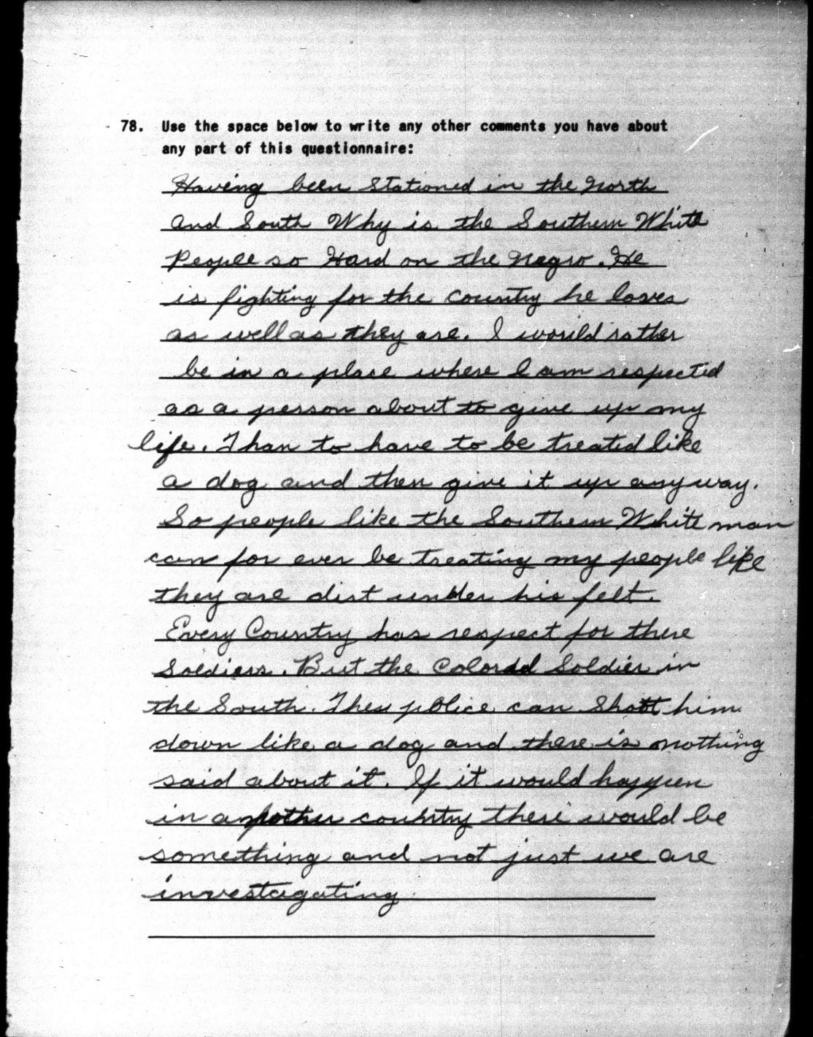

Document A (Survey 32, March 1943, 10-1185):
Having been stationed in the North and South Why is the Southern White People so hard on the Negro. He is fighting for the country he loves as well as they are. I would rather be in a place where I am respected as a person about to give up my life. Than to have to be treated like a dog and then give it up anyway. So people like the Southern White man can for ever be treating my people like they are dirt under his feet. Every Country has respect for there Soldiers. But the Colored Soldier in the South. These police can Shoot him down like a dog and there is nothing said about it. If it would happen in another country there would be something and not just we are investagating.

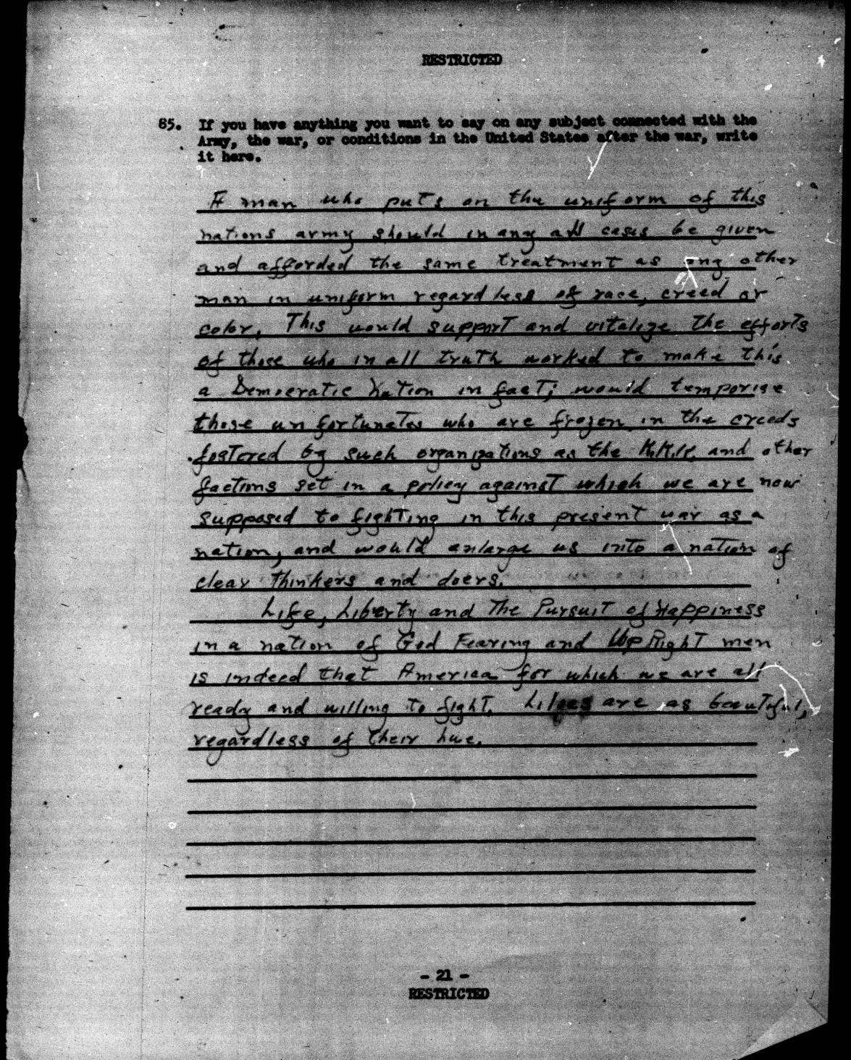

Document B (Survey 144, August 1944, 37-1451): A man who puts on the uniform of this nations army should in any all cases be given and afforded the same treatment as any other man in uniform regardless of race, creed or color. This would support and vitalize the efforts of those who in all truth worked to make this a Democratic nation in fact; would temporize those unfortunates who are frozen in the creeds fostered by such organizations as the K.K.K. and other factions set in a policy against which we are now supposed to fighting in this present war as a nation, and would enlarge us into a nations of clear thinkers and doers.

Life, Liberty and The Pursuit of Happiness in a nation of God fearing and Up Right men is indeed that America for which we are all ready and willing to fight. Lilies are as beautiful, regardless of their hue.

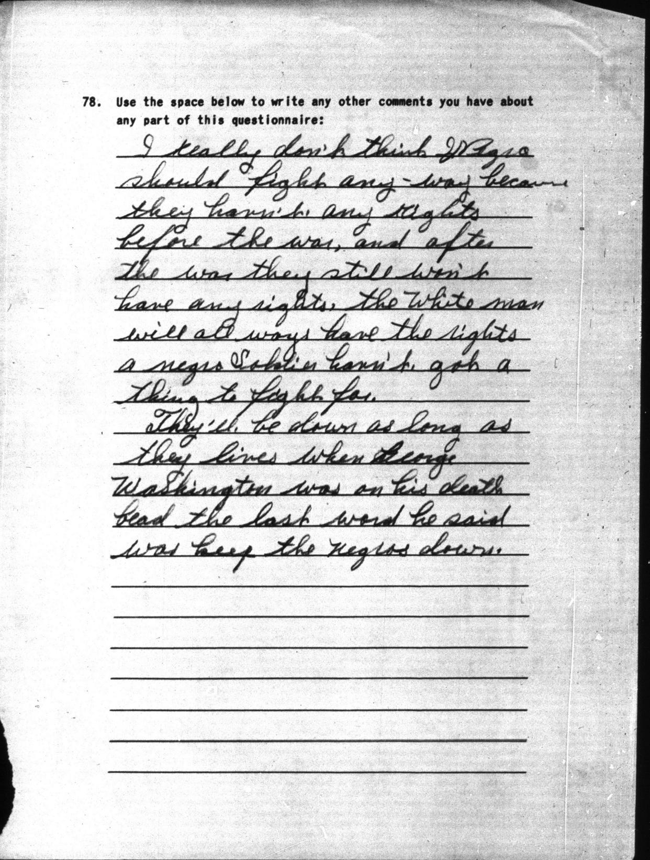

Document C (Survey 32, March 1943, 11-0121):
I really don't think Negros should fight any way because they haven't any rights before the war, and after the war they still won't have any rights. The White man will all ways have the rights a negro soldier hasn't got a thing to fight for.
They'll be down as long as they lives when George Washington was on his death bead the last word he said was keep the negros down.

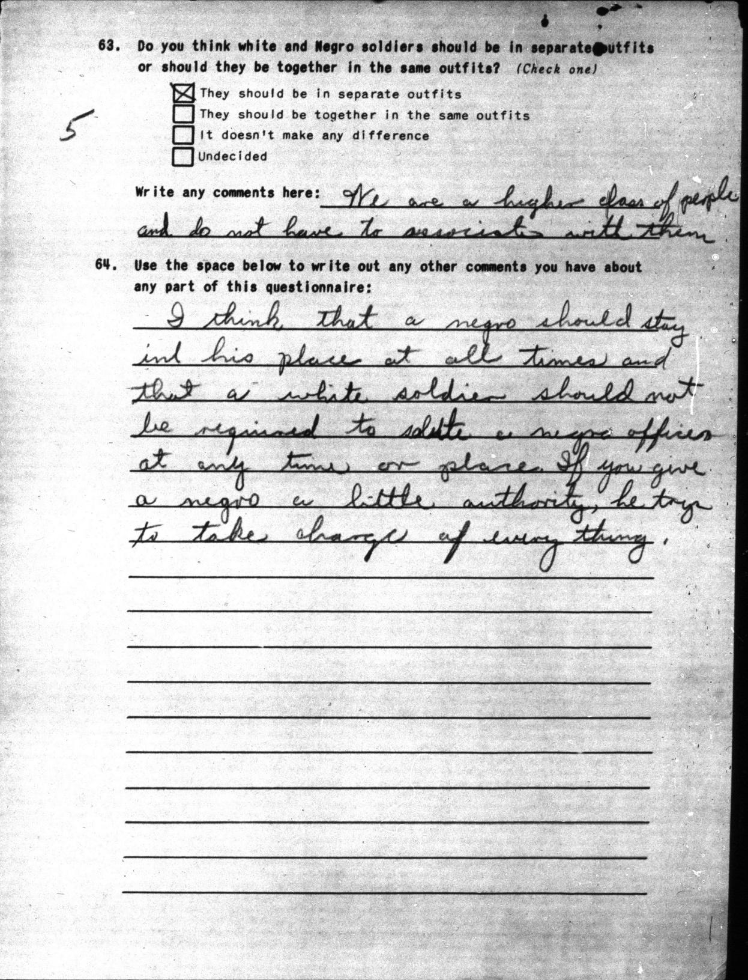

Document D (Survey 32, March 1943, 09-1161):
I think that a negro should stay in his place at all times and that a white soldier should not be required to salute a negro officer at any time or place. If you give a negro a little authority, he trys to take charge of every thing.

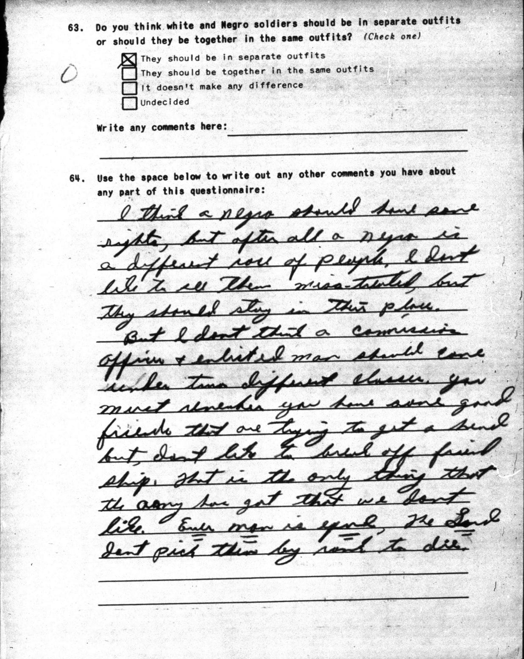

Document E (09-0424):
I think a negro should have some rights, but after all a negro is a different race of people. I don' t like to see them miss-treated, but they should stay in their place.
But I don't think a commission officer & enlisted man should come under two different classes. You must remember you have some good friends that are trying to get a head but, don't like to break off friendship. That is the only thing that the army has got that we dont like. Ever man is equal, the Lord dont pick them by rank to die.

