Information, Education & Media Lesson Plan
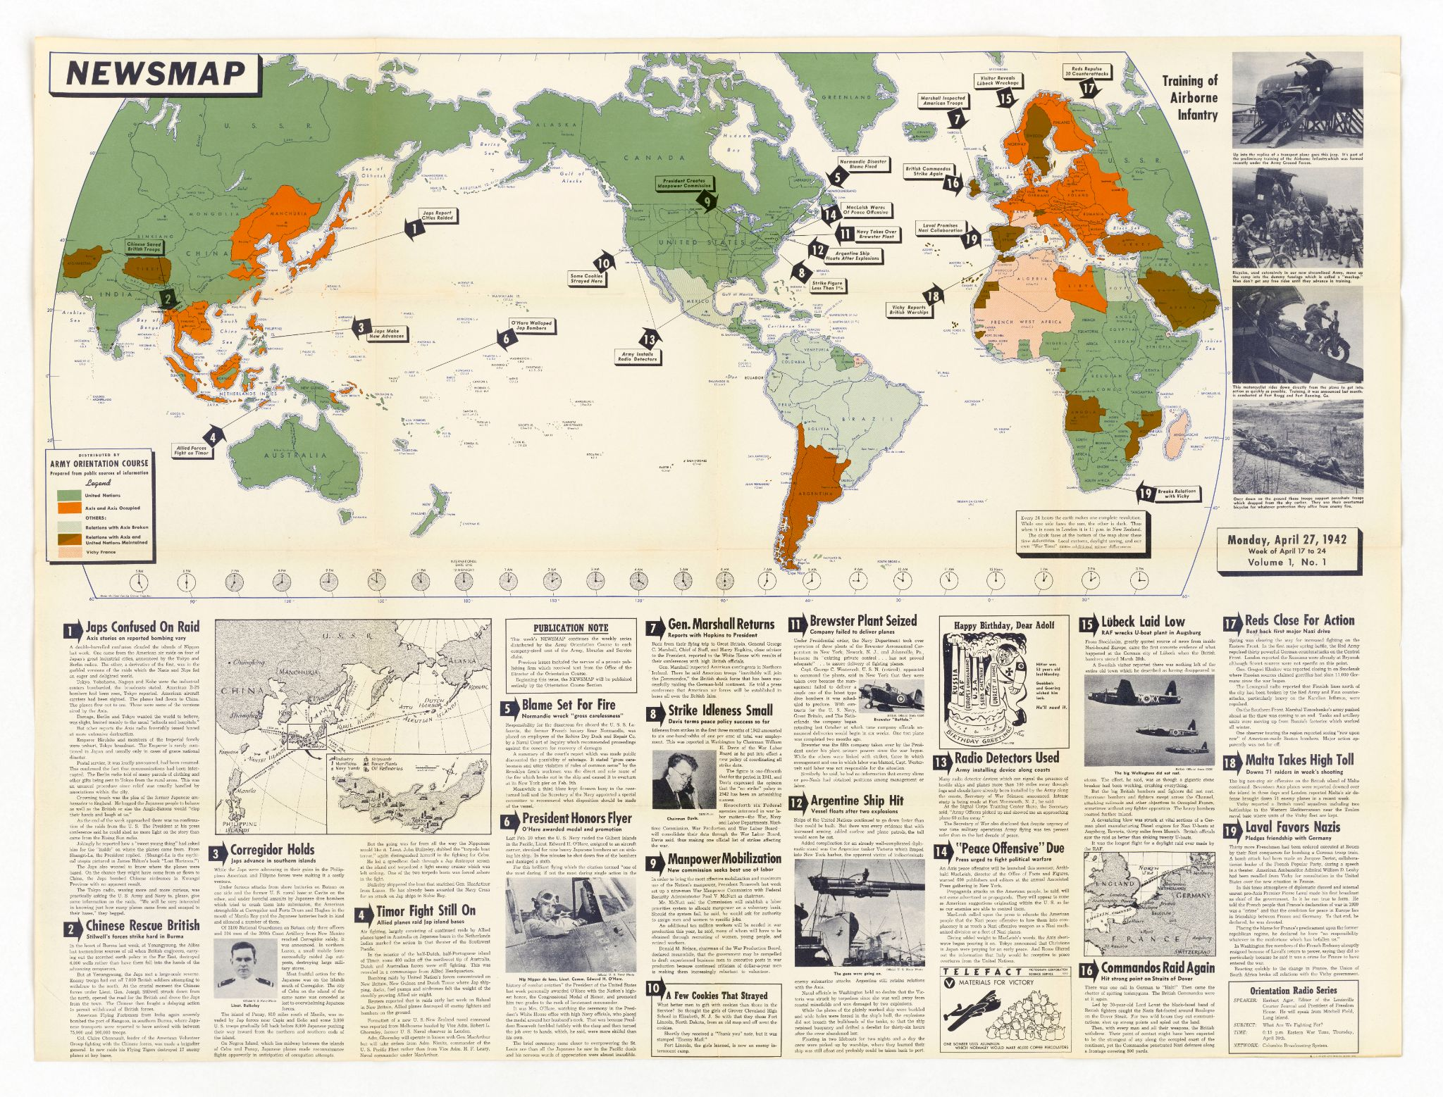
Introduction
During World War II, approximately 16 million men served in the military. These men were offered the opportunity to anonymously write their opinions on combat and other topics in a collection of surveys given by the Research Branch. These handwritten opinions sat largely untouched for decades until digitized and transcribed by The American Soldier in World War II project. This lesson plan utilizes a selection of these transcriptions to help students critically analyze primary sources to better understand the information, education, and media during World War II.

Students will also have the opportunity to use the SCIM-C Method. This method of analysis has been created to help students develop the knowledge and skills necessary to interpret historical primary sources and investigate meaningful historical questions.

Grade Level
High School/College Introductory (Age 16+)
Time Requirement
60 minutes
Materials
- Copies of Information, Education & Media Overview Essay
- Copies of Information, Education, & Media Responses for each group of students
- Copies of Student Worksheet for each student
Objectives
Students will be able to describe and explain the diverse views/experiences on information, education, and media in the US military during WWII by analyzing primary source documents on soldiers' experiences. They will revise their historical interpretation after reading each source, recognizing that by synthesizing information from multiple perspectives, they can develop a richer, more accurate summary of the past.
Key Terms
Primary sources: textual or visual materials created during the historical moment you are studying, such as letters, diary entries, photographs, posters, and newspaper articles
Secondary sources: materials created well after the events they discuss by someone who did not experience them firsthand. Books, journal articles, encyclopedia entries, and documentaries are good examples.
Procedures
- Begin by either having students read the overview essay, “Information, Education & Media,” to themselves or reading it together as a class. Once students have finished reading the essay, have them take a moment to write down some notes summarizing the experience of American GIs based on what they read. Ask a few students to identify the following about this text:
  - Identify 3 important details about soldiers’ experiences with obtaining education and media as detailed in the essay.
  - Identify 2 ways in which these experiences are still relevant to life in America today.
  - Identify 1 question you have or 1 source you would need to better understand these experiences. (15 minutes)
- Review the key terms listed above.
- Ask students whether the essay they just read is a primary or secondary source and how they can tell. Ask them what kinds of sources might be useful for learning more about what it was like to be a soldier during World War II (e.g., letters, diary entries, oral histories, maps or photographs of a training camp, a training manual, etc.). (5 minutes)
- Explain that students will now have the opportunity to build on their historical summaries of combat during the war by reading actual survey responses that soldiers wrote during World War II. You may choose for students to complete the activity individually or in groups. Distribute copies of the primary source responses and the Student Worksheet to each student or group.
- Instruct students to start by analyzing just one of the letters. Have them complete Part I of the Student Worksheet once they finish reading. (10 minutes)
- Have students read some of the additional responses, revising their historical summary each time and answering the questions on the Student Worksheet. Students can also think about the below questions when reading specific documents. (20 minutes)
- Return to the whole class to debrief. The object is for students to realize that while each primary source is a useful tool, the best historical interpretations will synthesize information from multiple perspectives. Here are some possible discussion questions: (10 minutes)
    - How did your historical summary change after you read the first response?
    - Did any of your responses contradict one another? How did you handle that in writing your summary?
    - Was there any one response that helped you the most in developing your summary? If so, why was it so helpful?
    - What details do you wish you knew more about before writing this summary?
    - What kinds of sources might help you find that information?
Assessment
You will be able to assess students’ ability to analyze individual primary sources based on the historical summaries they write, as well as the answers they provide on the Student Worksheet. You will be able to assess their ability to synthesize information from multiple sources and recognize the value of that process based on their historical summaries and the answers they give in discussion. You will also be able to assess their questioning of the sources provided to them.

Extension/Enrichment
- Have students visit The American Soldier in World War II website and search for keywords surrounding information, education, and media. Ask students to revise their historical summary after taking the information they find into account, and have them explain how the new source(s) helped enhance their understanding of what it was like for combat soldiers during World War II.
- Have students choose their favorite response out of the ones they read and do a “deep analysis,” extracting as much information as possible about the writer—what he liked or disliked, where he was from, his strengths and weaknesses, etc.—and build a profile of that person. The objective here is for students to practice extracting data from text, both the expressly written data and information they can infer by interpreting the details.
Education Standards
COMMON CORE STANDARDS
CCSS.ELA-LITERACY.RH.6-8.2 - Determine the central ideas or information of a primary or secondary source; provide an accurate summary of the source distinct from prior knowledge or opinions.
CCSS.ELA-LITERACY.RH.6-8.9 - Analyze the relationship between a primary and secondary source on the same topic.
CCSS.ELA-LITERACY.RH.9-10.1 - Cite specific textual evidence to support analysis of primary and secondary sources, attending to such features as the date and origin of the information.
CCSS.ELA-LITERACY.RH.9-10.2 - Determine the central ideas or information of a primary or secondary source; provide an accurate summary of how key events or ideas develop over the course of the text.
CCSS.ELA-LITERACY.RH.9-10.9 - Compare and contrast treatments of the same topic in several primary and secondary sources.
CCSS.ELA-LITERACY.RH.11-12.9 - Integrate information from diverse sources, both primary and secondary, into a coherent understanding of an idea or event, noting discrepancies among sources.
NATIONAL STANDARDS FOR HISTORY
HISTORICAL CONTENT ERA 8, STANDARD 3B
The student understands World War II and how the Allies prevailed.
HISTORICAL CONTENT ERA 8, STANDARD 3C
The student understands the impacts of World War II at home.
HISTORICAL THINKING STANDARD 2
The student is able to appreciate historical perspectives by demonstrating the ability to
(a) describe the past on its own terms, through the eyes and experiences of those who were there, as revealed
through their literature, diaries, letters, debates, arts, artifacts, and the like;
(b) consider the historical context in which the event unfolded–the values, outlook, options, and contingencies of that time and place; and
(c) avoid “present-mindedness,” and not judging the past solely in terms of present-day norms and values.
HISTORICAL THINKING STANDARD 4
The student is able to support interpretations with historical evidence in order to construct closely-reasoned arguments rather than facile opinions.

Image Source: NARA

Information, Education & Media Responses
Documents A, B & C relate to newspapers and magazines.
Documents D, E & F relate to orientation programs in the army.

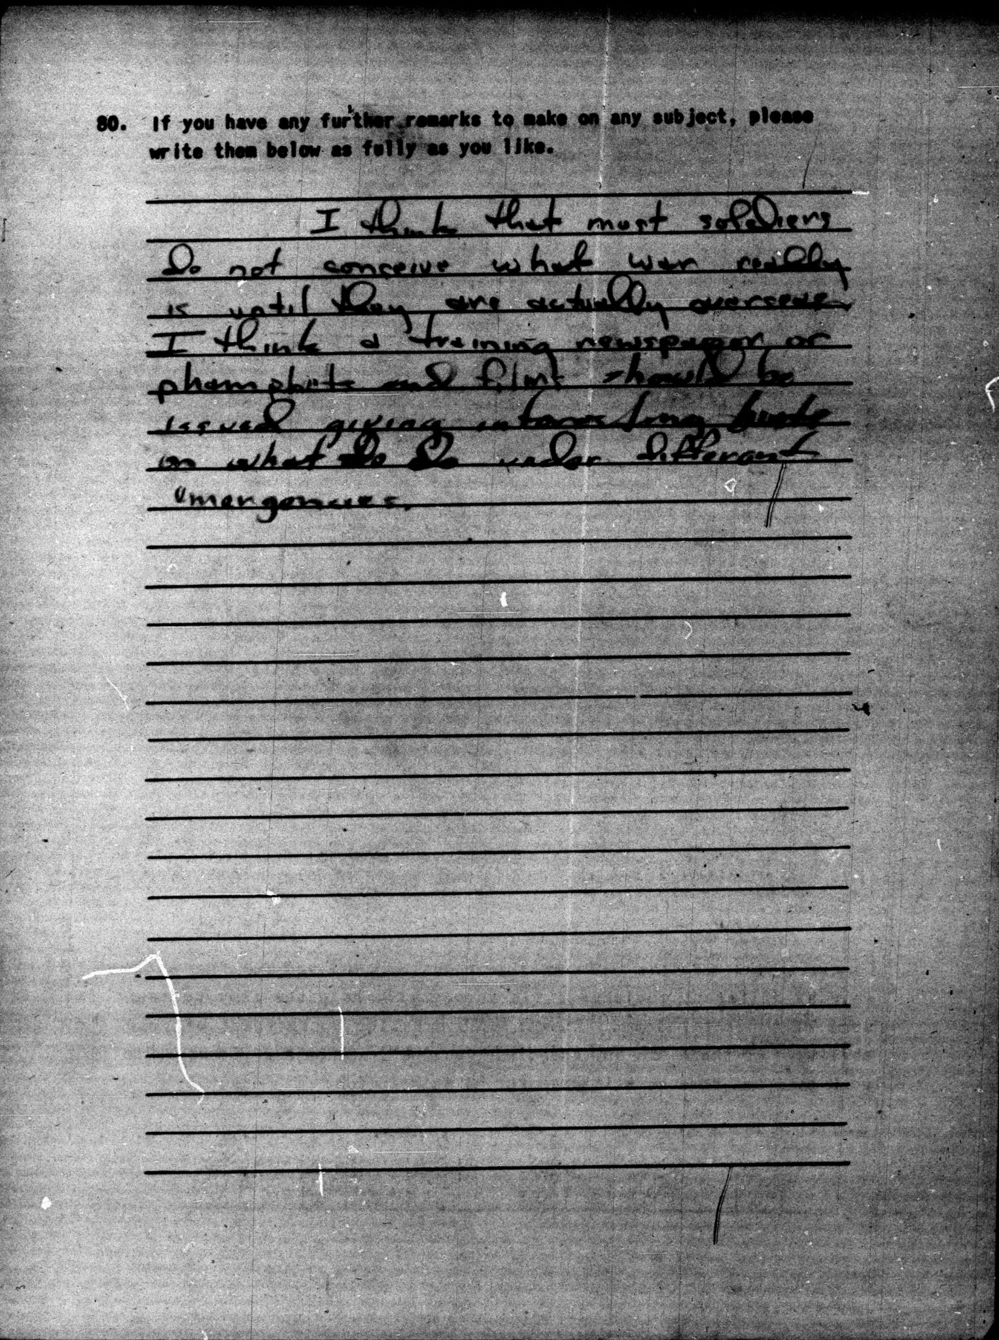
Document A, Survey 79, October 1943, 19-0661:
I think that most soldiers do not conceive what war really is until they are actually overseas. I think a training newspaper or phamplets and films should be issued giving information [unclear][unclear] on what to do under different emergencies.

Document B, Planning Survey II, May 1942, 02-0198:
The newspaper are putting out to much loose talk about what we are doing.

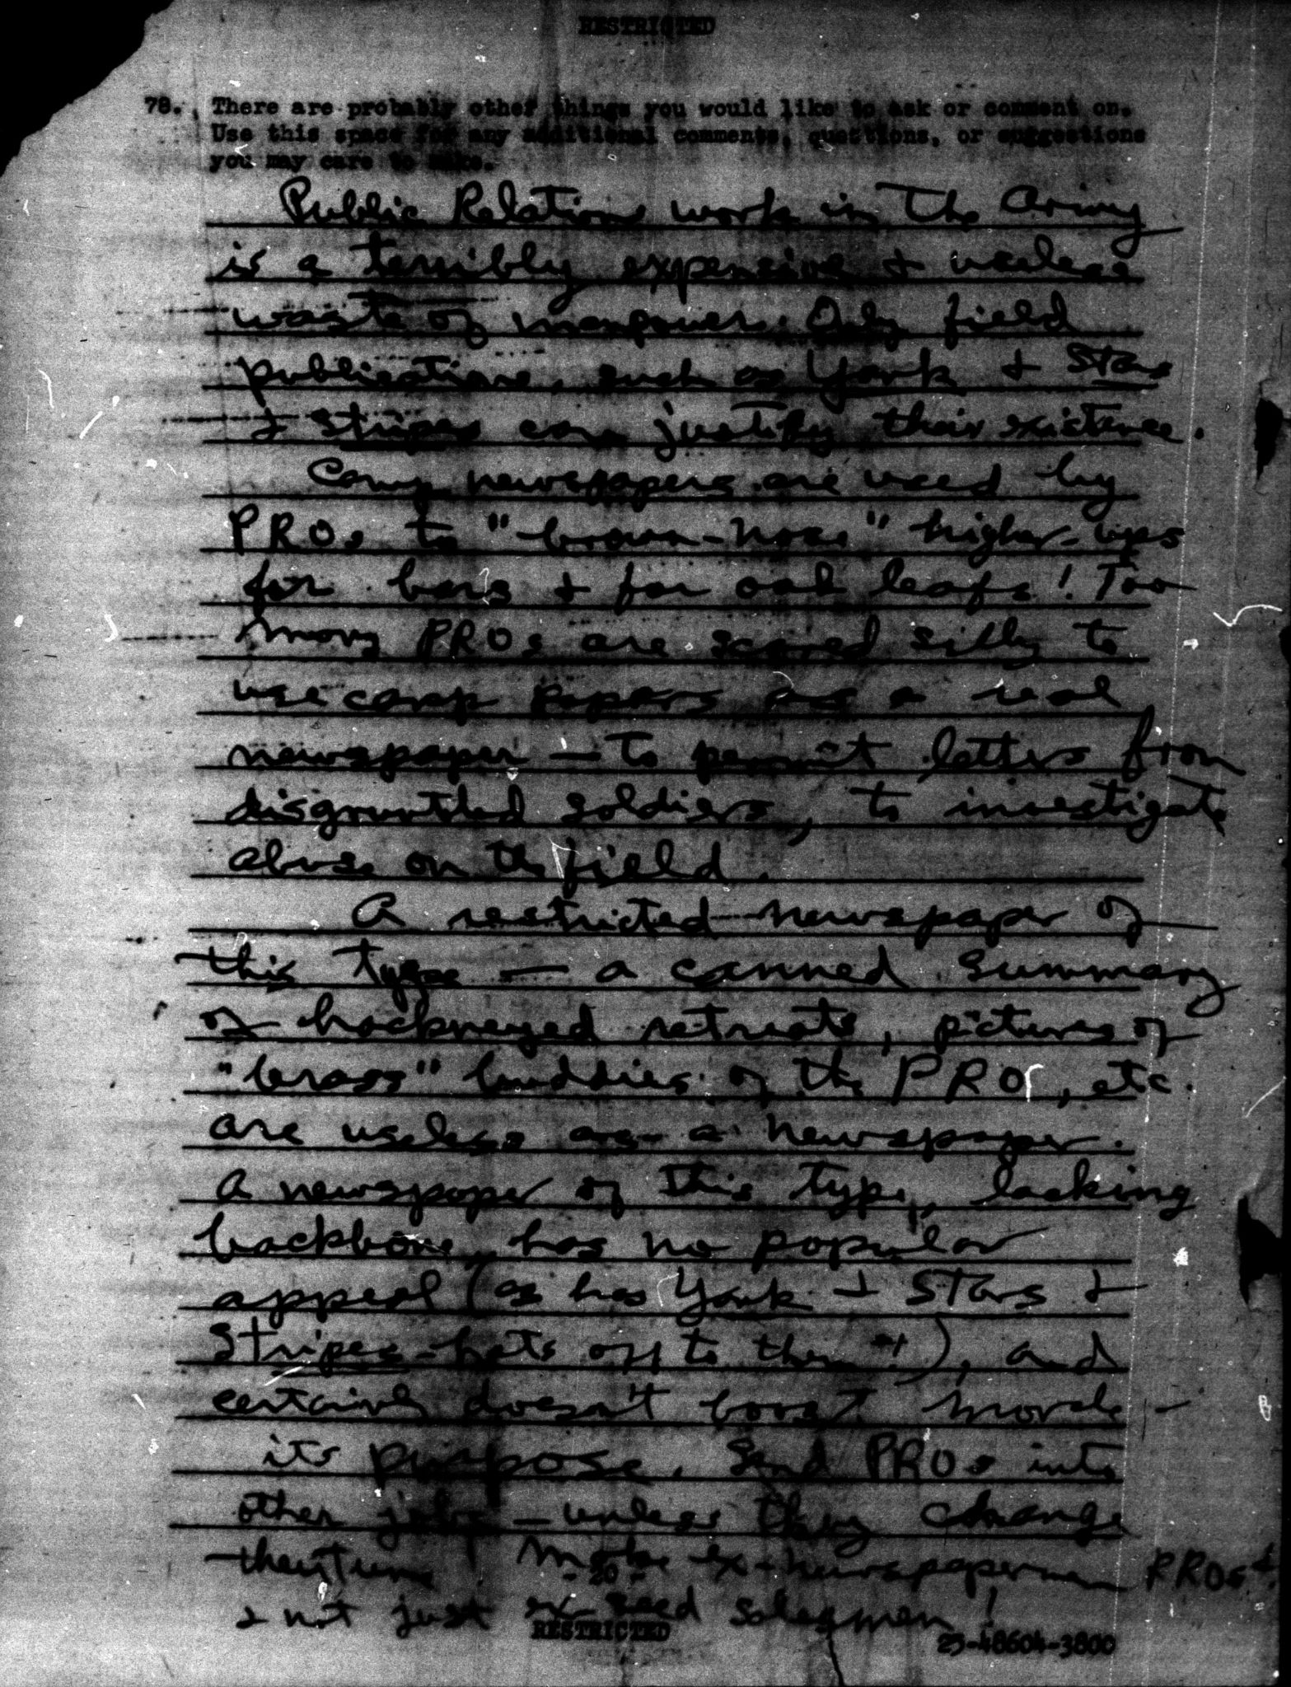
Document C, Survey 218, July 1945, 42-0786:
Public Relations work in the Army is a terribly expensive & useless waste of manpower. Only field publications, such as Yank & Stars & Stripes can justify their existence.
Camp newspapers are used by PROs to "brown-nose" higher-ups for bars & for oak leafs! Too many PROs are scared silly to use camp papers as a real newspaper - to permit letters from disgruntled soldiers, to investigate abuse on the field.
A restricted newspaper of this type - a canned summary of hackneyed retreats, pictures of "brass" buddies of the PRO, etc. are useless as a newspaper. A newspaper of this type, lacking backbone, has no popular appeal (as has Yank & Stars & Stripes - hats off to them!), and certainly doesn't boost morale - its purpose. Send PROs into other jobs - unless they change their tune! Make ex-newspapermen PROs & not just ex-seed salesmen!
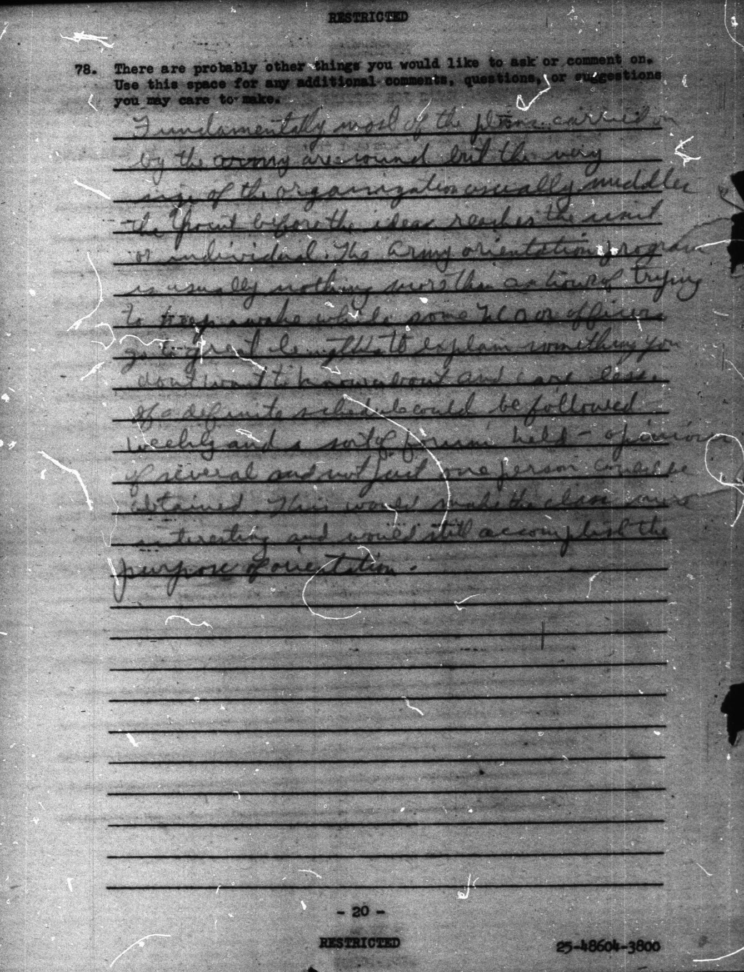
Document D, Survey 218, July 1945, 42-0891:
Fundamentally most of the plans carried on by the army are sound but the very size of the organization usually muddles the point before the idea reaches the unit or individual. The Army orientation program is usually nothing more than an hour of trying to keep awake while some NCO or officer go to great lengths to explain something you don't want to know about and care less. If a definite schedule could be followed weekly and a sort of forum held - opinions of several and not just one person could be obtained. This would make the class more interesting and would still accomplish the purpose of orientation.

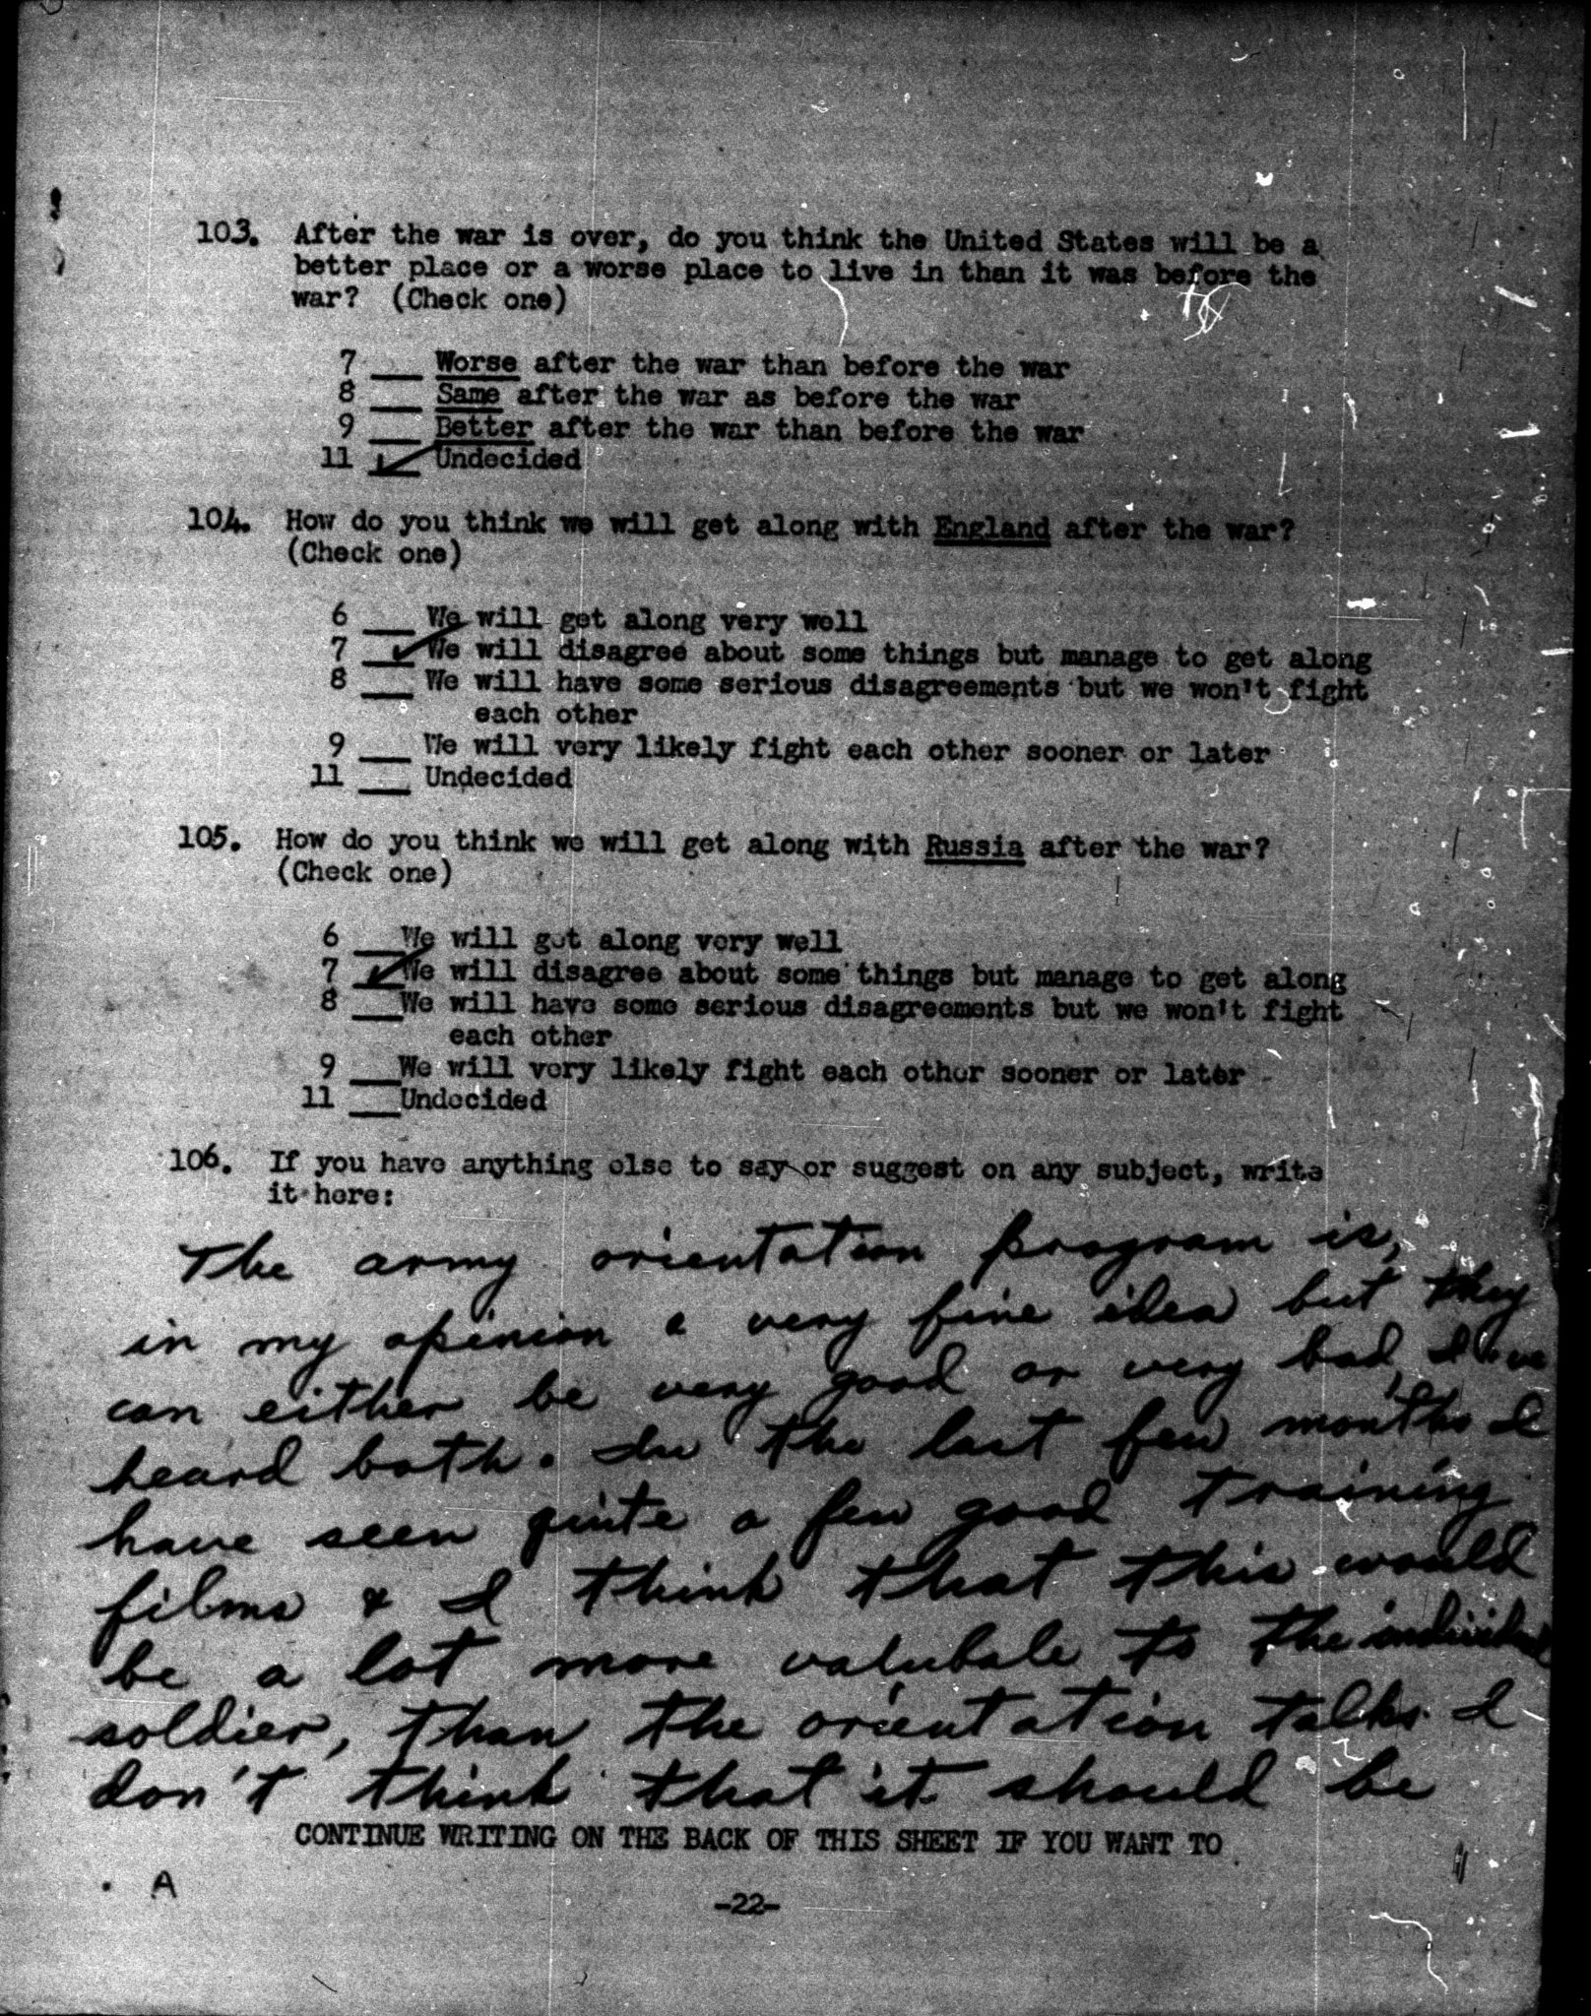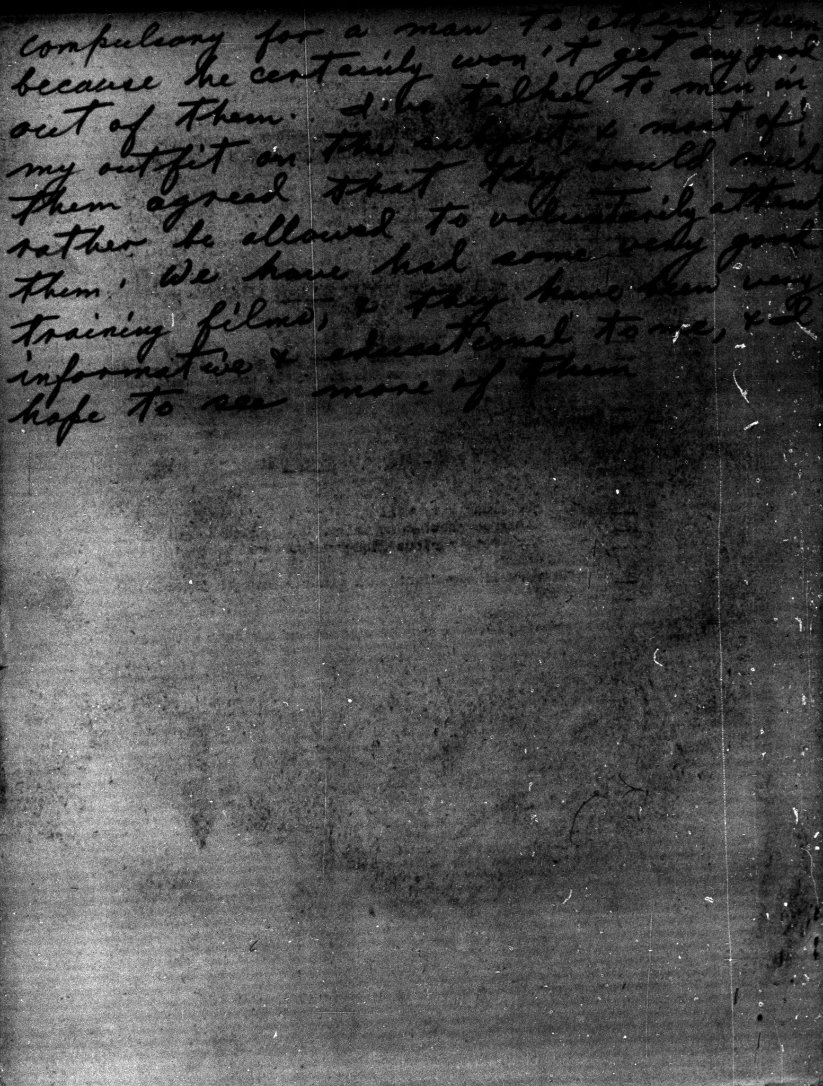
Document E, Survey 133, April-May 1944, 23-0094, 23-0095:
The army orientation program is, in my opinion a very fine idea but they can either be very good or very bad, I've heard both. In the last few months I have seen quite a few good training films & I think that this would be a lot more valuable to the individual soldier, than the orientation talks. I don't think that it should be compulsory for a man to attend them because he certainly won't get any good out of them. I've talked to men in my outfit on the subject, & most of them agreed that they would much rather be allowed to voluntarily attend them. We have had some very good training films, & they have been very informative & educational to me, & I hope to see more of them.
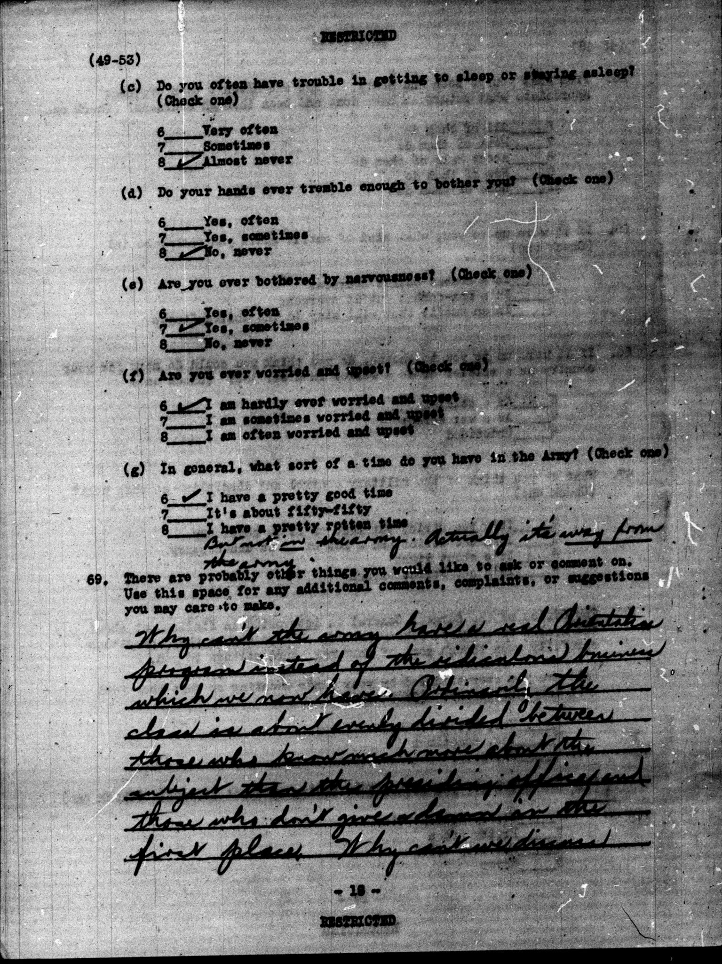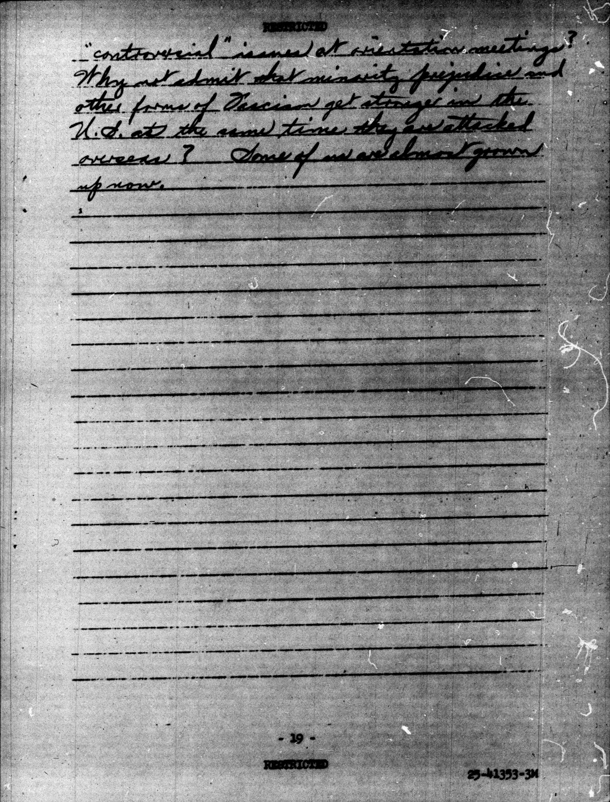
Document F, Survey 205, May 1945 41-0055, 41-0056:
Why can't the army have a real orientation program instead of the ridiculous business which we now have. Ordinarily, the class is about evenly divided between those who know much more about the subject than the presiding officer and those who don't give a damn in the first place. Why can't we discuss "controversial" issues at orientation meetings? Why not admit that minority prejudices and other forms of Fascism get stronger in the U.S. at the same time they are attacked overseas? Some of us are almost grown up now.

