Allies, Axis & the Aims of War Lesson Plan
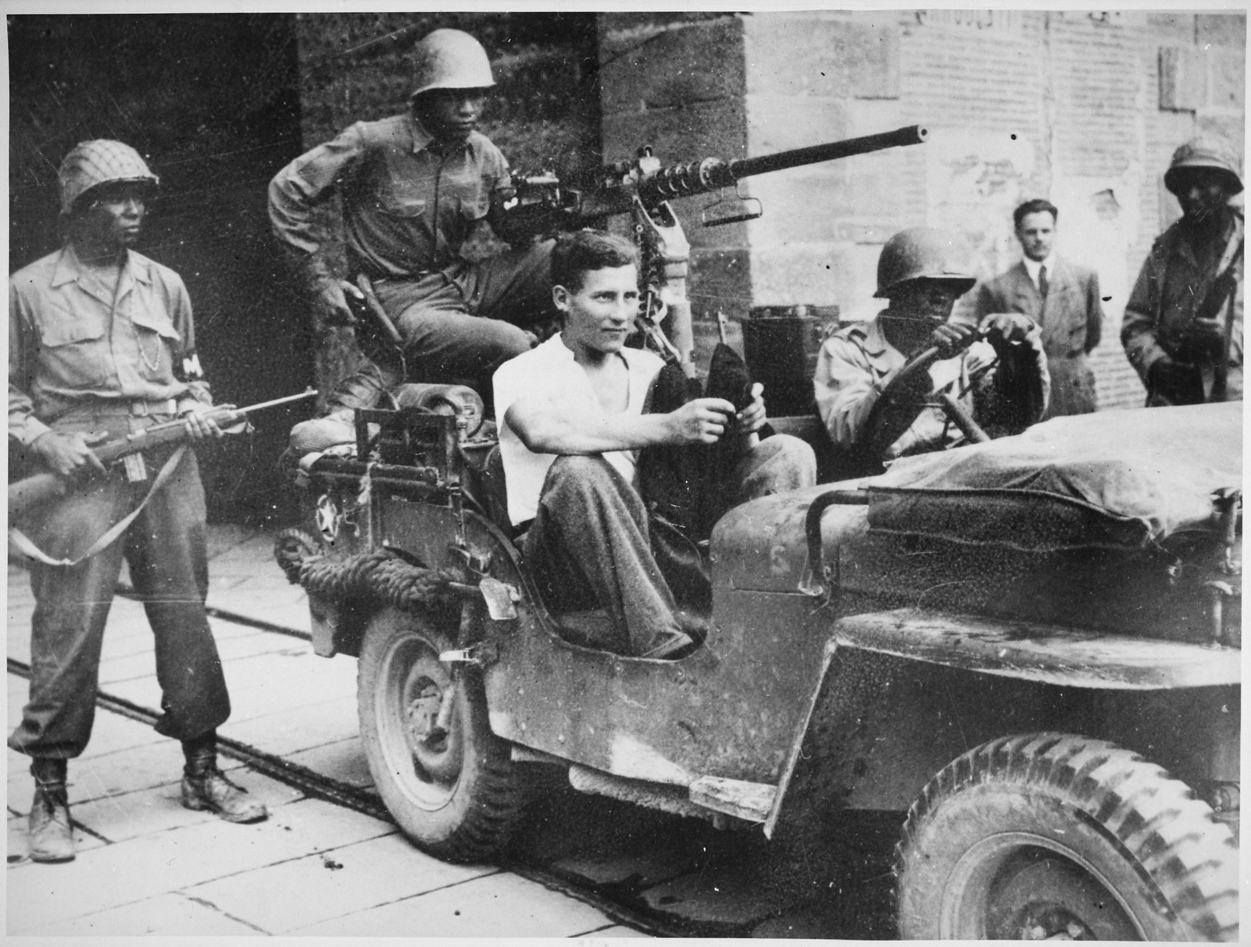
Introduction
During World War II, approximately 16 million Americans served in the military. Over half a million were offered the opportunity to anonymously write their opinions on combat and other topics in a series of surveys given by the Army Research Branch. These handwritten opinions sat largely untouched for decades until digitized and transcribed by The American Soldier in World War II project. This lesson plan utilizes a selection of these transcriptions to help students critically analyze primary sources to better understand the relationship between Americans, their allies, and their enemies during World War II.

Students will also have the opportunity to use the SCIM-C Method. This method of analysis has been created to help students develop the knowledge and skills necessary to interpret historical primary sources and investigate meaningful historical questions.

Grade Level
High School/College Introductory (Age 16+)
Time Requirement
60 minutes
Materials
- Copies of Allies, Axis & Aims of War Overview Essay
- Copies of Allies, Axis & Aims of War Responses for each group of students
- Copies of Student Worksheet for each student
Objectives
Students will be able to describe and explain the diverse views on allies and enemies in the US military during WWII by analyzing primary source documents on soldiers' experiences. They will revise their historical interpretation after reading each source, recognizing that by synthesizing information from multiple perspectives they can develop a richer, more accurate summary of the past.
Key Terms
Primary sources: textual or visual materials created during the historical moment you are studying, such as letters, diary entries, photographs, posters, and newspaper articles
Secondary sources: materials created well after the events they discuss by someone who did not experience them firsthand. Books, journal articles, encyclopedia entries, and documentaries are good examples.
Procedures
- Begin by either having students read the overview essay, “Allies, the Axis & the Aims of War,” to themselves or reading it together as a class. Once students have finished reading the essay, have them take a moment to write down some notes summarizing the view of American GIs of their allies and enemies based on what they read. Ask a few students to identify the following about this text:
  - Identify 3 important details about soldiers’ experience with allies and enemies detailed in the essay.
  - Identify 2 ways in which these experiences are still relevant to life in America today.
  - Identify 1 question you have or 1 source you would need to better understand these experiences. (15 minutes)
- Review the key terms listed above.
- Ask students whether the essay they just read is a primary or secondary source and how they can tell. Ask them what kinds of sources might be useful for learning more about what it was like to be a soldier in combat during World War II (e.g., letters, diary entries, oral histories, maps or photographs of a training camp, a training manual, etc.). (5 minutes)
- Explain that students will now have the opportunity to build on their historical summaries of allies and enemies during the war by reading actual survey responses that soldiers wrote during World War II. You may choose for students to complete the activity individually or in groups. Distribute copies of the primary source responses and the Student Worksheet to each student or group.
- Instruct students to start by analyzing just one of the letters. Have them complete Part I of the Student Worksheet once they finish reading. (10 minutes)
- Have students read some of the additional responses, revising their historical summary each time and answering the questions on the Student Worksheet. Students can also think about the below questions when reading specific documents. (20 minutes)
- Return to the whole class to debrief. The object is for students to realize that while each primary source is a useful tool, the best historical interpretations will synthesize information from multiple perspectives. Here are some possible discussion questions: (10 minutes)
- How did your historical summary change after you read the first response?
- Did any of your responses contradict one another? How did you handle that in writing your summary?
- Was there any one response that helped you the most in developing your summary? If so, why was it so helpful?
- What details do you wish you knew more about before writing this summary?
- What kinds of sources might help you find that information?
Assessment
You will be able to assess students’ ability to analyze individual primary sources based on the historical summaries they write, as well as the answers they provide on the Student Worksheet. You will be able to assess their ability to synthesize information from multiple sources and recognize the value of that process based on their historical summaries and the answers they give in discussion. You will also be able to assess their questioning of the sources provided to them.
Recommended Resources
Know Your Enemy (video)
The Big Three (article)

Extension/Enrichment
- Have students visit The American Soldier in World War II website and search for keywords surrounding allies and enemies. Ask students to revise their historical summary after taking the information they find into account, and have them explain how the new source(s) helped enhance their understanding of what it was like for soldiers during World War II.
Potential Keywords: Germans, Japanese, British, Russian, ally, enemy
- Have students choose their favorite response out of the ones they read and do a “deep analysis,” extracting as much information as possible about the writer—what he liked or disliked, where he was from, his strengths and weaknesses, etc.—and build a profile of that person. The objective here is for students to practice extracting data from text, both the expressly written data and information they can infer by interpreting the details.
Education Standards
COMMON CORE STANDARDS
CCSS.ELA-LITERACY.RH.6-8.2 - Determine the central ideas or information of a primary or secondary source; provide an accurate summary of the source distinct from prior knowledge or opinions.
CCSS.ELA-LITERACY.RH.6-8.9 - Analyze the relationship between a primary and secondary source on the same topic.
CCSS.ELA-LITERACY.RH.9-10.1 - Cite specific textual evidence to support analysis of primary and secondary sources, attending to such features as the date and origin of the information.
CCSS.ELA-LITERACY.RH.9-10.2 - Determine the central ideas or information of a primary or secondary source; provide an accurate summary of how key events or ideas develop over the course of the text.
CCSS.ELA-LITERACY.RH.9-10.9 - Compare and contrast treatments of the same topic in several primary and secondary sources.
CCSS.ELA-LITERACY.RH.11-12.9 - Integrate information from diverse sources, both primary and secondary, into a coherent understanding of an idea or event, noting discrepancies among sources.
NATIONAL STANDARDS FOR HISTORY
HISTORICAL CONTENT ERA 8, STANDARD 3B
The student understands World War II and how the Allies prevailed.
HISTORICAL CONTENT ERA 8, STANDARD 3C
The student understands the impacts of World War II at home.
HISTORICAL THINKING STANDARD 2
The student is able to appreciate historical perspectives by demonstrating the ability to
(a) describe the past on its own terms, through the eyes and experiences of those who were there, as revealed
through their literature, diaries, letters, debates, arts, artifacts, and the like;
(b) consider the historical context in which the event unfolded–the values, outlook, options, and contingencies of that time and place; and
(c) avoid “present-mindedness,” and not judging the past solely in terms of present-day norms and values.
HISTORICAL THINKING STANDARD 4
The student is able to support interpretations with historical evidence in order to construct closely-reasoned arguments rather than facile opinions.

Image Source: NARA

Allies, Axis & the Aims of War Responses
Documents A, B & C discuss American perspectives of their Allies
Documents D, E & F discuss American perspectives of their Enemies.

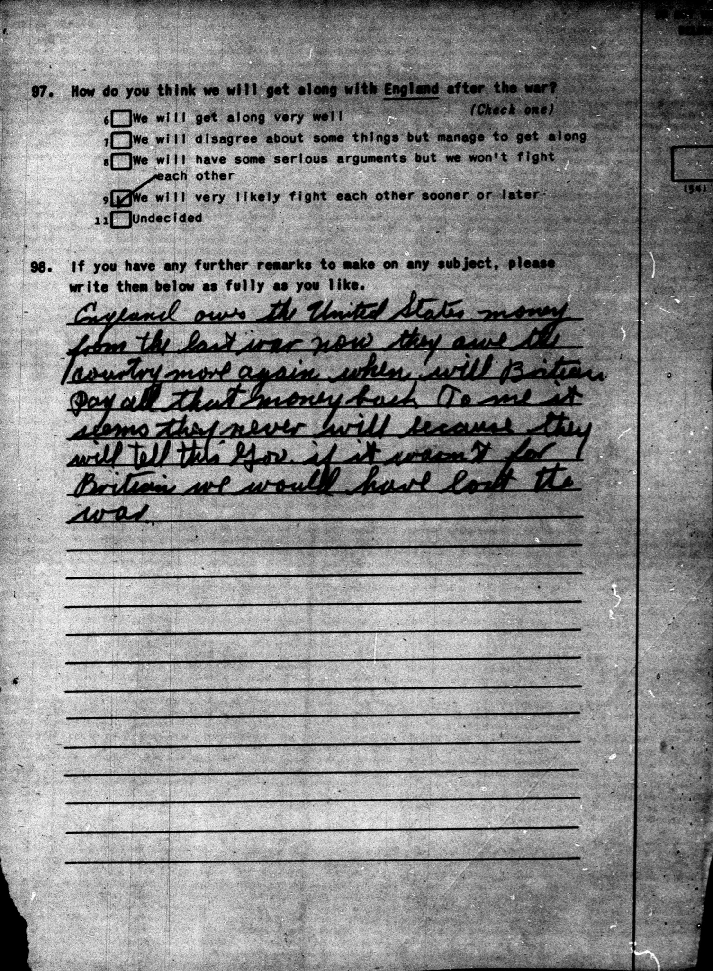

Document A, Survey 63, July-Sept 1943, 15-0401:
England owes the United States money from the last war now they owe the country more again when will Britain pay all that money back To me it seems they never will because they will tell this Gov. [Government] if it wasn't for Britain we would have lost the war.
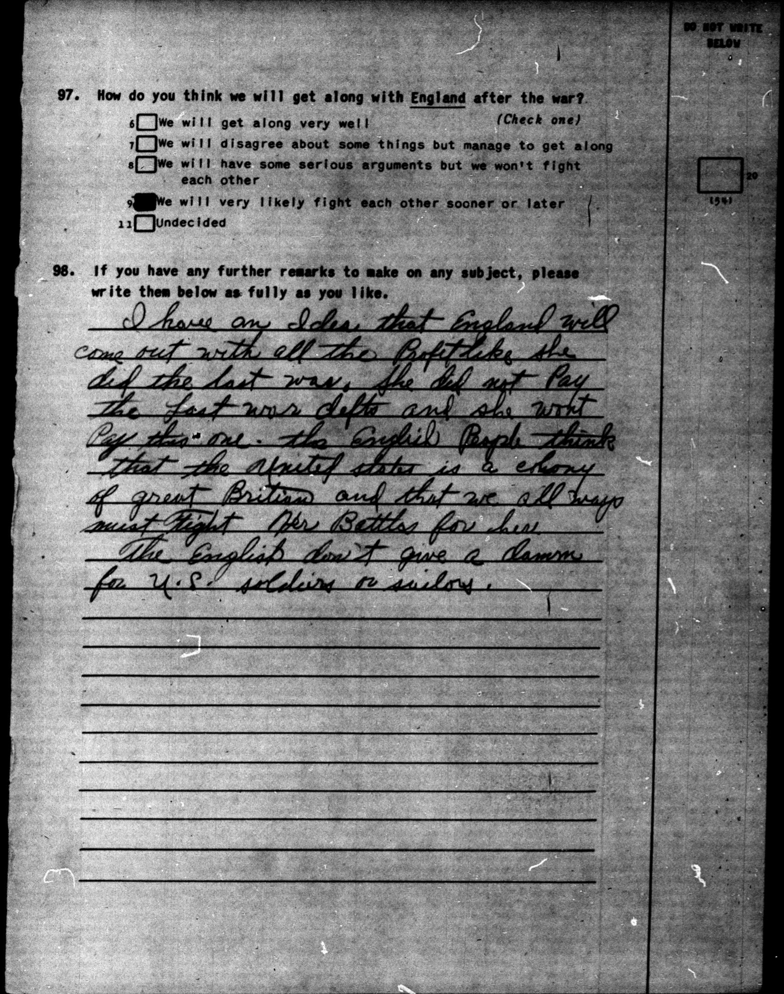
Document B, Survey 63, July-Sept 1943, 15-0913:
I have an idea that England will come out with all the profit like she did the last war. She did not pay the last war defts [debts] and she won't pay this one. The English People think that the United States is a colony of great Britain and that we all ways must fight her Battles for her.
The English don't give a damn for U.S. soldiers or sailors.

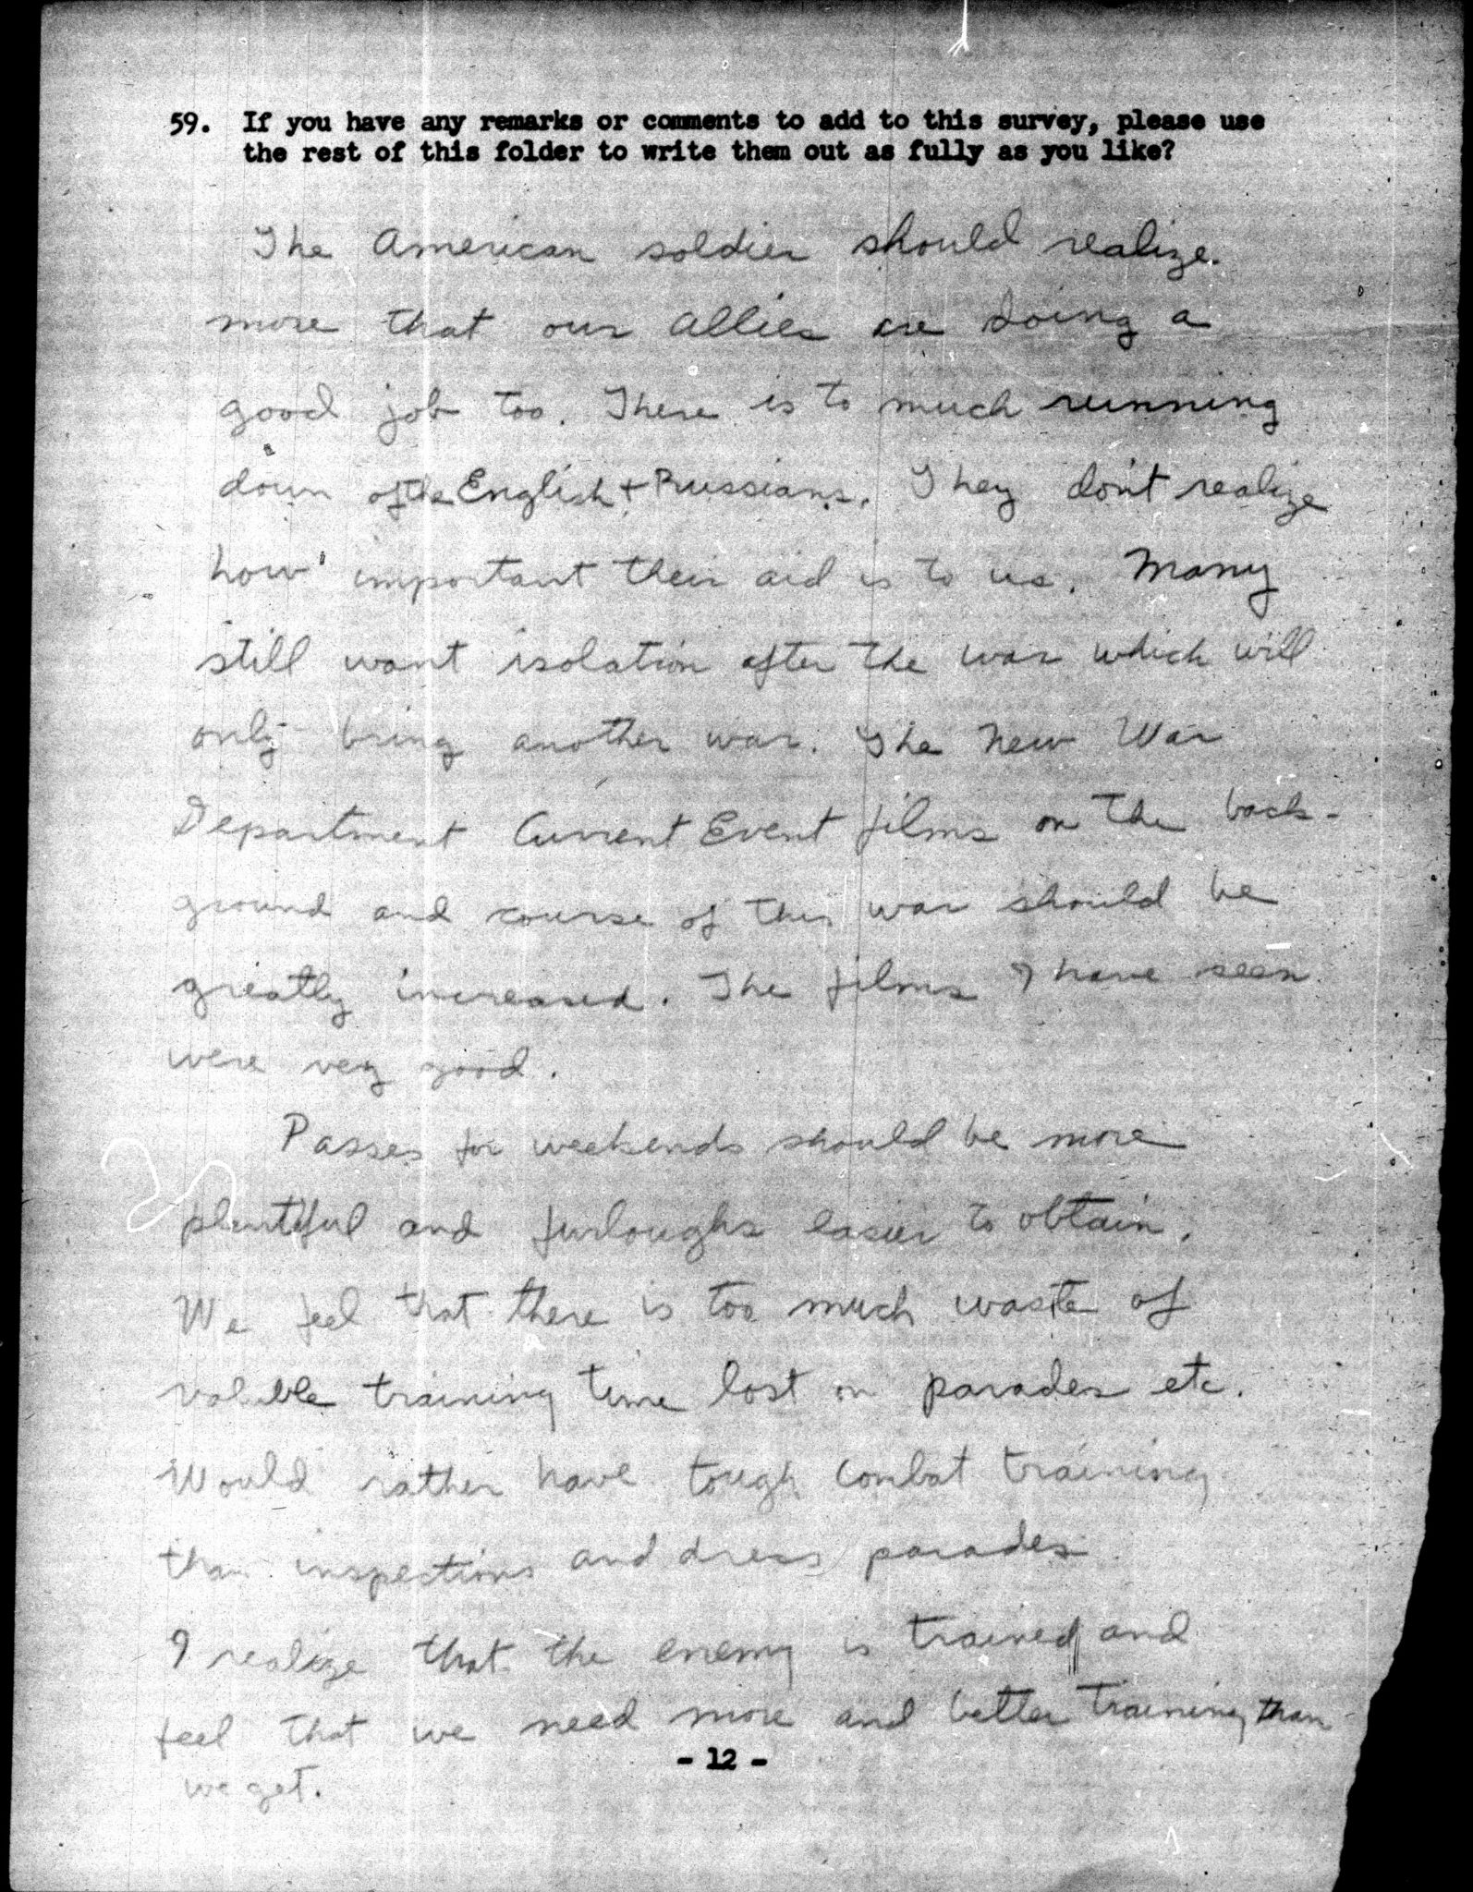
Document C, Planning Survey V, December 1942, 04-0226:
The American soldier should realize more that our allies are doing a good job too. There is to much running down of the English & Russians. They don't realize how important their aid is to us. Many still want isolation after the war which will only bring another war. The New War Department Current Event films on the background and course of this war should be greatly increased. The films I have seen were very good.
Passes for weekends should be more plentiful and furloughs easier to obtain. We feel that there is too much waste of valuable training time lost on parades etc. Would rather have tough combat training than inspections and dress parades. I realize that the enemy is trained and feel that we need more and better training than we get.

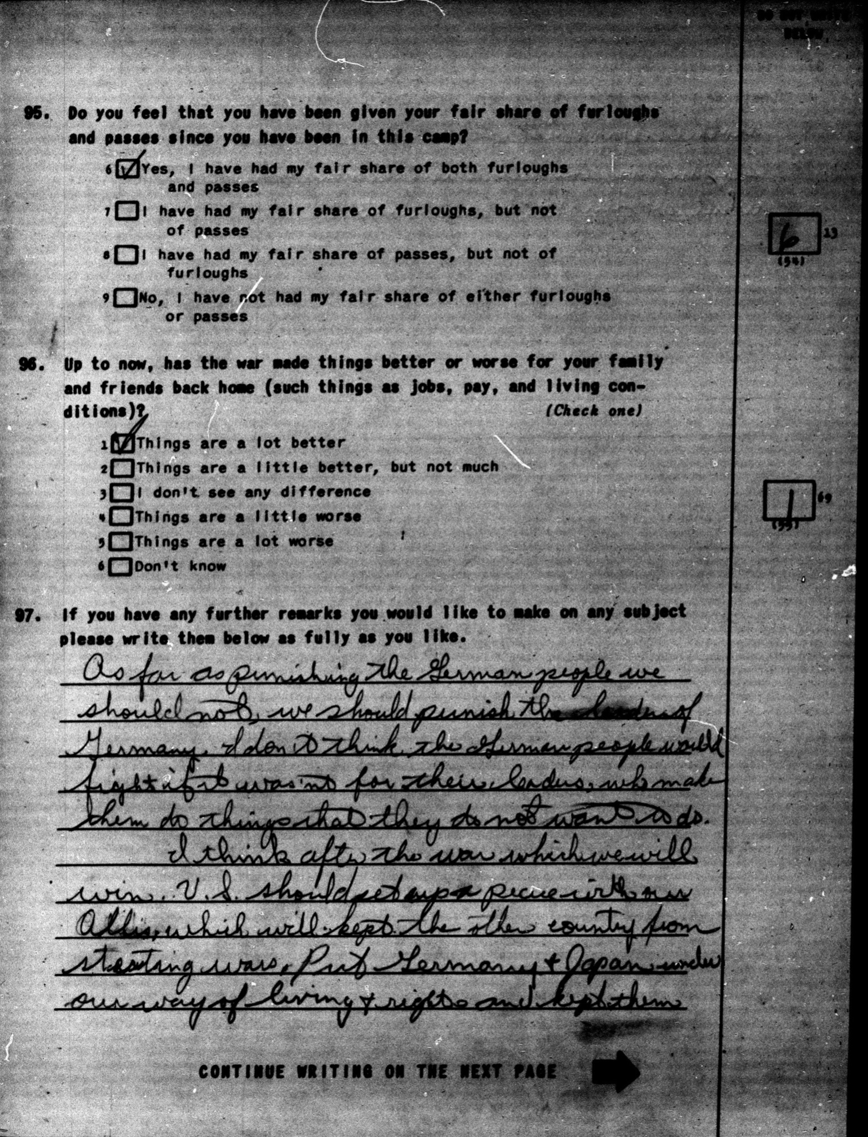
Document D, Survey 64, July 1943, 17-1343:
As far as punishing the German people we should not, we should punish the leaders of Germany. I don't think the German people would fight if it wasn't for their leaders, who make them do things that they do not want to do.
I think after the war which we will win U.S. should set up a peace with our Allies, which will kept the other country from starting wars. Put Germany & Japan under our way of living & rights and kept them.
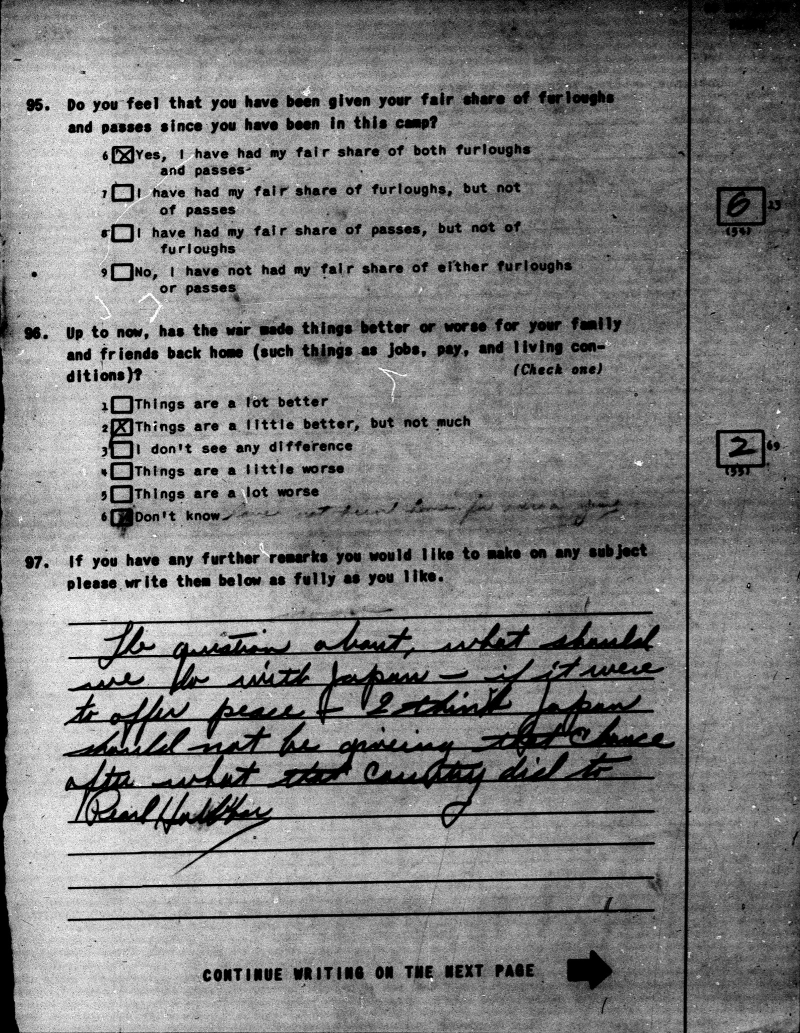

Document E, Survey 64, July 1943, 18-0414:
The question about, what should we do with Japan - if it were to offer peace - I think Japan should not be giving that chance after what that country did to Pearl Harbor

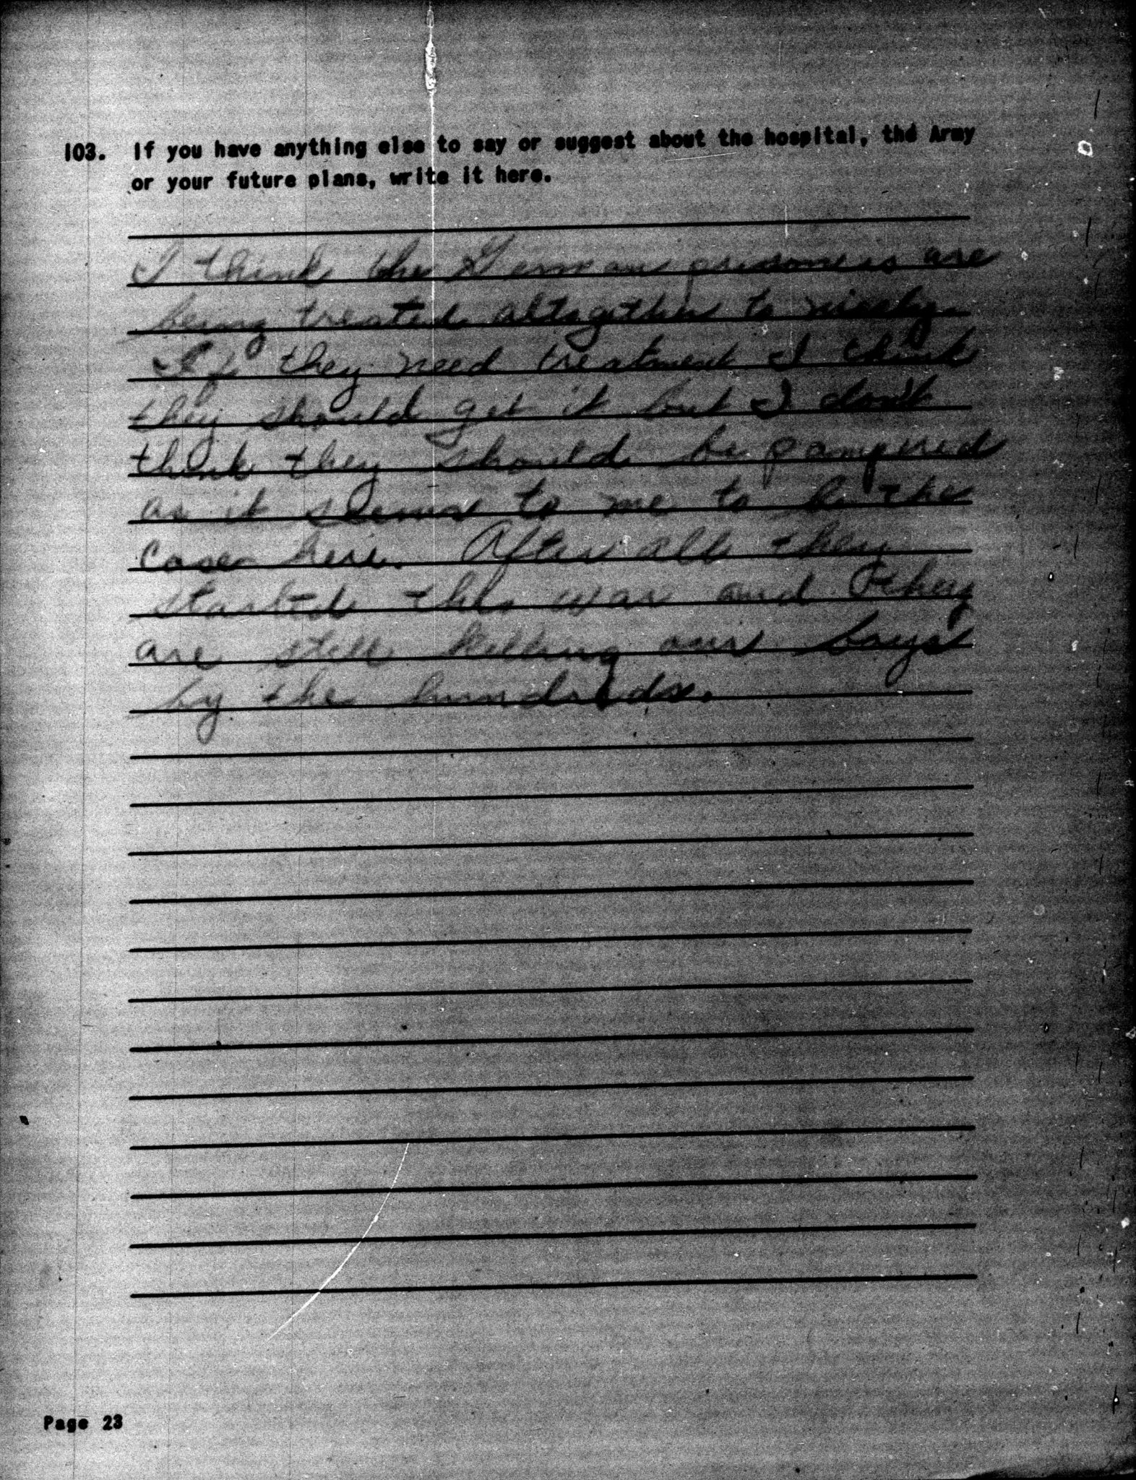
Document F, Survey 77, October 1943, 18-0897:
I think the German prisoners are being treated altogether to nicely. If they need treatment I think they should get it but I don't think they should be pampered as it seems to me to be the case here. After all they started the war and they are still killing our boys by the hundreds.

