Recreation & Entertainment Lesson Plan
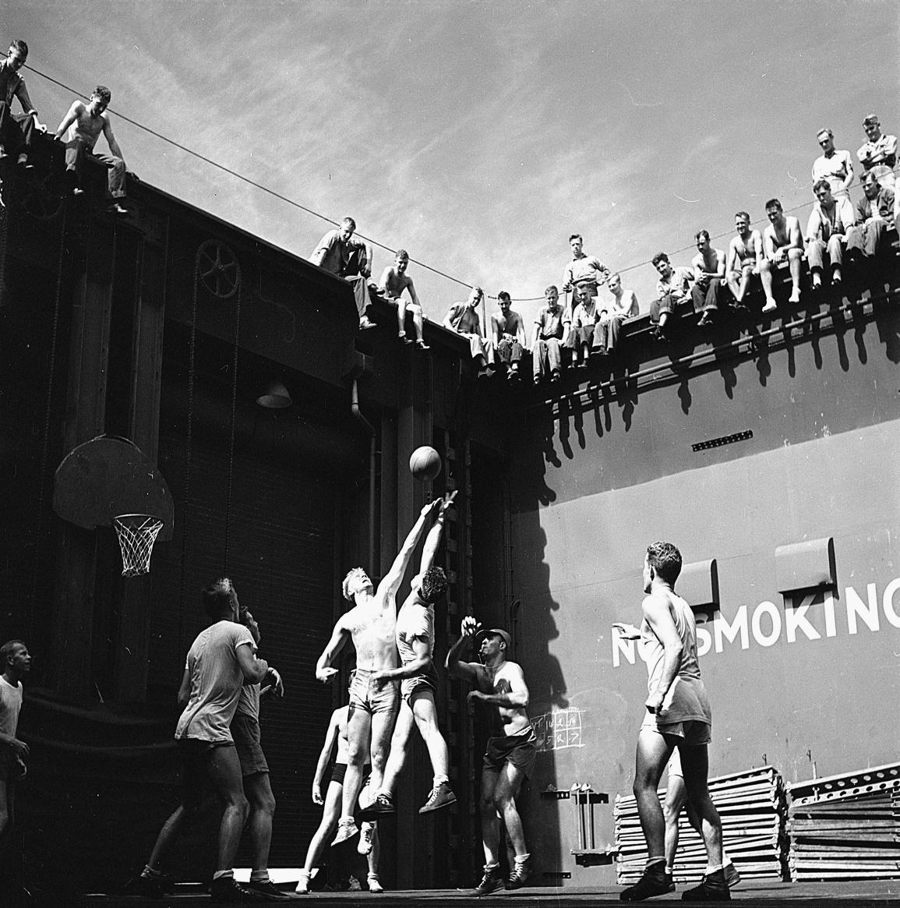
Introduction
Because of their sacrifice in fighting in World War II, a wide array of entertainment and recreation opportunities were offered to American GIs. United Service Organization shows, sports, games, and radio all became important parts of the American soldier’s life. These men were offered the opportunity to anonymously write their opinions on entertainment and other topics in a collection of surveys given by the Research Branch. These handwritten opinions sat largely untouched for decades until digitized and transcribed by The American Soldier in World War II project. This lesson plan utilizes a selection of these transcriptions to help students critically analyze primary sources to better understand the recreation and entertainment during World War II.

Students will also have the opportunity to use the SCIM-C Method. This method of analysis has been created to help students develop the knowledge and skills necessary to interpret historical primary sources and investigate meaningful historical questions.

Grade Level
High School/College Introductory (Age 16+)
Time Requirement
60 minutes
Materials
- Copies of Recreation & Welfare and Entertainment Overview Essays
- Copies of Recreation & Entertainment Responses for each group of students
- Copies of Student Worksheet for each student
Objectives
Students will be able to describe and explain the diverse views/experiences on entertainment in the US military during WWII by analyzing primary source documents on soldiers' experiences. They will revise their historical interpretation after reading each source, recognizing that by synthesizing information from multiple perspectives they can develop a richer, more accurate summary of the past.
Key Terms
Primary sources: textual or visual materials created during the historical moment you are studying, such as letters, diary entries, photographs, posters, and newspaper articles
Secondary sources: materials created well after the events they discuss by someone who did not experience them firsthand. Books, journal articles, encyclopedia entries, and documentaries are good examples.
Procedures
- Begin by either having students read the overview essays, “Entertainment” and “Recreation & Welfare,” to themselves or reading it together as a class. You may also have half the class read the first essay while the other half reads the second essay. Once students have finished reading the essays, have them take a moment to write down some notes summarizing the experience of soldiers with entertainment and recreation based on what they read. Ask a few students to identify the following about this text:
  - Identify 3 important details about the soldier’s experiences with entertainment detailed in the essay.
  - Identify 2 ways in which these experiences are still relevant to life in America today.
  - Identify 1 question you have or 1 source you would need to better understand these experiences. (15 minutes)
- Review the key terms listed above.
- Ask students whether the essay they just read is a primary or secondary source and how they can tell. Ask them what kinds of sources might be useful for learning more about what it was like to be a soldier in World War II (e.g., letters, diary entries, oral histories, maps or photographs of a training camp, a training manual, etc.). (5 minutes)
- Explain that students will now have the opportunity to build on their historical summaries of entertainment and recreation during the war by reading actual survey responses that soldiers wrote during World War II. You may choose for students to complete the activity individually or in groups. Distribute copies of the primary source responses and the Student Worksheet to each student or group.
- Instruct students to start by analyzing just one of the letters. Have them complete Part I of the Student Worksheet once they finish reading. (10 minutes)
- Have students read some of the additional responses, revising their historical summary each time and answering the questions on the Student Worksheet. Students can also think about the below questions when reading specific documents. (20 minutes)
- Return to the whole class to debrief. The object is for students to realize that while each primary source is a useful tool, the best historical interpretations will synthesize information from multiple perspectives. Here are some possible discussion questions: (10 minutes)
    - How did your historical summary change after you read the first response?
    - Did any of your responses contradict one another? How did you handle that in writing your summary?
    - Was there any one response that helped you the most in developing your summary? If so, why was it so helpful?
    - What details do you wish you knew more about before writing this summary?
    - What kinds of sources might help you find that information?
Assessment
You will be able to assess students’ ability to analyze individual primary sources based on the historical summaries they write, as well as the answers they provide on the Student Worksheet. You will be able to assess their ability to synthesize information from multiple sources and recognize the value of that process based on their historical summaries and the answers they give in discussion. You will also be able to assess their questioning of the sources provided to them.
Recommended Resources
USO Show (Video)
Armed Forces Radio Broadcast Clip (Video)
“Donut Dollies” and the American Red Cross (Article)

Extension/Enrichment
- Have students visit The American Soldier in World War II website and search for keywords surrounding entertainment and recreation. Ask students to revise their historical summary after taking the information they find into account, and have them explain how the new source(s) helped enhance their understanding of what it was like for soldiers during World War II.
Potential Keywords: entertainment, recreation, Red Cross, radio, USO, baseball, dance

- Have students choose their favorite response out of the ones they read and do a “deep analysis,” extracting as much information as possible about the writer—what he liked or disliked, where he was from, his strengths and weaknesses, etc.—and build a profile of that person. The objective here is for students to practice extracting data from text, both the expressly written data and information they can infer by interpreting the details.
Education Standards
COMMON CORE STANDARDS
CCSS.ELA-LITERACY.RH.6-8.2 - Determine the central ideas or information of a primary or secondary source; provide an accurate summary of the source distinct from prior knowledge or opinions.
CCSS.ELA-LITERACY.RH.6-8.9 - Analyze the relationship between a primary and secondary source on the same topic.
CCSS.ELA-LITERACY.RH.9-10.1 - Cite specific textual evidence to support analysis of primary and secondary sources, attending to such features as the date and origin of the information.
CCSS.ELA-LITERACY.RH.9-10.2 - Determine the central ideas or information of a primary or secondary source; provide an accurate summary of how key events or ideas develop over the course of the text.
CCSS.ELA-LITERACY.RH.9-10.9 - Compare and contrast treatments of the same topic in several primary and secondary sources.
CCSS.ELA-LITERACY.RH.11-12.9 - Integrate information from diverse sources, both primary and secondary, into a coherent understanding of an idea or event, noting discrepancies among sources.
NATIONAL STANDARDS FOR HISTORY
HISTORICAL CONTENT ERA 8, STANDARD 3B
The student understands World War II and how the Allies prevailed.
HISTORICAL CONTENT ERA 8, STANDARD 3C
The student understands the impacts of World War II at home.
HISTORICAL THINKING STANDARD 2
The student is able to appreciate historical perspectives by demonstrating the ability to
(a) describe the past on its own terms, through the eyes and experiences of those who were there, as revealed
through their literature, diaries, letters, debates, arts, artifacts, and the like;
(b) consider the historical context in which the event unfolded–the values, outlook, options, and contingencies of that time and place; and
(c) avoid “present-mindedness,” and not judging the past solely in terms of present-day norms and values.
HISTORICAL THINKING STANDARD 4
The student is able to support interpretations with historical evidence in order to construct closely-reasoned arguments rather than facile opinions.

Image Source: NARA

Recreation & Entertainment Responses
Document A includes comments about USO shows.
Document B includes comments about music.
Document C includes comments about sports.
Document D includes complaints about the lack of free time soldiers have.
Document E includes comments about dances.

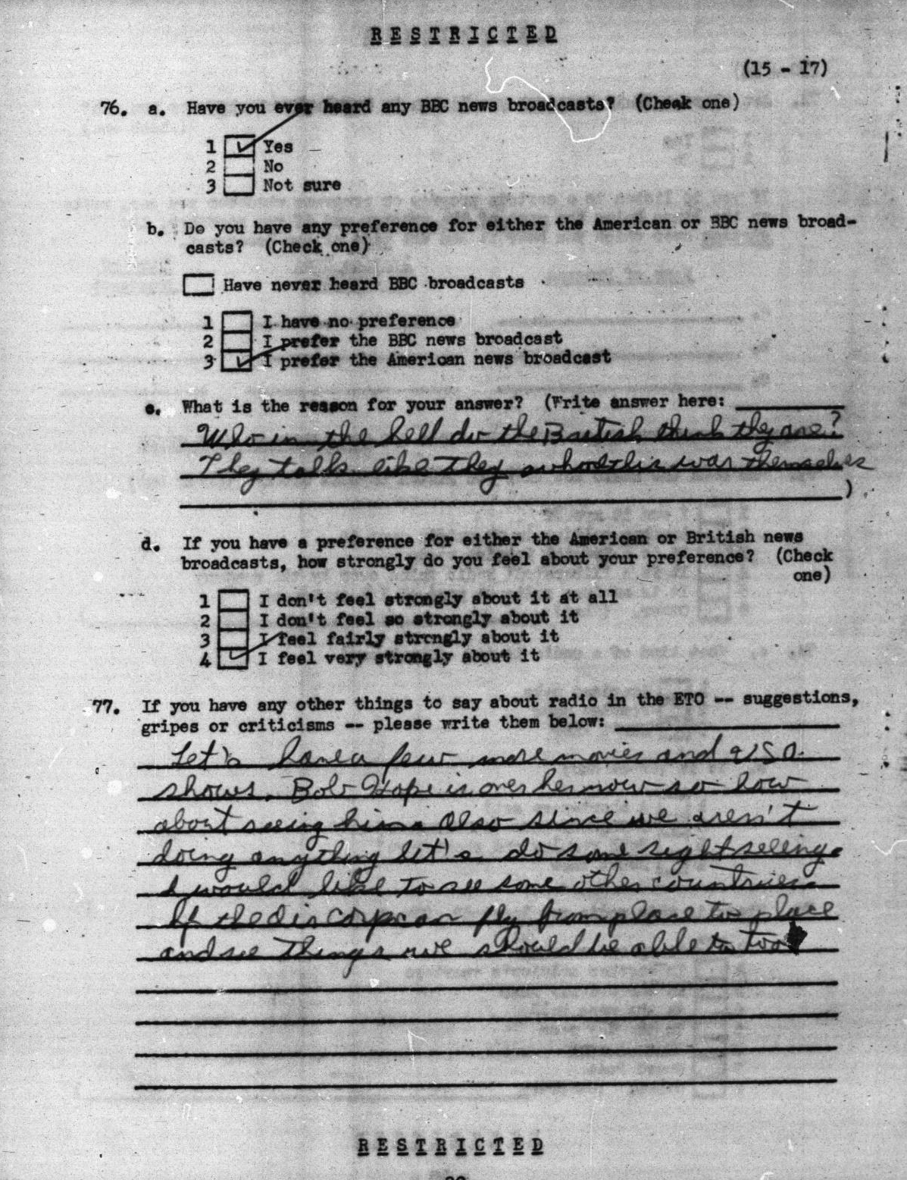

Document A (Survey 218, July 1945, 42-1813):
Let's have a few more movies and USO shows. Bob Hope is over here now so how about seeing him. Also since we aren't doing anything let's do some sight seeing. I would like to see some other countries. If the Air Corps can fly from place to place and see things we should be able too.

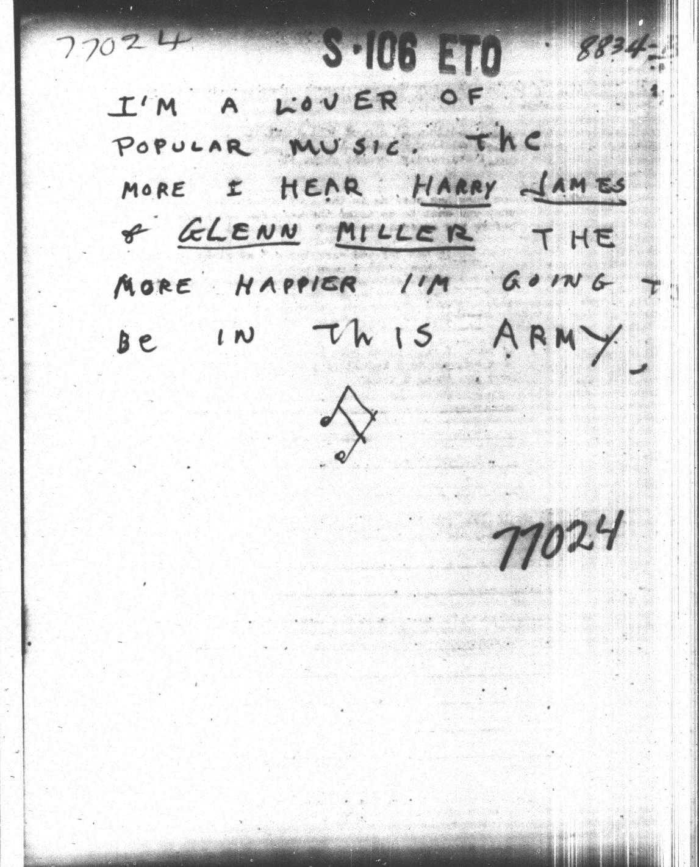

Document B (Survey 106, June 1944, 32-0582):
I’m a lover of popular music. The more I hear Harry James & Glenn Miller the happier I’m going to be in this army.

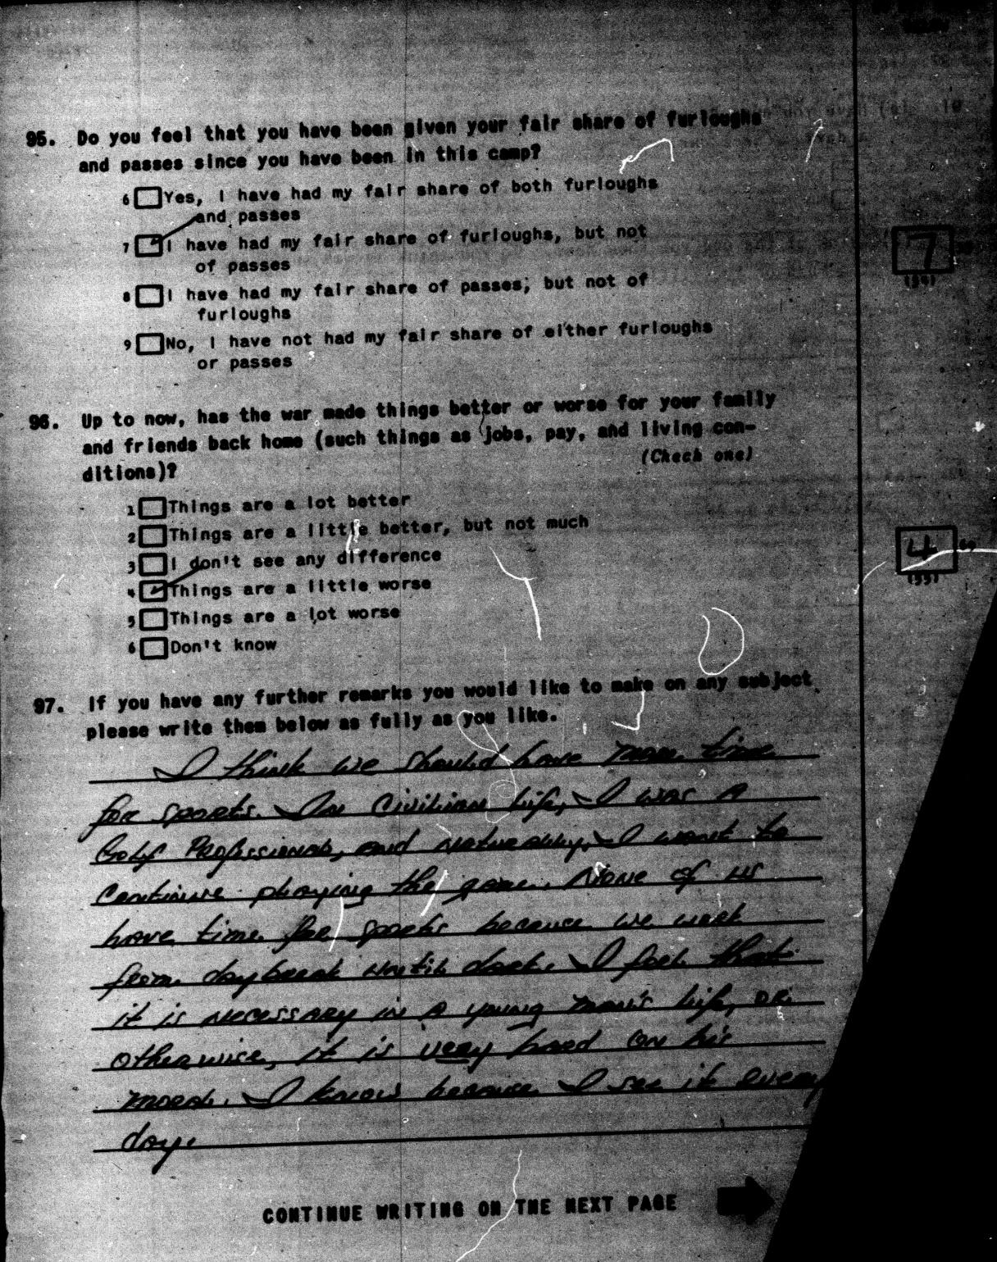

Document C (Survey 95, January-February 1944, 17-1506):
I think we should have more time for sports. In civilian life, I was a Golf Professional, and naturally, I want to continue playing the game. None of us have time for sports because we work from daybreak until dark. I feel that it is necessary in a young man's life, or otherwise, it is very hard on his morale. I know because I see it every day.

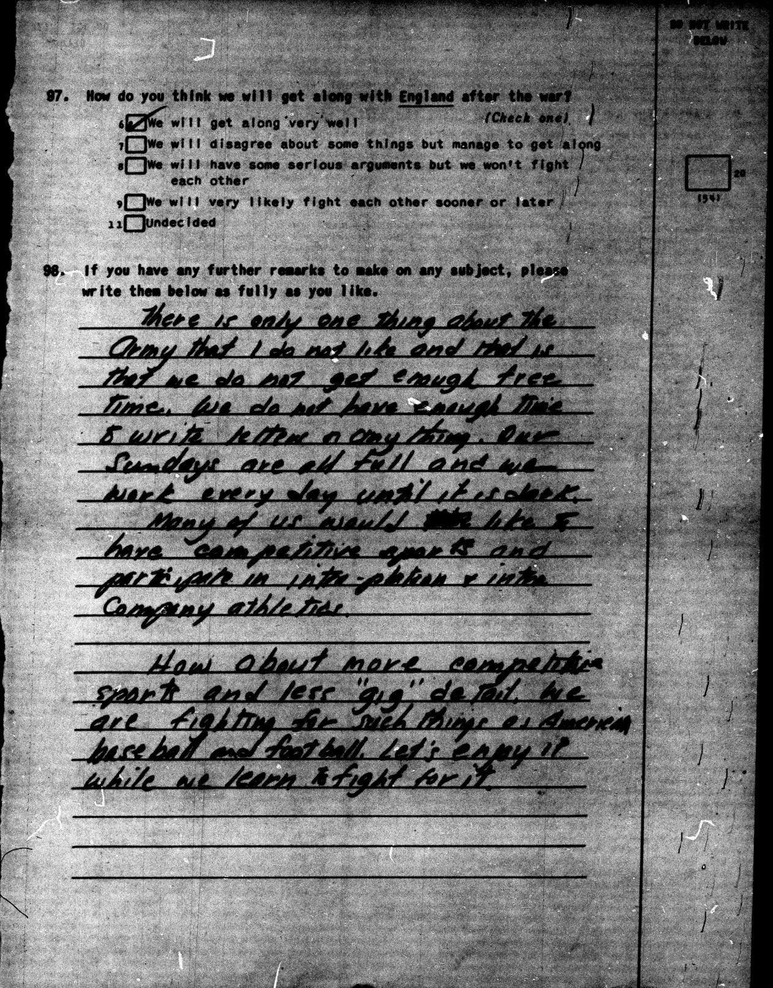

Document D (Survey 63, July-September 1943, 15-0404):
There is only one thing about the army that I do not like and that is that we do not get enough free time. We do not have enough time to write letters or any thing. Our Sundays are all full and we work every day until it is dark.
Many of us would like to have competitive sports and participate in intra-platoon & intra company athletics.
How about more competitive sports and less "gig" detail. We are fighting for such things as American baseball and football. Let's enjoy it while we learn to fight for it.

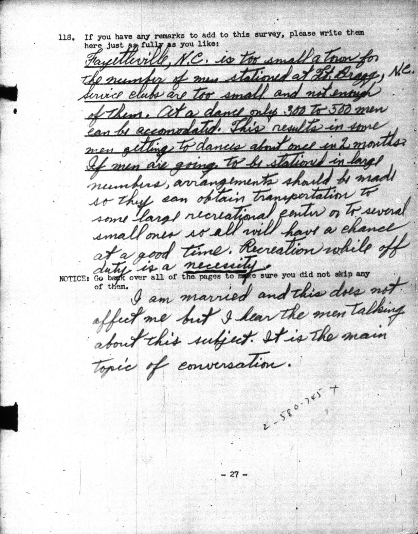
Document E (Planning Survey I, December 1941, 01-1031):
Fayetteville, N.C. is too small a town for the number of men stationed at Ft. Bragg, N.C. Service clubs are too small and not enough of them. At a dance only 300 to 500 men can be accommodated. This results in some men getting to dance about once in 2 months. If men are going to be stationed in large numbers, arrangements should be made so they can obtain transportation to some large recreational center or to several small ones so all will have a chance at a good time. Recreation while off duty is a necessity.
I am married and this does not affect me but I hear the men talking about this subject. It is the main topic of conversation.

