Medical Care & Mental Health Lesson Plan
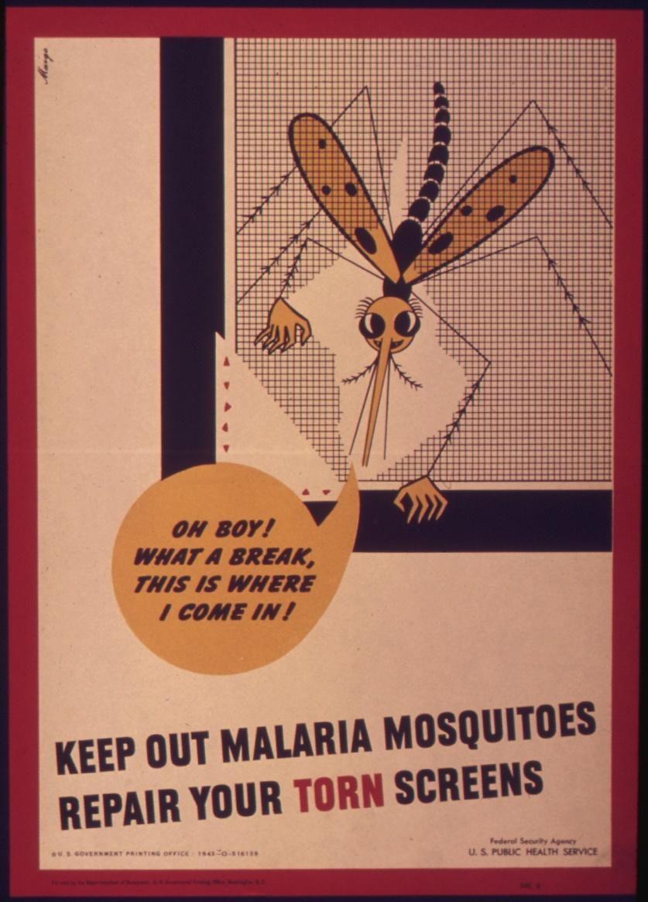
Introduction
During World War II, approximately 16 million Americans served in the military. Over half a million were offered the opportunity to anonymously write their opinions on combat and other topics in a series of surveys given by the Army Research Branch. These handwritten opinions sat largely untouched for decades until digitized and transcribed by The American Soldier in World War II project. This lesson plan utilizes a selection of these transcriptions to help students critically analyze primary sources to better understand the reality of medical care during World War II.
Students will also have the opportunity to use the SCIM-C Method. This method of analysis has been created to help students develop the knowledge and skills necessary to interpret historical primary sources and investigate meaningful historical questions.
Grade Level
High School/College Introductory (Age 16+)
Time Requirement
1 class period
Materials
- Copies of Medical Care & Mental Health Overview Essay
- Copies of Medical Care & Mental Health Responses for each group of students
- Copies of Student Worksheet for each student
Objectives
Students will analyze both primary and secondary sources related to the experiences of the American soldier during World War II. They will revise their historical interpretation after reading each source, recognizing that by synthesizing information from multiple perspectives, they can develop a richer more accurate summary of the past.
Key Terms
Primary sources: textual or visual materials created during the historical moment you are studying, such as letters, diary entries, photographs, posters, and newspaper articles
Secondary sources: materials created well after the events they discuss by someone who did not experience them firsthand. Books, journal articles, encyclopedia entries, and documentaries are good examples.
Procedures
- Begin by either having students read the overview essay, “Medical Care & Mental Health,” to themselves or reading it together as a class. Once students have finished reading the essay, have them take a moment to write down some notes summarizing the experience of American soldiers who needed medical care based on what they read. Ask a few students to share their ideas, noting cases where students interpreted the essay differently or chose different aspects of the text to emphasize. Ask students to identify the following about this text:
    - Identify 3 important details about medical care detailed in the essay.
    - Identify 2 ways in which these experiences are still relevant to life in America today.
    - Identify 1 question you have or 1 source you would need to better understand these experiences. (15 minutes)
- Review the key terms listed above.
- Ask students whether the essay they just read is a primary or secondary source and how they can tell. Ask them what kinds of primary sources might be useful for learning more about what it was like to be treated for a health problem in World War II (e.g., letters, diary entries, oral histories, maps or photographs of a training camp, a training manual, etc.). (5 minutes)
- Explain that students will now have the opportunity to build on their historical summaries of medical care during the war by reading actual survey responses that soldiers wrote during World War II. You may choose for students to complete the activity individually or in groups. Distribute copies of the primary source responses and the Student Worksheet to each student or group.
- Instruct students to start by analyzing just one of the letters—any one they like, or you may specify one. Have them complete Part I of the Student Worksheet once they finish reading. (10 minutes)
- Have students read as many of the additional letters as they have time for, revising their historical summary each time and answering the questions on the Student Worksheet. (20 minutes)
- Return to the whole class to debrief. The object is for students to realize that while each primary source is a useful tool, the best historical interpretations will synthesize information from multiple perspectives. Here are some possible discussion questions: (10 minutes)
    - How did your historical summary change after you read the first response?
    - Did any of your responses contradict one another? How did you handle that in writing your summary?
    - Was there any one response that helped you the most in developing your summary? If so, why was it so helpful?
    - What details do you wish you knew more about before writing this summary?
    - What kinds of sources might help you find that information?
Assessment
You will be able to assess students’ ability to analyze individual primary sources based on the historical summaries they write, as well as the answers they provide on the Student Worksheet. You will be able to assess their ability to synthesize information from multiple sources and recognize the value of that process based on their historical summaries and the answers they give in discussion.
Recommended Resources
First Aid for Battle Injuries (Video)
The US Army Medical Corps (Article)
Lasting Effects of PTSD on World War II Soldiers (Article)
Extension/Enrichment
- Have students visit The American Soldier in World War II website and search for keywords surrounding the experiences with medical care. Ask students to revise their historical summary after taking the information they find into account, and have them explain how the new source(s) helped enhance their understanding of what it was like for injured soldiers during World War II.
Potential Keywords: hospital, medicine, psychology, stress, doctor, malaria, VD
- Have students choose their favorite response out of the ones they read and do a “deep analysis,” extracting as much information as possible about the writer—what he liked or disliked, where he was from, his strengths and weaknesses, etc.—and build a profile of that person. The objective here is for students to practice extracting data from text, both the expressly written data and information they can infer by interpreting the details.
Education Standards
COMMON CORE STANDARDS
CCSS.ELA-LITERACY.RH.6-8.2 - Determine the central ideas or information of a primary or secondary source; provide an accurate summary of the source distinct from prior knowledge or opinions.
CCSS.ELA-LITERACY.RH.6-8.9 - Analyze the relationship between a primary and secondary source on the same topic.
CCSS.ELA-LITERACY.RH.9-10.1 - Cite specific textual evidence to support analysis of primary and secondary sources, attending to such features as the date and origin of the information.
CCSS.ELA-LITERACY.RH.9-10.2 - Determine the central ideas or information of a primary or secondary source; provide an accurate summary of how key events or ideas develop over the course of the text.
CCSS.ELA-LITERACY.RH.9-10.9 - Compare and contrast treatments of the same topic in several primary and secondary sources.
CCSS.ELA-LITERACY.RH.11-12.9 - Integrate information from diverse sources, both primary and secondary, into a coherent understanding of an idea or event, noting discrepancies among sources.
NATIONAL STANDARDS FOR HISTORY
HISTORICAL CONTENT ERA 8, STANDARD 3B
The student understands World War II and how the Allies prevailed.
HISTORICAL CONTENT ERA 8, STANDARD 3C
The student understands the impacts of World War II at home.
HISTORICAL THINKING STANDARD 2
The student is able to appreciate historical perspectives by demonstrating the ability to
(a) describe the past on its own terms, through the eyes and experiences of those who were there, as revealed
through their literature, diaries, letters, debates, arts, artifacts, and the like;
(b) consider the historical context in which the event unfolded–the values, outlook, options, and contingencies of that time and place; and
(c) avoid “present-mindedness,” and not judging the past solely in terms of present-day norms and values.
HISTORICAL THINKING STANDARD 4
The student is able to support interpretations with historical evidence in order to construct closely-reasoned arguments rather than facile opinions.

Image Source: NARA
Medical Care & Mental Health Responses
Document A informs students about malaria during WWII.
Document B is about concerns of long-term injury for soldiers.
Documents C, D & E provide information about shell shock and PTSD.

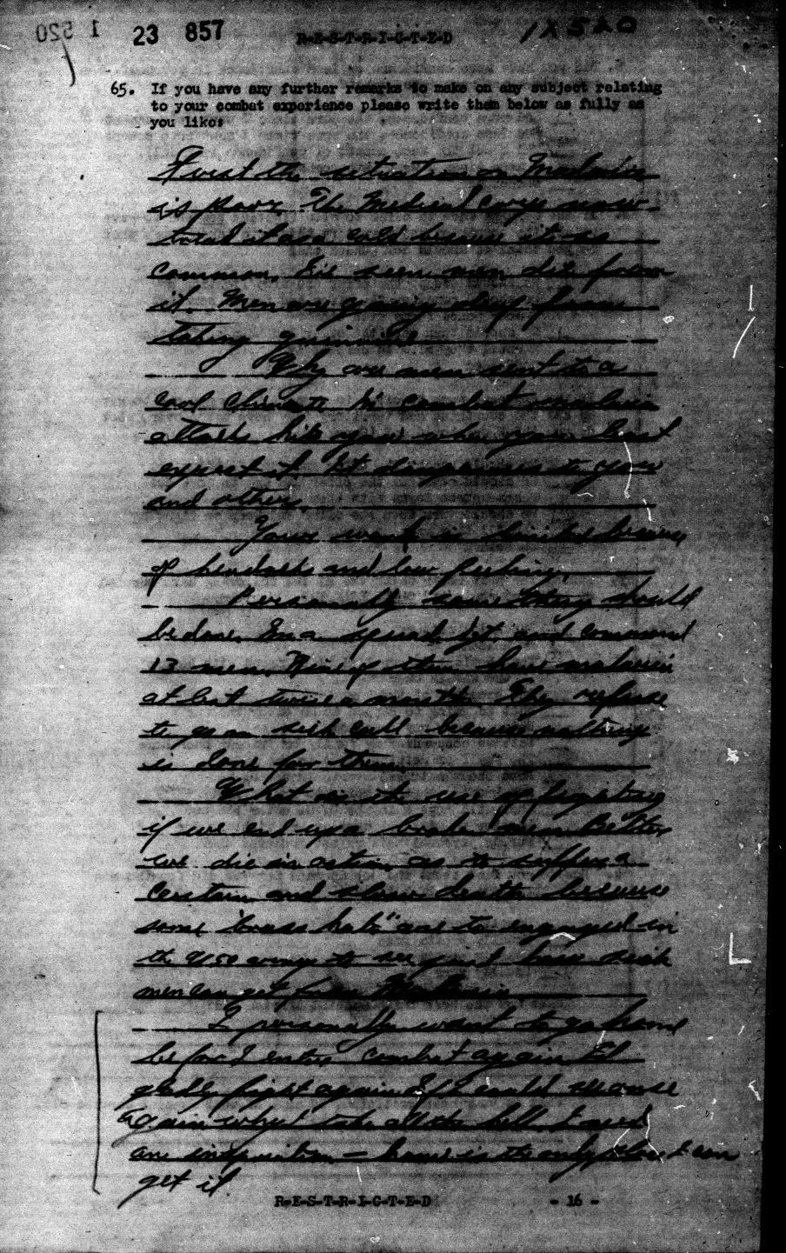
Document A (Survey 100, January-April 1944, 25-0844):
First the situation on Malaria is poor. The medical corp now treat it as a cold because its so common. I've seen men die from it. Men are going deaf from taking quinine.
Why are men sent to a bad climate in combat, malaria attacks hit you when you least expect it. It dangerous to you and others.
Your work is limited because of headache and low feeling.
Personally something should be done. I'm a squad Sgt. and command 13 men. Nine of them have malaria at best twice a month. They refuse to go on sick call because nothing is done for them.
What is the use of fighting if we end up a broke man. Better we die in action as to suffer a certain and slow death because some "brass hats" are to engaged in the USO army to see just how sick men can get from Malaria.
I personally want to go home before I enter combat again. I'd gladly fight again if I could see once again. Why take all the hell I need an inspiration - home is the only place I can get it.
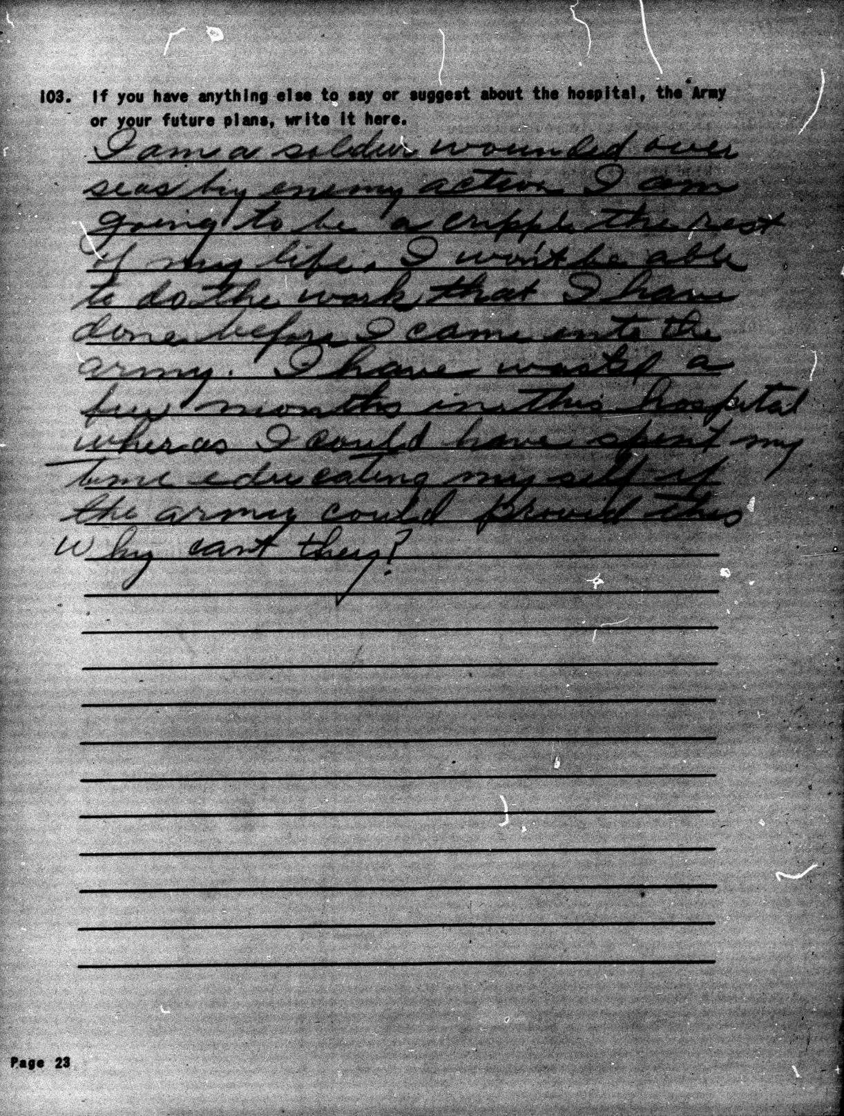

Document B (Survey 77, October-November 1943, 18-0729):
I am a soldier wounded over seas by enemy action. I am going to be a cripple the rest of my life. I won't be able to do the work that I have done before I came into the army. I have wasted a few months in this hospital wheras I could have spent my time educating my self if the army could provid this. Why cant they?

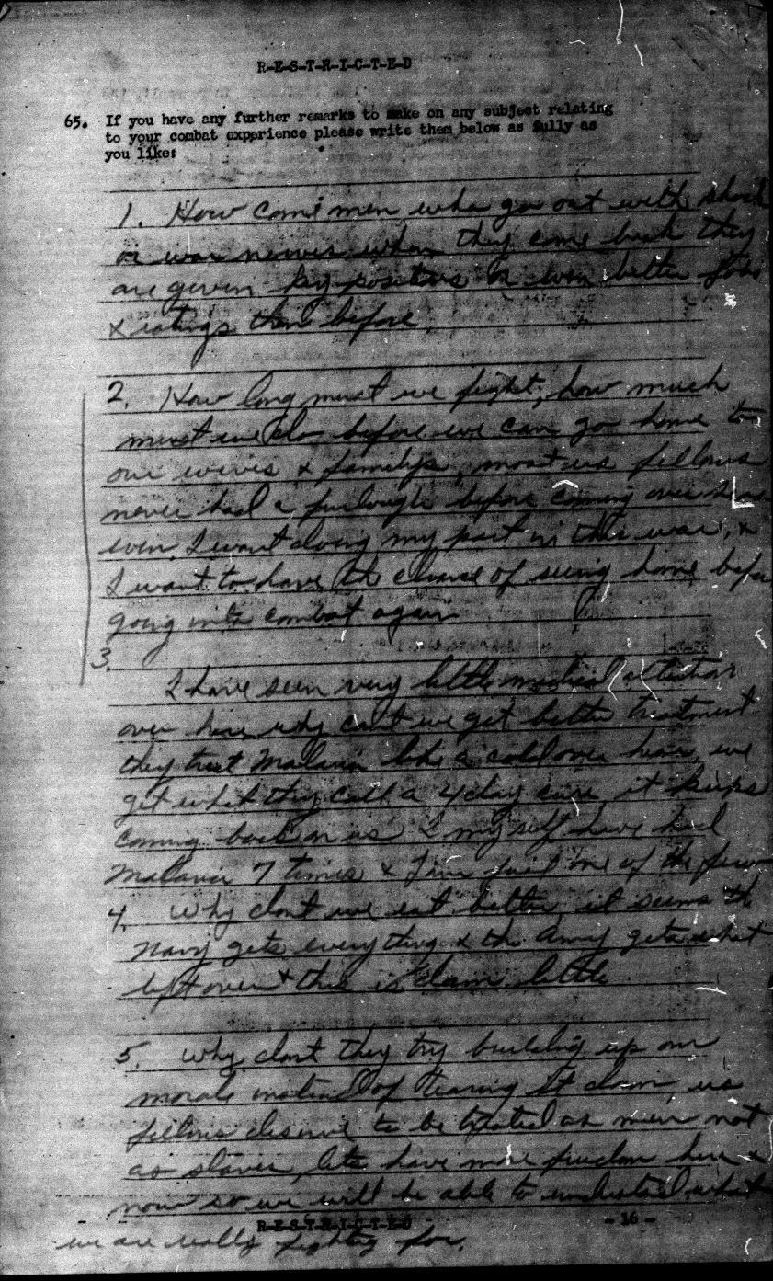

Document C (Survey 100, January-April 1944, 25-1141):
1. How come men who go out with shock or war nerves when they come back they are given key positions or even better jobs & ratings than before.

2. How long must we fight, how much must we do before we can go home to our wives & families, most us fellows never had a furlough before coming over seas even. I want doing my part in this war, & i want to have the chance of seeing home before going into combat again.

3. I have seen very little medical attention over here why can't we get better treatment they treat Malaria like a cold over here. We get what they call a 4 day cure, it keeps coming back on us. I myself have had Malaria 7 times & I'm just one of the few.

4. Why don't we eat better. It seems the Navy gets everything & the army gets what left over & this is dam little.

5. Why don't they try building up our morale instead of tearing it down, us fellows deserve to be treated as men not as slaves, lets. have more freedom here & now so we will be able to understand what we are really fighting for.

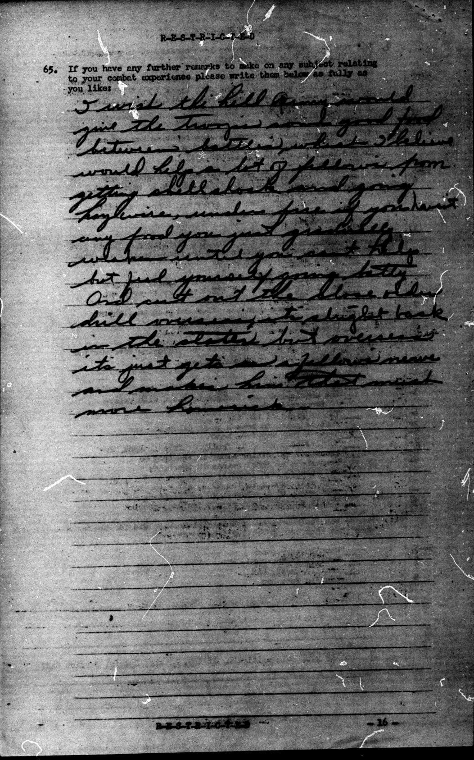
Document D (Survey 100, January-April 1944, 25-0780):
I wish the hell Army would give the troops some good food between battles, which I believe would help a lot of fellows from getting shell shock and going haywire, under fire if you haven't any food you just gradually weaken until you can't help but feel yourself going batty. And cut out the close order drill overseas its alright back in the states but overseas its just gets on a fellows nerves and makes him that much more homesick.

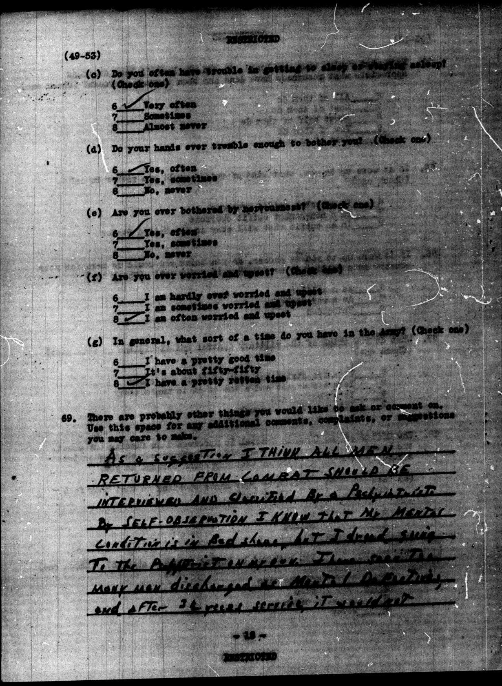

Document E (Survey 205, May 1945, 41-0264):
As a suggestion I think all men returned from combat should be interviewed and classified by a psychiatrist. By self-observation I know that my mental condition is in bad shape, but I dread going to the psychiatrist on my own. I have seen the many men discharged as disfunction, and after [unclear]3 1/2[unclear] years service, it would not.

