Combat Lesson Plan
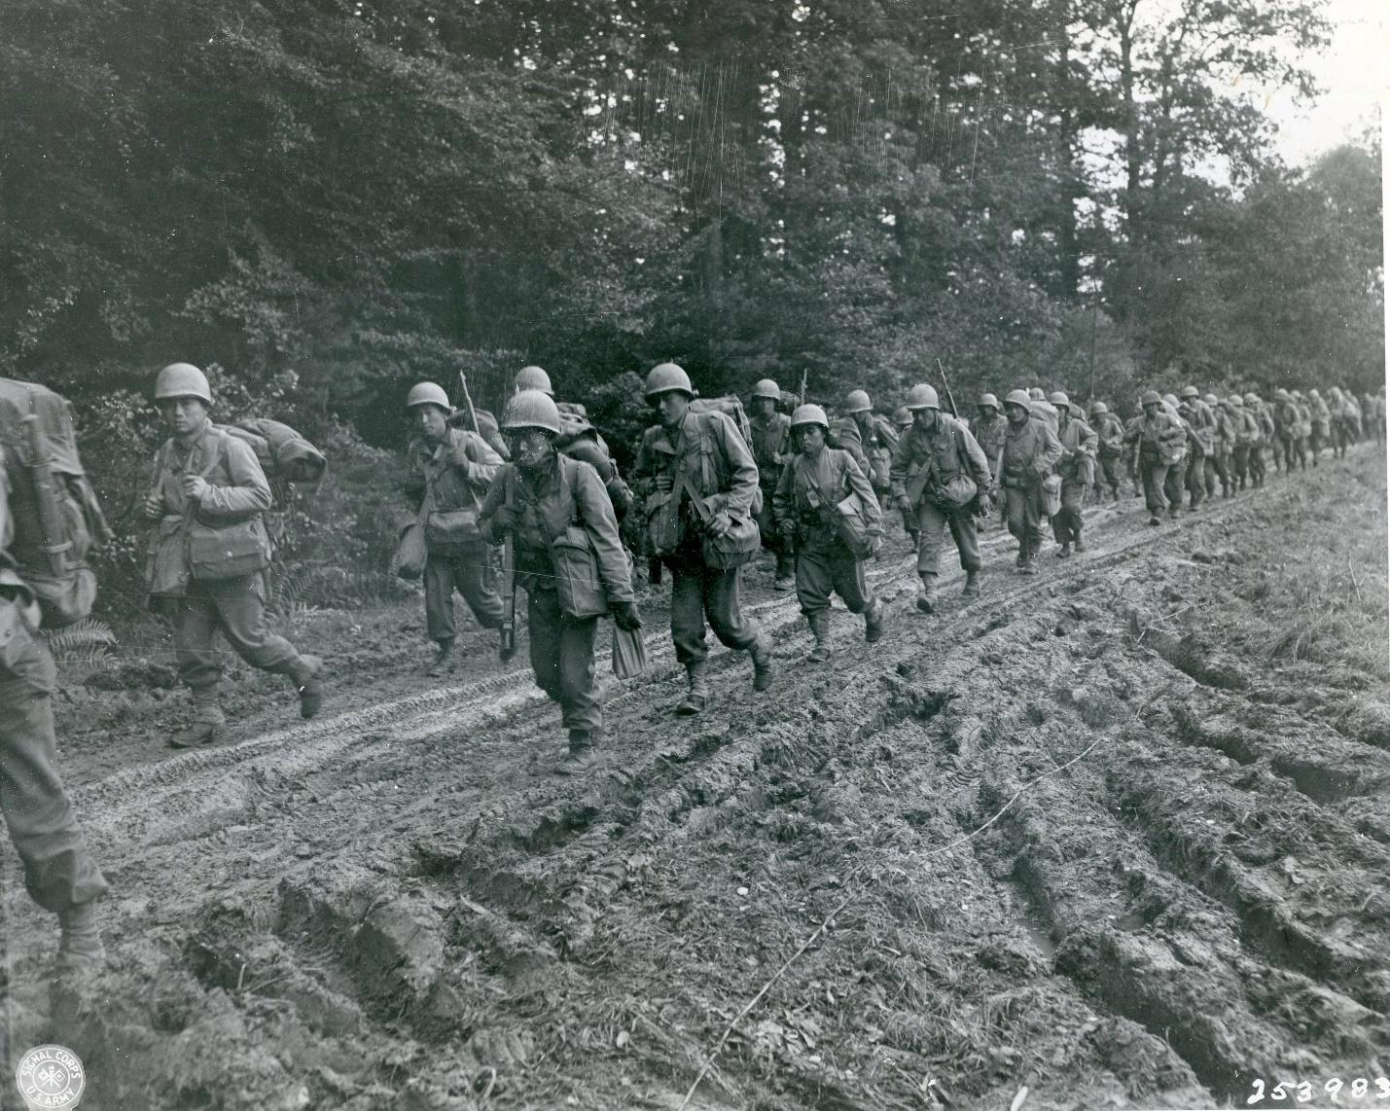
Introduction
During World War II, approximately 16 million Americans served in the military. Over half a million were offered the opportunity to anonymously write their opinions on combat and other topics in a series of surveys given by the Army Research Branch. These handwritten opinions sat largely untouched for decades until digitized and transcribed by The American Soldier in World War II project. This lesson plan utilizes a selection of these transcriptions to help students critically analyze primary sources to better understand the reality of combat during World War II.

Students will also have the opportunity to use the SCIM-C Method. This method of analysis has been created to help students develop the knowledge and skills necessary to interpret historical primary sources and investigate meaningful historical questions.

Grade Level
High School/College Introductory (Age 16+)
Time Requirement
60 minutes
Materials
- Copies of Ground Combat and Air Combat Overview Essays
- Copies of Combat Responses for each group of students
- Copies of Student Worksheet for each student
Objectives
Students will be able to describe and explain the diverse views/experiences on combat in the US military during WWII by analyzing primary source documents on soldiers' experiences. They will revise their historical interpretation after reading each source, recognizing that by synthesizing information from multiple perspectives they can develop a richer, more accurate summary of the past.
Key Terms
Primary sources: textual or visual materials created during the historical moment you are studying, such as letters, diary entries, photographs, posters, and newspaper articles
Secondary sources: materials created well after the events they discuss by someone who did not experience them firsthand. Books, journal articles, encyclopedia entries, and documentaries are good examples.
Procedures
- Begin by either having students read the overview essays, “Air Combat” and “Ground Combat,” to themselves or reading it together as a class. If it helps, half of the class can read the first essay while the other half reads the second essay. Once students have finished reading the essays, have them take a moment to write down some notes summarizing the experience of American GIs in combat based on what they read. Ask a few students to identify the following about this text:
  - Identify 3 important details about soldiers’ experiences with combat detailed in the essay.
  - Identify 2 ways in which these experiences are still relevant to life in America today.
  - Identify 1 question you have or 1 source you would need to better understand these experiences. (15 minutes)
- Review the key terms listed above.
- Ask students whether the essay they just read is a primary or secondary source and how they can tell. Ask them what kinds of sources might be useful for learning more about what it was like to be a soldier in combat during World War II (e.g., letters, diary entries, oral histories, maps or photographs of a training camp, a training manual, etc.). (5 minutes)
- Explain that students will now have the opportunity to build on their historical summaries of combat during the war by reading actual survey responses that soldiers wrote during World War II. You may choose for students to complete the activity individually or in groups. Distribute copies of the primary source responses and the Student Worksheet to each student or group.
- Instruct students to start by analyzing just one of the letters. Have them complete Part I of the Student Worksheet once they finish reading. (10 minutes)
- Have students read some of the additional responses, revising their historical summary each time and answering the questions on the Student Worksheet. Students can also think about the below questions when reading specific documents. (20 minutes)
- Return to the whole class to debrief. The object is for students to realize that while each primary source is a useful tool, the best historical interpretations will synthesize information from multiple perspectives. Here are some possible discussion questions: (10 minutes)
- How did your historical summary change after you read the first response?
- Did any of your responses contradict one another? How did you handle that in writing your summary?
- Was there any one response that helped you the most in developing your summary? If so, why was it so helpful?
- What details do you wish you knew more about before writing this summary?
- What kinds of sources might help you find that information?
Assessment
You will be able to assess students’ abilities to analyze individual primary sources based on the historical summaries they write, as well as the answers they provide on the Student Worksheet. You will be able to assess their ability to synthesize information from multiple sources and recognize the value of that process based on their historical summaries and the answers they give in discussion. You will also be able to assess their questioning of the sources provided to them.
Recommended Resources
Life in the Infantry (Article)
Battle of the Bulge (Video)

Extension/Enrichment
- Have students visit The American Soldier website and search for keywords surrounding combat. Ask students to revise their historical summary after taking the information they find into account, and have them explain how the new source(s) helped enhance their understanding of what it was like for combat soldiers during World War II.
Potential Keywords: combat, plane, flying, battle, bomb, mission

- Have students choose their favorite response out of the ones they read and do a “deep analysis,” extracting as much information as possible about the writer—what he liked or disliked, where he was from, his strengths and weaknesses, etc.—and build a profile of that person. The objective here is for students to practice extracting data from text, both the expressly written data and information they can infer by interpreting the details.
Education Standards
COMMON CORE STANDARDS
CCSS.ELA-LITERACY.RH.6-8.2 - Determine the central ideas or information of a primary or secondary source; provide an accurate summary of the source distinct from prior knowledge or opinions.
CCSS.ELA-LITERACY.RH.6-8.9 - Analyze the relationship between a primary and secondary source on the same topic.
CCSS.ELA-LITERACY.RH.9-10.1 - Cite specific textual evidence to support analysis of primary and secondary sources, attending to such features as the date and origin of the information.
CCSS.ELA-LITERACY.RH.9-10.2 - Determine the central ideas or information of a primary or secondary source; provide an accurate summary of how key events or ideas develop over the course of the text.
CCSS.ELA-LITERACY.RH.9-10.9 - Compare and contrast treatments of the same topic in several primary and secondary sources.
CCSS.ELA-LITERACY.RH.11-12.9 - Integrate information from diverse sources, both primary and secondary, into a coherent understanding of an idea or event, noting discrepancies among sources.
NATIONAL STANDARDS FOR HISTORY
HISTORICAL CONTENT ERA 8, STANDARD 3B
The student understands World War II and how the Allies prevailed.
HISTORICAL CONTENT ERA 8, STANDARD 3C
The student understands the impacts of World War II at home.
HISTORICAL THINKING STANDARD 2
The student is able to appreciate historical perspectives by demonstrating the ability to
(a) describe the past on its own terms, through the eyes and experiences of those who were there, as revealed
through their literature, diaries, letters, debates, arts, artifacts, and the like;
(b) consider the historical context in which the event unfolded–the values, outlook, options, and contingencies of that time and place; and
(c) avoid “present-mindedness,” and not judging the past solely in terms of present-day norms and values.
HISTORICAL THINKING STANDARD 4
The student is able to support interpretations with historical evidence in order to construct closely-reasoned arguments rather than facile opinions.

Image source: NARA

Combat Responses
Documents A & B discuss issues relating to air combat.
Documents C, D & E discuss issues relating to ground combat.

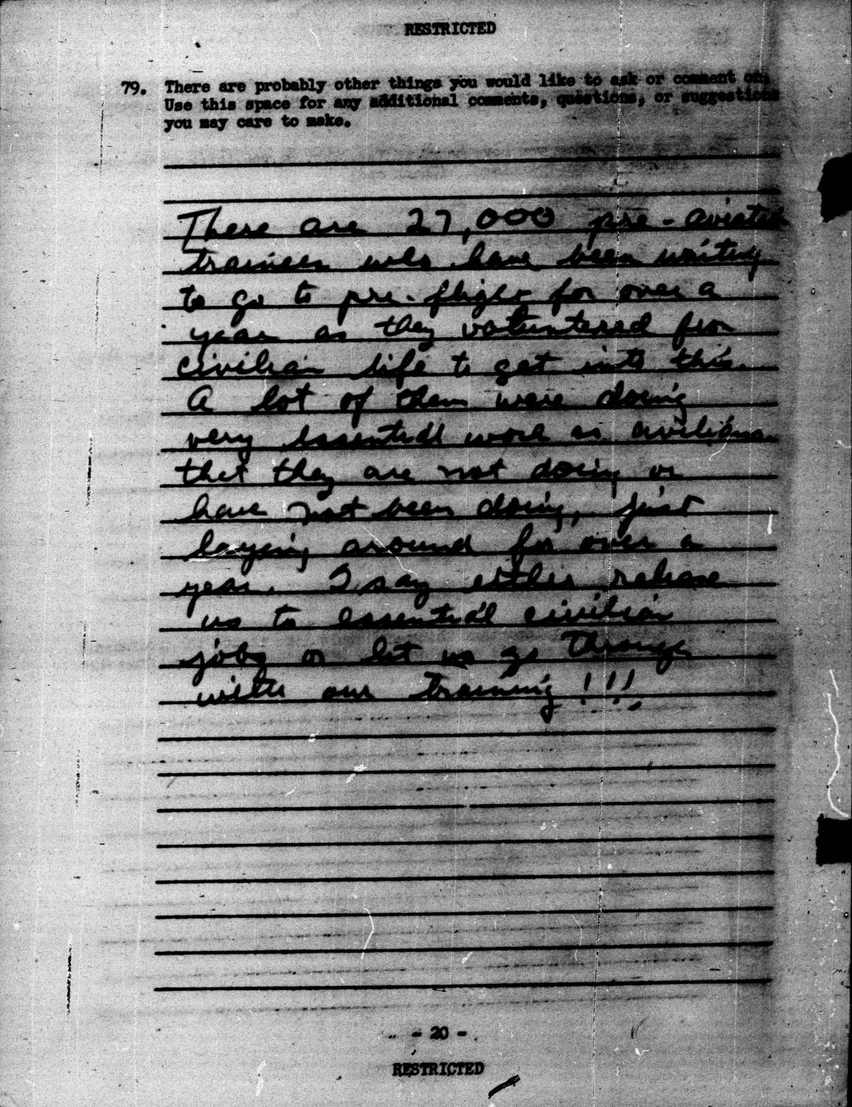
Document A (Survey 218, July 1945, 43-1141):
There are 27,000 pre-aviator trainees who have been waiting to go to pre-flight for over a year as they volunteered from civilian life to get into this. A lot of them were doing very essential work as civilians that they are not doing or have not been doing, just laying around for over a year. I say either release us to essential civilian jobs or let us go through with our training!!!

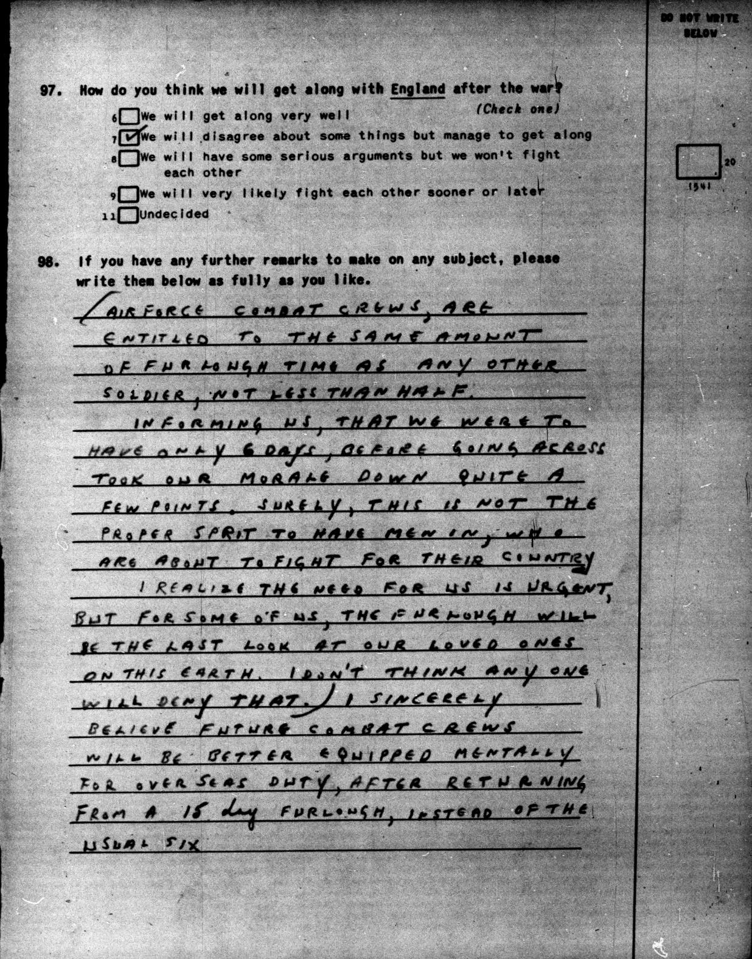
Document B (Survey 63, July-September 1943, 15-0965):
Air Force combat crews, are entitled to the same amount of furlough time as any other soldier, not less than half.
Informing us, that we were to have only 6 days, before going across took our morale down quite a few points. Surely, this is not the proper sprit to have men in, we are about to fight for their country.
I realize the need for us is urgent, but for some of us, the furlough will be the last look at our loved ones on this earth. I don't think any one will deny that. I sincerely believe future combat crews will be better equipped mentally for overseas duty, after returning from a 15 day furlough, instead of the usual six.
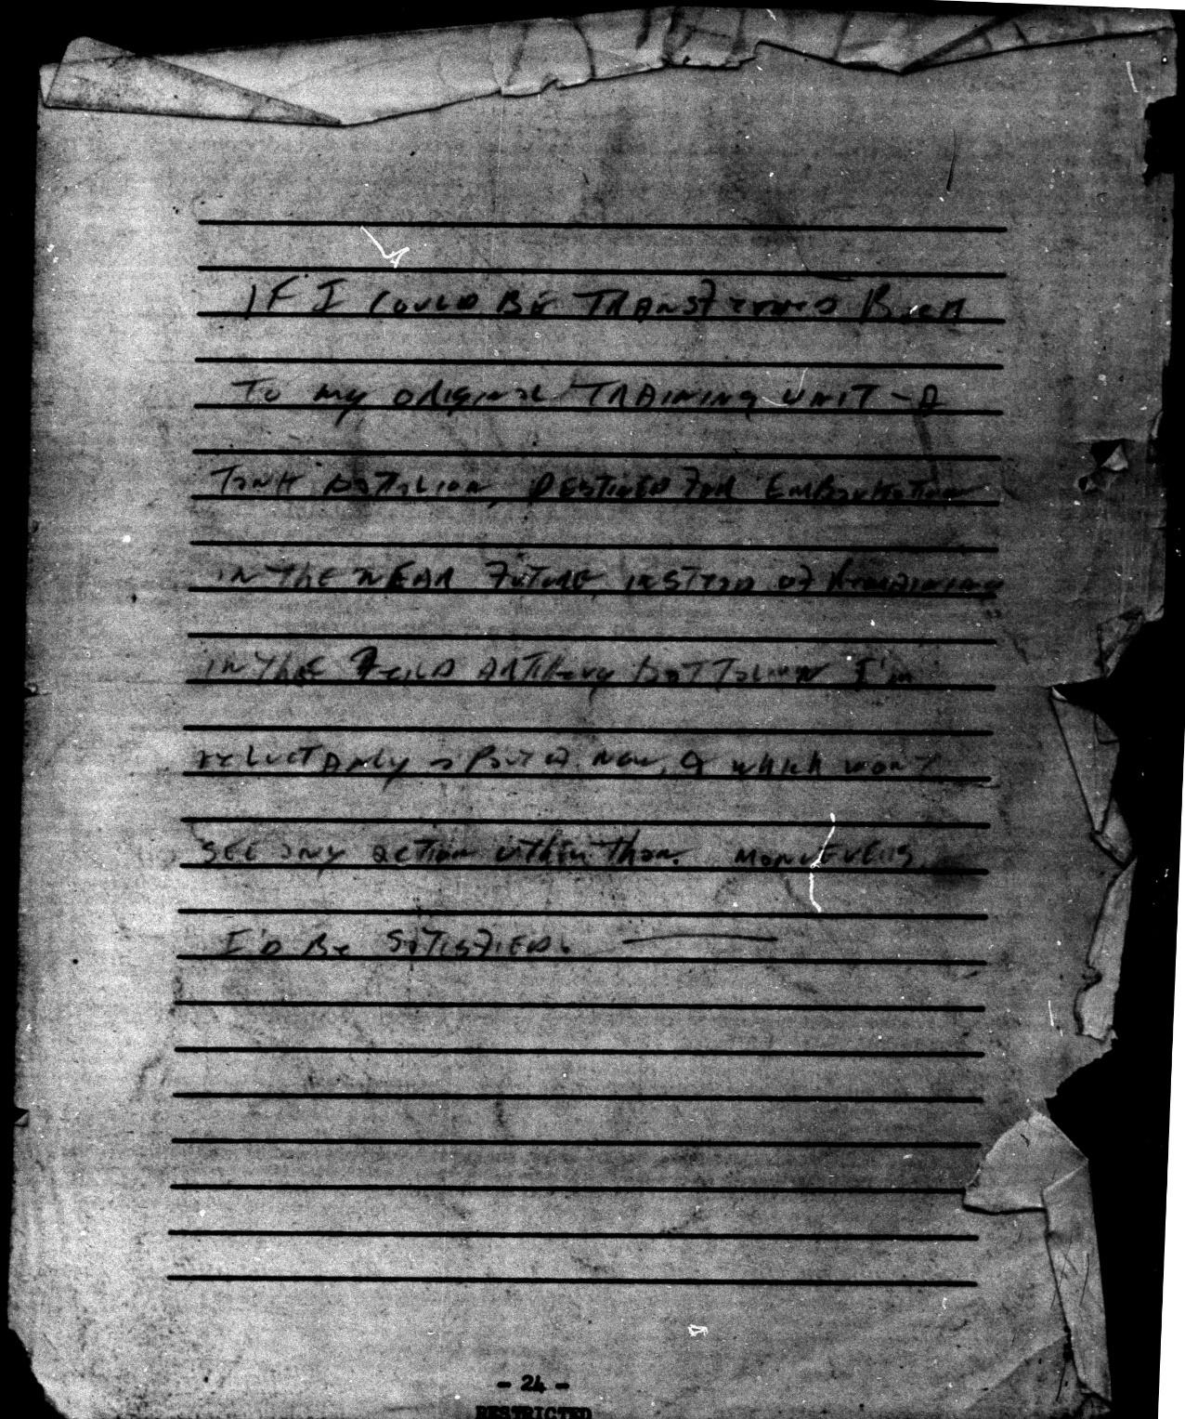
Document C (Survey 106, June 1944, 26-0574):
If I could be transferred back to my original training unit––a tank battalion destined for embattlement in the near future instead of remaining in the field artillery battlement I'm reluctantly a part of now, of which won't see any action other than maneuvers I'd be satisfied.

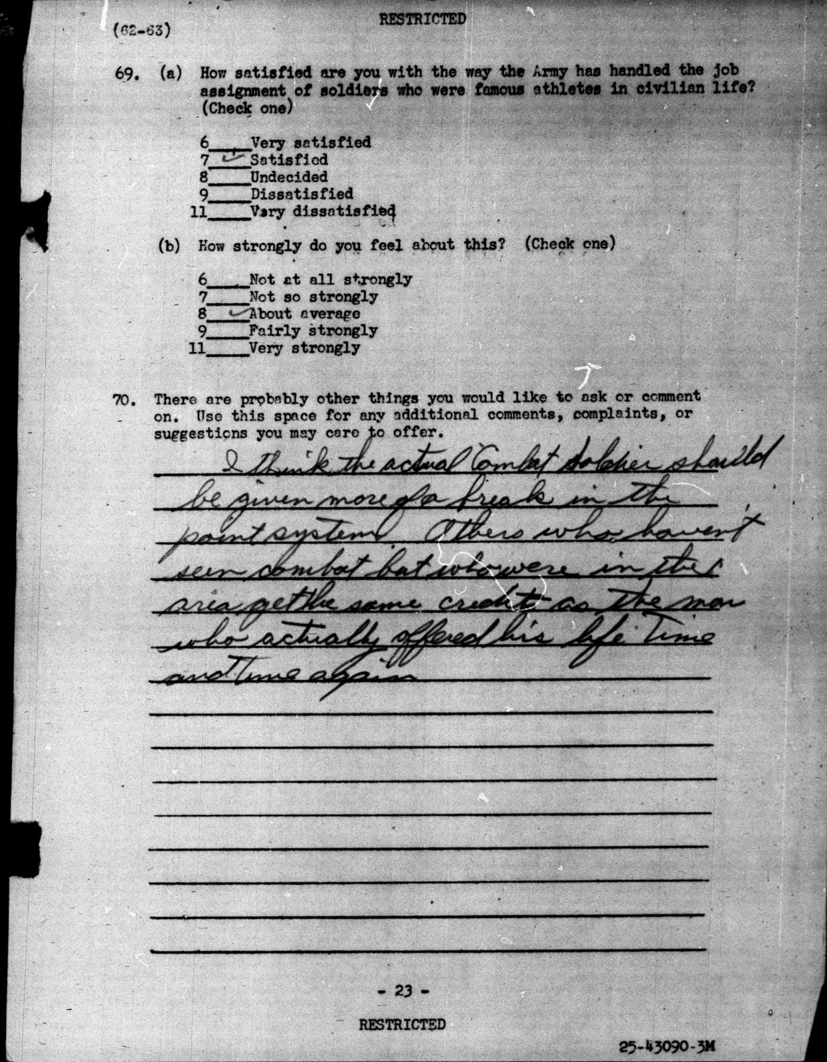
Document D (Survey 211, June 1945, 42-1389):
I think the actual Combat Soldier should be given more of a break in the point system. Others who haven't seen combat but who were in the area get the same credit as the men who actually offered his life time and time again.

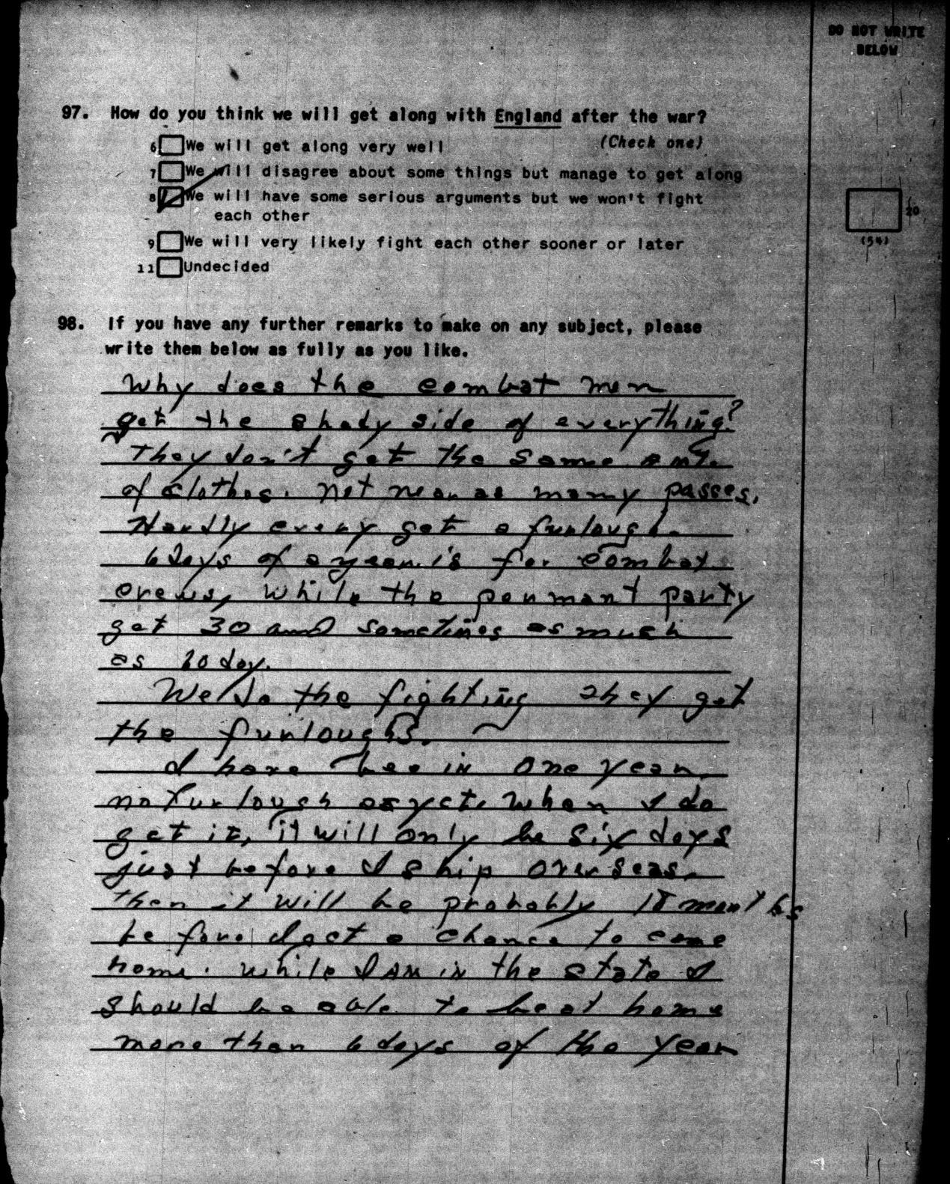

Document E (Survey 63, July-September 1943, 15-0816):
Why does the combat men get the shady side of everything? They don't get the same amt. of clothes. Not near as many passes. Hardly every get a furlough. 6 days of a year is for combat crews, while the penmant party get 30 and sometimes as much as 60 day.
We do the fighting they get the furloughs.
I have been in one year, no furlough as yet. When I do get it, it will only be six days just before I ship overseas, then it will be probably 18 months before I get a chance to come home. While I am in the state I should be able to be at home more than 6 days of the year.

