The Citizen Soldier Lesson Plan
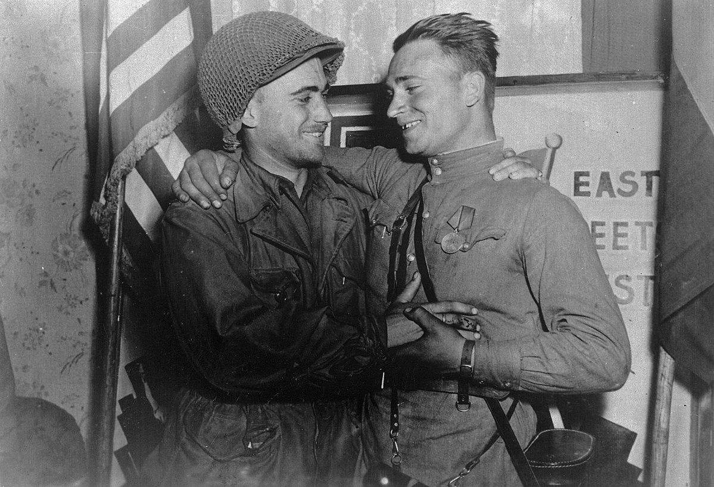
Introduction
During World War II, approximately 16 million Americans served in the military. Over half a million were offered the opportunity to anonymously write their opinions on combat and other topics in a series of surveys given by the Army Research Branch. These handwritten opinions sat largely untouched for decades until digitized and transcribed by The American Soldier in World War II project. This lesson plan utilizes a selection of these transcriptions to help students critically analyze primary sources to better understand the citizen soldier during World War II.

Students will also have the opportunity to use the SCIM-C Method. This method of analysis has been created to help students develop the knowledge and skills necessary to interpret historical primary sources and investigate meaningful historical questions.

Grade Level
High School/College Introductory (Age 16+)
Time Requirement
60 minutes
Materials
- Copies of The Citizen-Soldier Overview Essay
- Copies of Citizen-Soldier Responses for each group of students
- Copies of Student Worksheet for each student
Objectives
Students will be able to describe and explain the diverse views/experiences on being a soldier in the US military during WWII by analyzing primary source documents on soldiers' experiences. They will revise their historical interpretation after reading each source, recognizing that by synthesizing information from multiple perspectives they can develop a richer, more accurate summary of the past.
Key Terms
Primary sources: textual or visual materials created during the historical moment you are studying, such as letters, diary entries, photographs, posters, and newspaper articles
Secondary sources: materials created well after the events they discuss by someone who did not experience them firsthand. Books, journal articles, encyclopedia entries, and documentaries are good examples.
Procedures
- Begin by either having students read the overview essay, “The Citizen-Soldier,” to themselves or reading it together as a class. Once students have finished reading the essay, have them take a moment to write down some notes summarizing the experience of American GIs based on what they read. Ask a few students to identify the following about this text:
  - Identify 3 important details about soldiers’ experiences detailed in the essay.
  - Identify 2 ways in which these experiences are still relevant to life in America today.
  - Identify 1 question you have or 1 source you would need to better understand these experiences. (15 minutes)
- Review the key terms listed above.
- Ask students whether the essay they just read is a primary or secondary source and how they can tell. Ask them what kinds of sources might be useful for learning more about what it was like to be a soldier in combat during World War II (e.g., letters, diary entries, oral histories, maps or photographs of a training camp, a training manual, etc.). (5 minutes)
- Explain that students will now have the opportunity to build on their historical summaries of being a soldier during the war by reading actual survey responses that soldiers wrote during World War II. You may choose for students to complete the activity individually or in groups. Distribute copies of the primary source responses and the Student Worksheet to each student or group.
- Instruct students to start by analyzing just one of the letters. Have them complete Part I of the Student Worksheet once they finish reading. (10 minutes)
- Have students read some of the additional responses, revising their historical summary each time and answering the questions on the Student Worksheet. Students can also think about the below questions when reading specific documents. (20 minutes)
- Return to the whole class to debrief. The object is for students to realize that while each primary source is a useful tool, the best historical interpretations will synthesize information from multiple perspectives. Here are some possible discussion questions: (10 minutes)
    - How did your historical summary change after you read the first response?
    - Did any of your responses contradict one another? How did you handle that in writing your summary?
    - Was there any one response that helped you the most in developing your summary? If so, why was it so helpful?
    - What details do you wish you knew more about before writing this summary?
    - What kinds of sources might help you find that information?
Assessment
You will be able to assess students’ ability to analyze individual primary sources based on the historical summaries they write, as well as the answers they provide on the Student Worksheet. You will be able to assess their ability to synthesize information from multiple sources and recognize the value of that process based on their historical summaries and the answers they give in discussion. You will also be able to assess their questioning of the sources provided to them.
Recommended Resources
The Draft in WWII (Article)

Extension/Enrichment
- Have students visit The American Soldier in World War II website and search for keywords surrounding the citizen soldier. Ask students to revise their historical summary after taking the information they find into account, and have them explain how the new source(s) helped enhance their understanding of what it was like for combat soldiers during World War II.
Potential Keywords: draft, conscription, treatment, education

- Have students choose their favorite response out of the ones they read and do a “deep analysis,” extracting as much information as possible about the writer—what he liked or disliked, where he was from, his strengths and weaknesses, etc.—and build a profile of that person. The objective here is for students to practice extracting data from text, both the expressly written data and information they can infer by interpreting the details.
Education Standards
COMMON CORE STANDARDS
CCSS.ELA-LITERACY.RH.6-8.2 - Determine the central ideas or information of a primary or secondary source; provide an accurate summary of the source distinct from prior knowledge or opinions.
CCSS.ELA-LITERACY.RH.6-8.9 - Analyze the relationship between a primary and secondary source on the same topic.
CCSS.ELA-LITERACY.RH.9-10.1 - Cite specific textual evidence to support analysis of primary and secondary sources, attending to such features as the date and origin of the information.
CCSS.ELA-LITERACY.RH.9-10.2 - Determine the central ideas or information of a primary or secondary source; provide an accurate summary of how key events or ideas develop over the course of the text.
CCSS.ELA-LITERACY.RH.9-10.9 - Compare and contrast treatments of the same topic in several primary and secondary sources.
CCSS.ELA-LITERACY.RH.11-12.9 - Integrate information from diverse sources, both primary and secondary, into a coherent understanding of an idea or event, noting discrepancies among sources.
NATIONAL STANDARDS FOR HISTORY
HISTORICAL CONTENT ERA 8, STANDARD 3B
The student understands World War II and how the Allies prevailed.
HISTORICAL CONTENT ERA 8, STANDARD 3C
The student understands the impacts of World War II at home.
HISTORICAL THINKING STANDARD 2
The student is able to appreciate historical perspectives by demonstrating the ability to
(a) describe the past on its own terms, through the eyes and experiences of those who were there, as revealed
through their literature, diaries, letters, debates, arts, artifacts, and the like;
(b) consider the historical context in which the event unfolded–the values, outlook, options, and contingencies of that time and place; and
(c) avoid “present-mindedness,” and not judging the past solely in terms of present-day norms and values.
HISTORICAL THINKING STANDARD 4
The student is able to support interpretations with historical evidence in order to construct closely-reasoned arguments rather than facile opinions.

Image Source: NARA

The Citizen Soldier Responses
The following documents deal with complaints about the draft, equality, and the safety of soldiers.

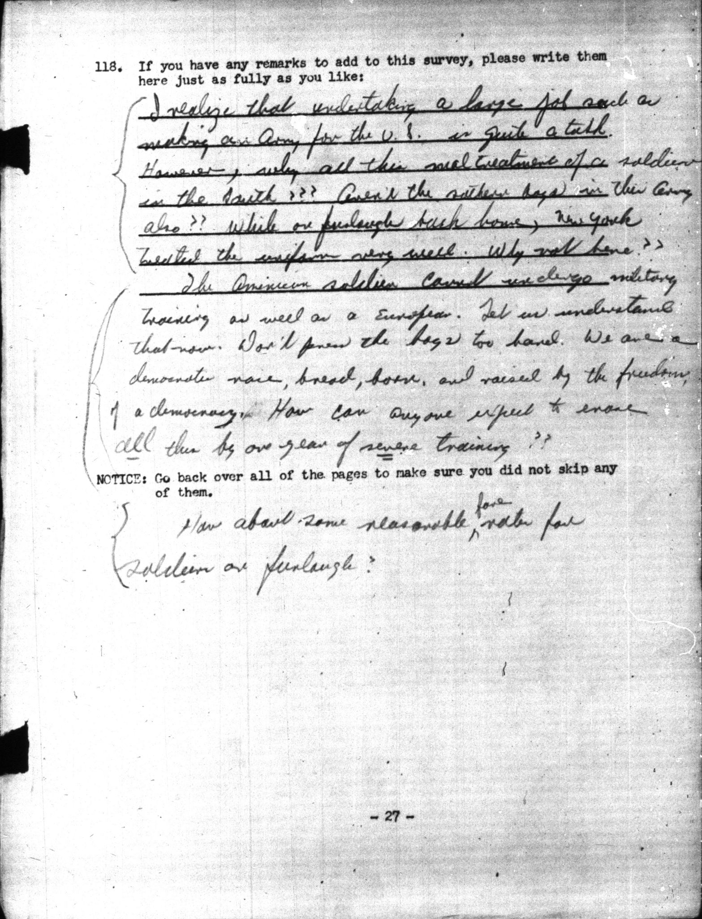
Document A, Planning Survey I, December 1941, 01-0927:
I realize that undertaking a large job such as making an Army for the U.S. is quite a task. However, why all the maltreatment of a soldier in the South??? Aren't the southern boys in the army also?? While on furlough back home, New York treated the uniform very well. Why not here?? The American soldier could undergo military training as well as a European. Let us understand that now. Don't press the boys too hard. We are a democratic race, bread, born, and raised by the freedom of a democracy. How can anyone expect to erase all this by one year of severe training?? How about some reasonable [insertion]fare[insertion] rates for soldiers on furlough?
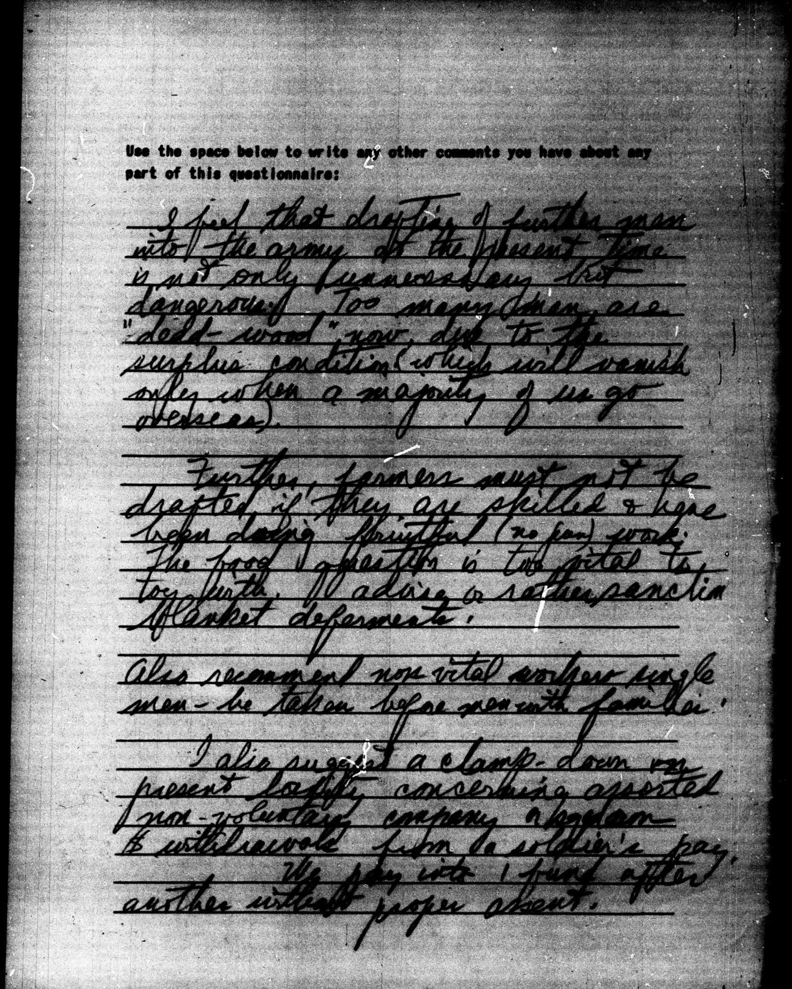
Document B, Survey 44, April 1943, 14-0810:
I feel that drafting of further men into the army at the present time is not only unnecessary but dangerous. Too many men are "dead-wood" now due to the surplus condition (which will vanish only when a majority of us go overseas).
Further, farmers must not be drafted if they are skilled & have been doing fruitful (no pun) work. The food question is too vital to toy with. I advise or rather sanction blanket deferments.
Also recommend non-vital workers single men - be taken before men with families.
I also suggest a clamp-down on present [unclear]laxity[unclear] concerning assorted non-voluntary company or squadron $ withdrawals from a soldier's pay.
We pay into 1 fund after another without proper assent.
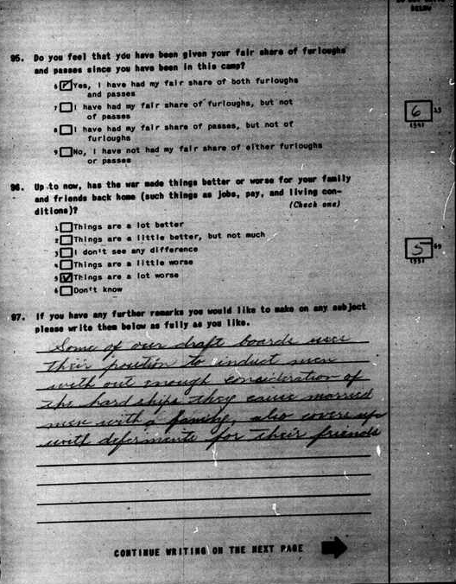
Document C, Survey 64, July-September 1943, 64-0743:
Some of our draft boards use their position to induct men without enough consideration of the hardships they cause married men with a family, also covers up with deferments for their friends.

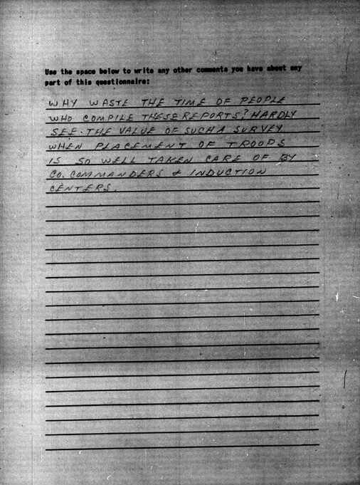
Document D, Survey 44, April 1943, 44-0443:
Why waste the time of people who compile these reports? Hardly see the value of such a survey when placement of troops is so well taken care of by Co. commanders & induction centers.

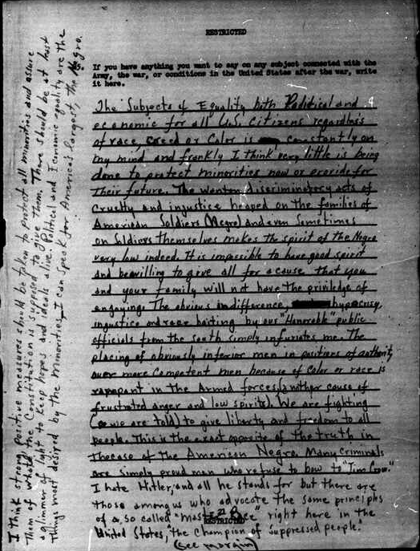
Document E, Survey 144, August 1944, 144-0844: The Subject of Equality both Political and economic for all U.S. citizens regardless of race, creed or color is constantly on my mind and frankly I think very little is being done to protect minorities now or provide for their future. The wanton discriminatory acts of cruelty and injustice heaped on the families of American Soldiers (Negro) and even sometimes on soldiers themselves makes the spirit of the Negro very low indeed. It is impossible to have good spirit and be willing to give all for a cause that you and your family will not have the priviledge of enjoying. The obvious indifference, hypocrisy, injustice and race baiting by our "Honorable" public officials from the south simply infuriates me. The placing of obviously inferior men in positions of authority over more competent men because of color or race is rampant in the Armed forces (another cause of frustrated anger and low spirits). We are fighting (we are told) to give liberty and freedom to all people. This is the exact opposite of the truth in the case of the American Negro. Many criminals are simply proud men who refuse to bow to "Jim Crow." I hate Hitler, and all he stands for but there are those among us who advocate the same principles of a so called "Master Race" right here in the United States, "the champion of suppressed people." I think strong, positive measures should be taken to protect all minorities and assure them of what the Constitution is supposed to give them. There should be at least a glimmer of light to keep hopes and ideals alive. Political and Economic equality are the things most desired by the minorities - I can speak for America's largest, the Negro.

