Assignment, Training & Discipline Lesson Plan
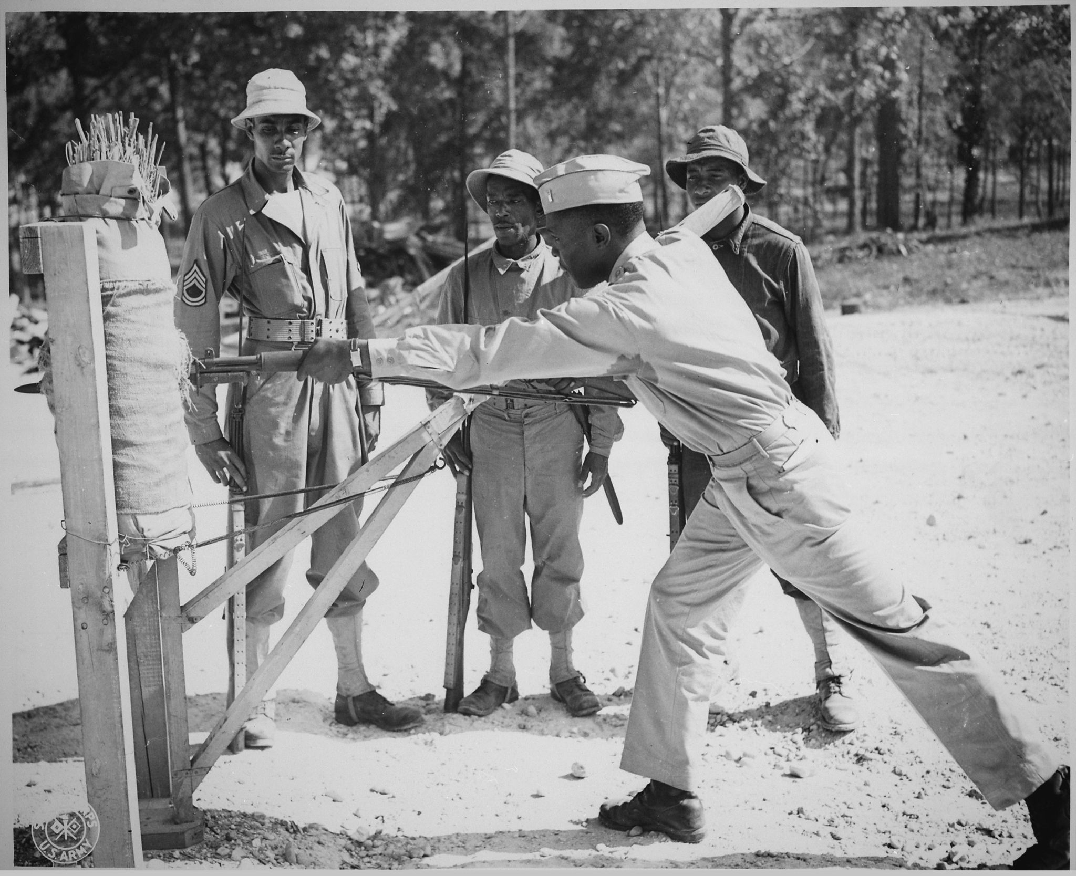
Introduction
During World War II, approximately 16 million Americans served in the military. Over half a million were offered the opportunity to anonymously write their opinions on combat and other topics in a series of surveys given by the Army Research Branch. These handwritten opinions sat largely untouched for decades until digitized and transcribed by The American Soldier in World War II project. This lesson plan utilizes a selection of these transcriptions to help students critically analyze primary sources to better understand the reality of assignment, training, and discipline during World War II.

Students will also have the opportunity to use the SCIM-C Method. This method of analysis has been created to help students develop the knowledge and skills necessary to interpret historical primary sources and investigate meaningful historical questions.

Grade Level
High School/College Introductory (Age 16+)
Time Requirement
60 minutes
Materials
- Copies of Assignment & Promotion and Discipline & Military Justice Overview Essays
- Copies of Assignment, Training & Discipline Responses for each group of students
- Copies of Student Worksheet for each student
Objectives
Students will be able to describe and explain the diverse views/experiences on how they were trained, their assignments, and how they were disciplined in the US military during WWII by analyzing primary source documents on soldiers' experiences. They will revise their historical interpretation after reading each source, recognizing that by synthesizing information from multiple perspectives they can develop a richer, more accurate summary of the past.
Key Terms
Primary sources: textual or visual materials created during the historical moment you are studying, such as letters, diary entries, photographs, posters, and newspaper articles
Secondary sources: materials created well after the events they discuss by someone who did not experience them firsthand. Books, journal articles, encyclopedia entries, and documentaries are good examples.
Procedures
- Begin by either having students read the overview essays, “Training, Assignment, Promotion & Leadership” and “Discipline & Military Justice,” to themselves or reading it together as a class. If it helps, half of the class can read the first essay while the other half reads the second essay. Once students have finished reading the essays, have them take a moment to write down some notes summarizing the experience of American GIs based on what they read. Ask a few students to identify the following about this text:
  - Identify 3 important details about soldiers’ experiences with training and discipline detailed in the essay.
  - Identify 2 ways in which these experiences are still relevant to life in America today.
  - Identify 1 question you have or 1 source you would need to better understand these experiences. (15 minutes)
- Review the key terms listed above.
- Ask students whether the essay they just read is a primary or secondary source and how they can tell. Ask them what kinds of sources might be useful for learning more about what it was like to be a soldier during World War II (e.g., letters, diary entries, oral histories, maps or photographs of a training camp, a training manual, etc.). (5 minutes)
- Explain that students will now have the opportunity to build on their historical summaries of combat during the war by reading actual survey responses that soldiers wrote during World War II. You may choose for students to complete the activity individually or in groups. Distribute copies of the primary source responses and the Student Worksheet to each student or group.
- Instruct students to start by analyzing just one of the letters. Have them complete Part I of the Student Worksheet once they finish reading. (10 minutes)
- Have students read some of the additional responses, revising their historical summary each time and answering the questions on the Student Worksheet. Students can also think about the below questions when reading specific documents. (20 minutes)
- Return to the whole class to debrief. The object is for students to realize that while each primary source is a useful tool, the best historical interpretations will synthesize information from multiple perspectives. Here are some possible discussion questions: (10 minutes)
- How did your historical summary change after you read the first response?
- Did any of your responses contradict one another? How did you handle that in writing your summary?
- Was there any one response that helped you the most in developing your summary? If so, why was it so helpful?
- What details do you wish you knew more about before writing this summary?
- What kinds of sources might help you find that information?
Assessment
You will be able to assess students’ abilities to analyze individual primary sources based on the historical summaries they write, as well as the answers they provide on the Student Worksheet. You will be able to assess their ability to synthesize information from multiple sources and recognize the value of that process based on their historical summaries and the answers they give in discussion. You will also be able to assess their questioning of the sources provided to them.
Recommended Resources
Training the Military GI (Article)

Extension/Enrichment
- Have students visit The American Soldier in World War II website and search for keywords surrounding assignment, training, and discipline. Ask students to revise their historical summary after taking the information they find into account, and have them explain how the new source(s) helped enhance their understanding of what it was like for soldiers during World War II.
Potential Keywords: training, skills, assignment, unit, discipline, punishment, morale, rating, job, NCO, Non-Coms, officers, AGCT

- Have students choose their favorite response out of the ones they read and do a “deep analysis,” extracting as much information as possible about the writer—what he liked or disliked, where he was from, his strengths and weaknesses, etc.—and build a profile of that person. The objective here is for students to practice extracting data from text, both the expressly written data and information they can infer by interpreting the details.
Education Standards
COMMON CORE STANDARDS
CCSS.ELA-LITERACY.RH.6-8.2 - Determine the central ideas or information of a primary or secondary source; provide an accurate summary of the source distinct from prior knowledge or opinions.
CCSS.ELA-LITERACY.RH.6-8.9 - Analyze the relationship between a primary and secondary source on the same topic.
CCSS.ELA-LITERACY.RH.9-10.1 - Cite specific textual evidence to support analysis of primary and secondary sources, attending to such features as the date and origin of the information.
CCSS.ELA-LITERACY.RH.9-10.2 - Determine the central ideas or information of a primary or secondary source; provide an accurate summary of how key events or ideas develop over the course of the text.
CCSS.ELA-LITERACY.RH.9-10.9 - Compare and contrast treatments of the same topic in several primary and secondary sources.
CCSS.ELA-LITERACY.RH.11-12.9 - Integrate information from diverse sources, both primary and secondary, into a coherent understanding of an idea or event, noting discrepancies among sources.
NATIONAL STANDARDS FOR HISTORY
HISTORICAL CONTENT ERA 8, STANDARD 3B
The student understands World War II and how the Allies prevailed.
HISTORICAL CONTENT ERA 8, STANDARD 3C
The student understands the impacts of World War II at home.
HISTORICAL THINKING STANDARD 2
The student is able to appreciate historical perspectives by demonstrating the ability to
(a) describe the past on its own terms, through the eyes and experiences of those who were there, as revealed
through their literature, diaries, letters, debates, arts, artifacts, and the like;
(b) consider the historical context in which the event unfolded–the values, outlook, options, and contingencies of that time and place; and
(c) avoid “present-mindedness,” and not judging the past solely in terms of present-day norms and values.
HISTORICAL THINKING STANDARD 4
The student is able to support interpretations with historical evidence in order to construct closely-reasoned arguments rather than facile opinions.

Image Source: NARA

Assignment, Training & Discipline Responses
Documents A, B, C & D cover topics related to assignment and training.
Documents E & F cover discipline methods in the military.

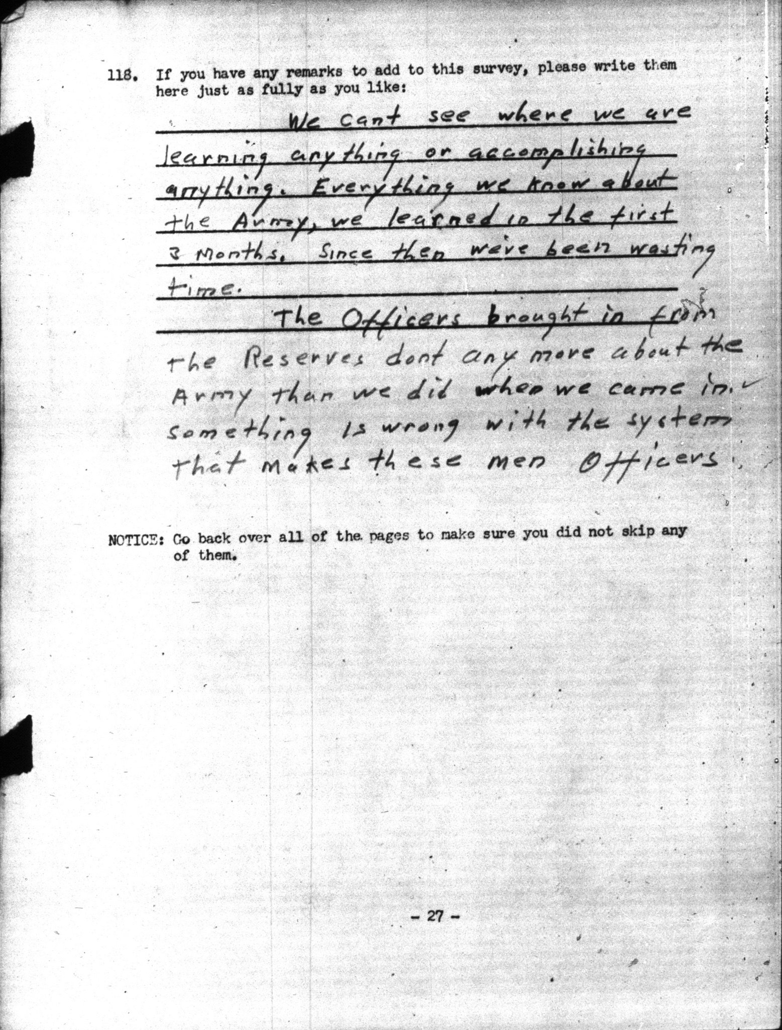

Document A, Planning Survey 1, December 1941, 01-1422:
We cant see where we are learning anything or accomplishing anything. Everything we know about the Army, we learned in the first 3 months. Since then we've been wasting time.
The Officers brought in from the Reserves dont any more about the Army than we did when we came in. Something is wrong with the system that makes these men Officers.
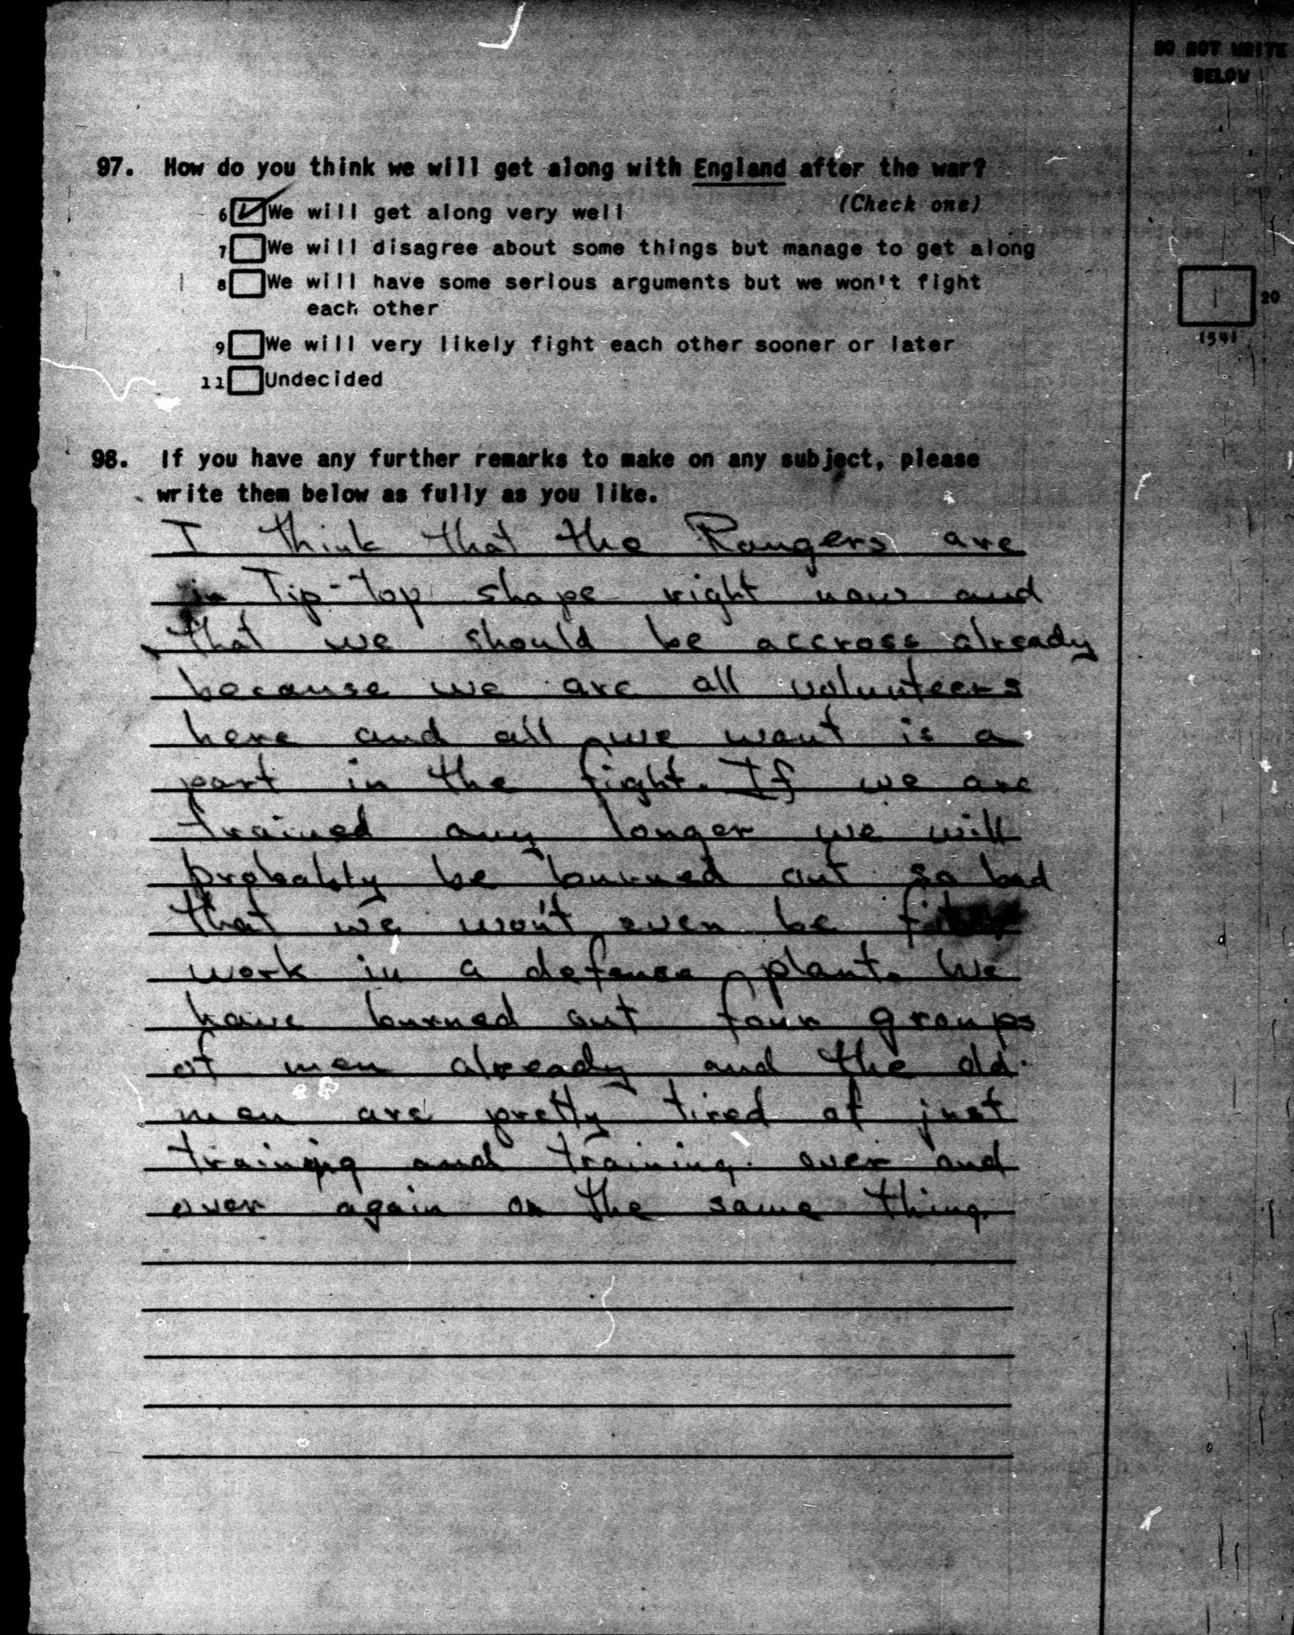

a
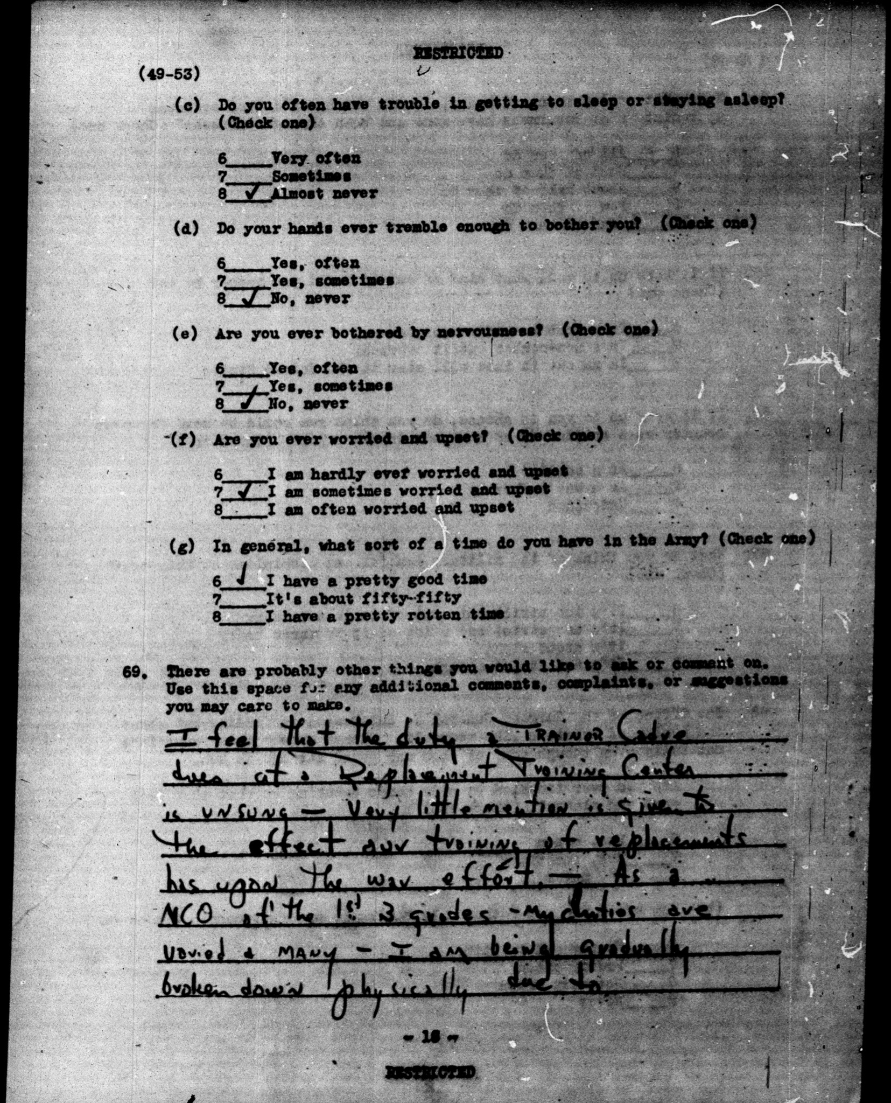

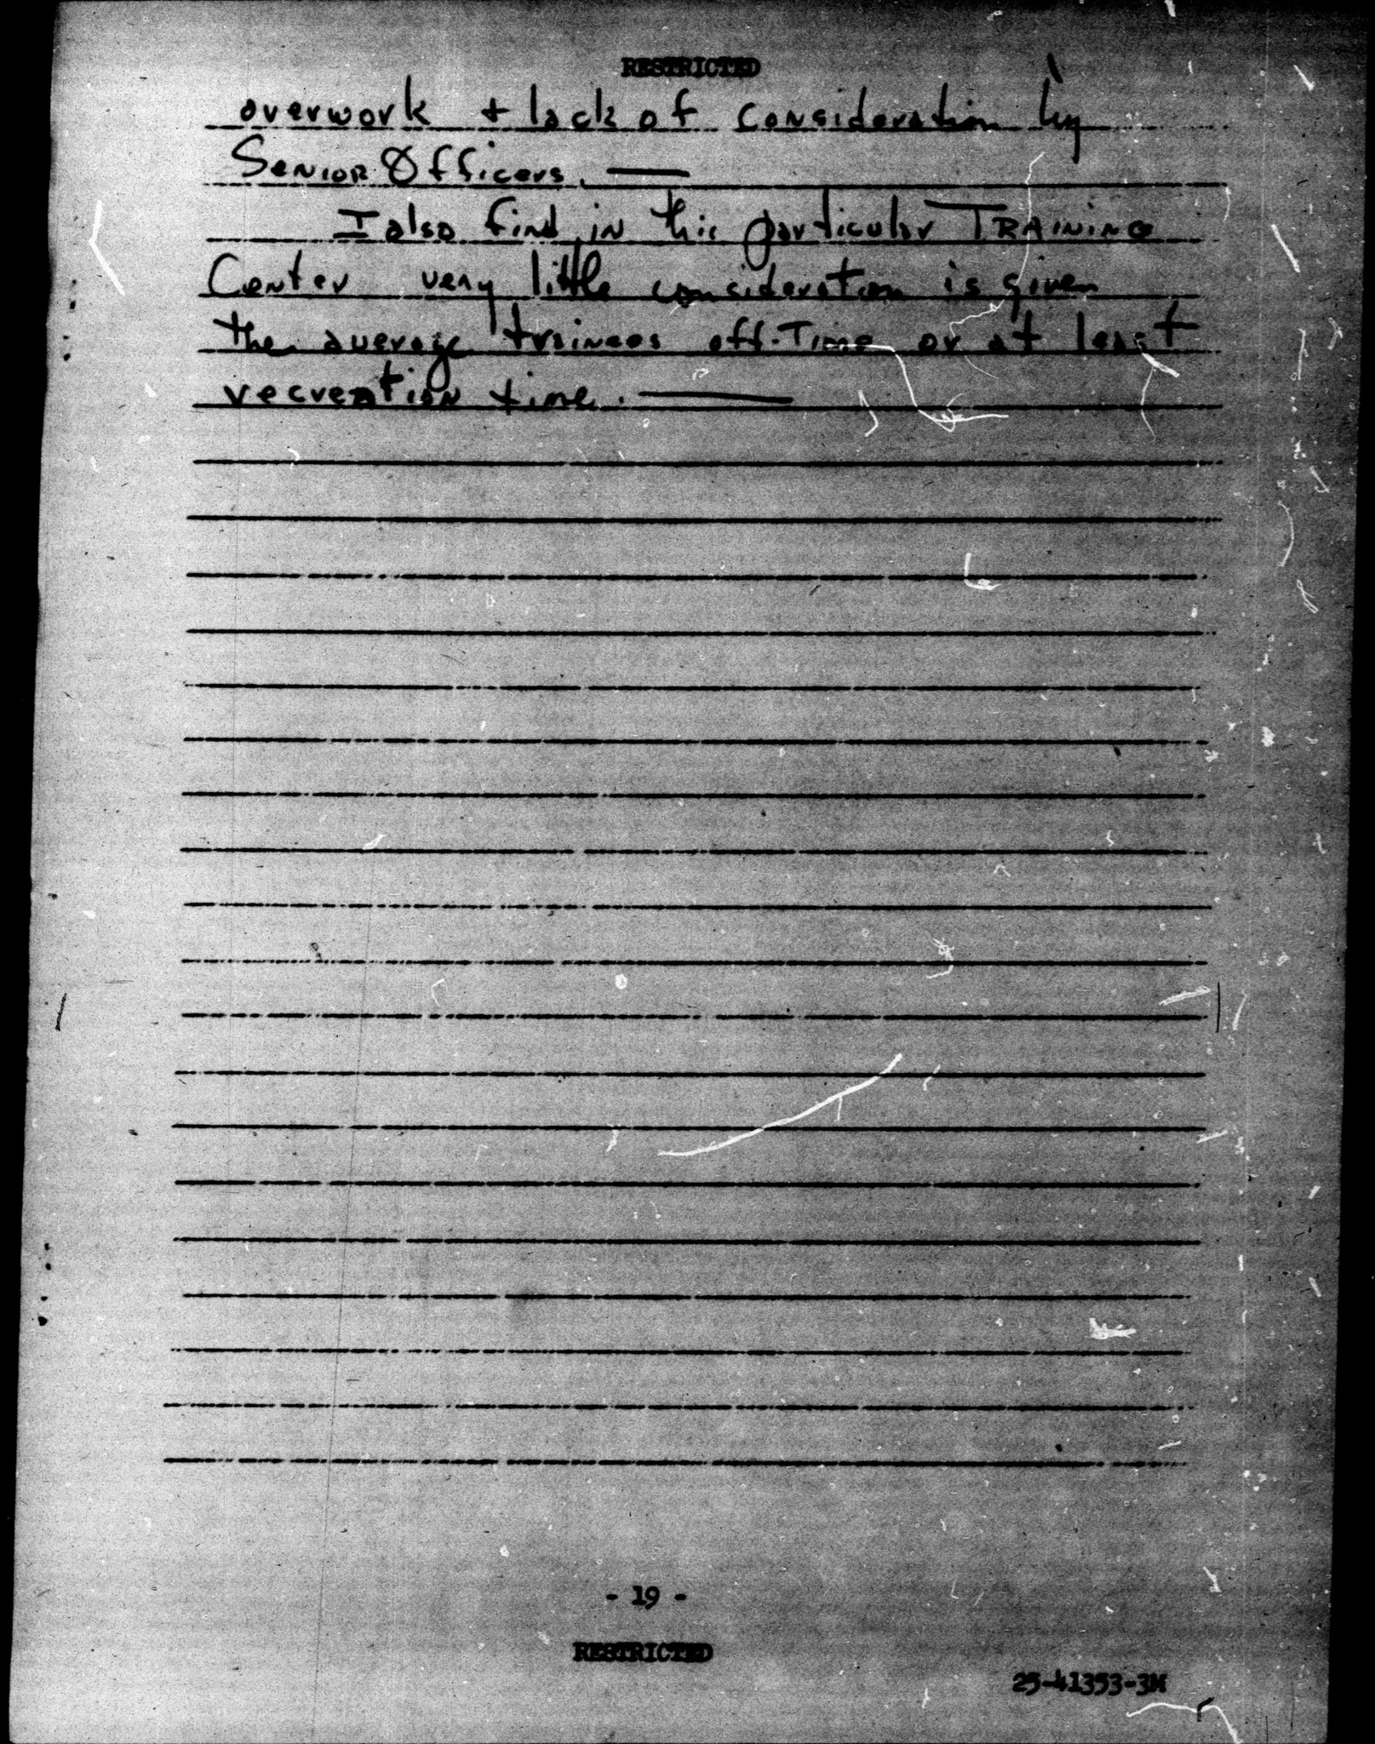

Document C, Survey 205, May 1945, 41-0943 and 41-0944 [2 pages]:
I feel that the duty & Trainor Cadre does at Replacement Training Center is unsung - very little mention is give to the effect our training of replacements has upon the war effort. - As a Non-Comissioned officer at the 1st B grades my duties are varied & many - I am being gradually broken down physically due to overwork & lack of consideration by Senior Officers. I also find in this particular training center very little consideration is give the average trainees off-time or at least recreation time
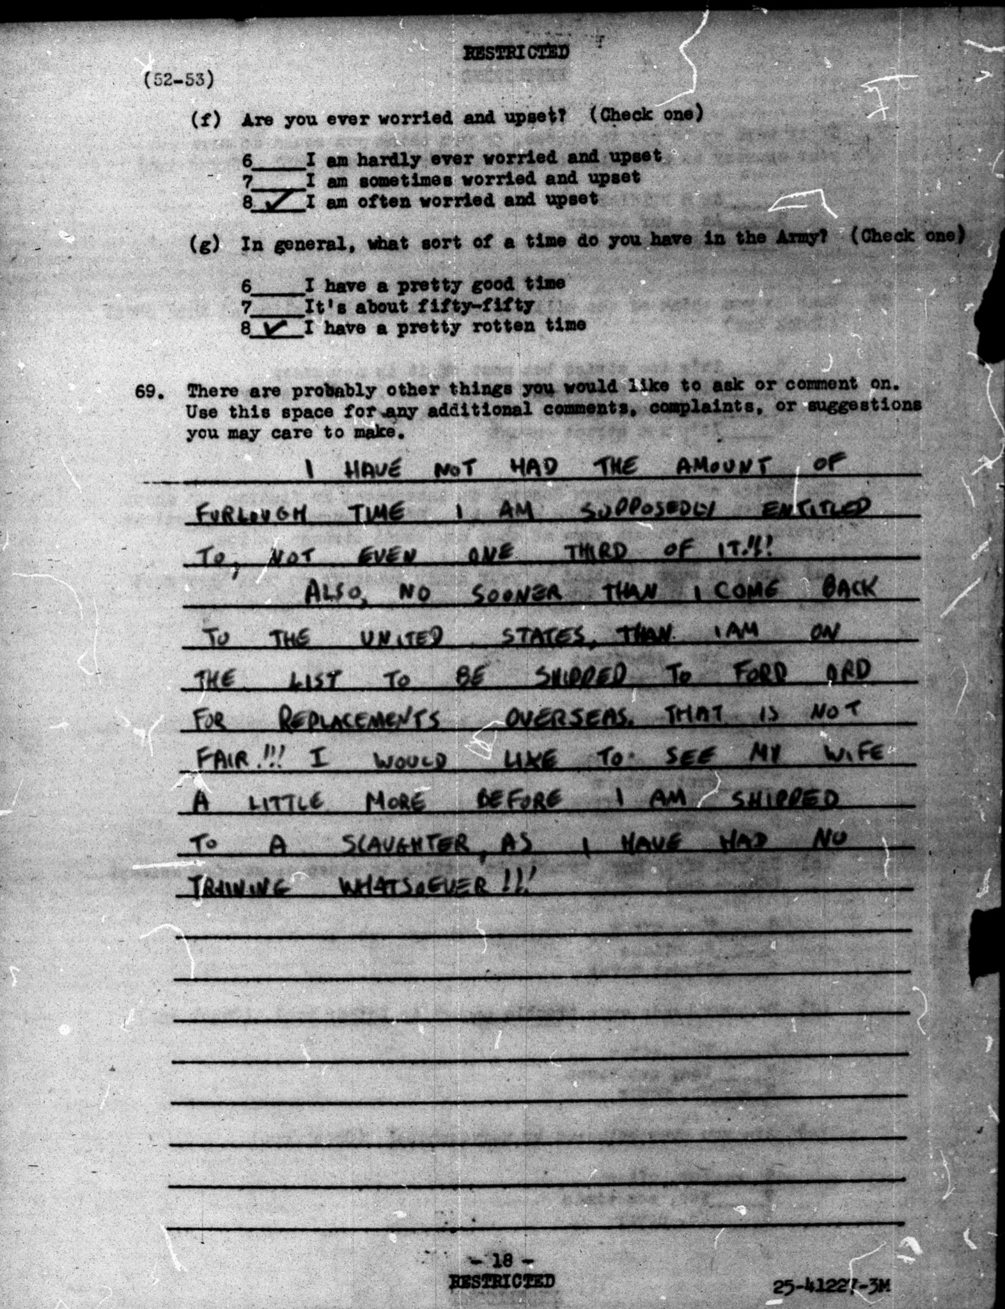

Document D, Survey 205, May 1945, 42-0503:
I have not had the amount of furlough time I am supposedly entitled to, not even one third of it!!
Also, no sooner then I come back to the United States than I am on the list to be shipped to Fort Ord [California] for replacements overseas. That is not fair!!! I would like to see my wife a little more before I am shipped to a slaughter, as I have had no training whatsoever!!!

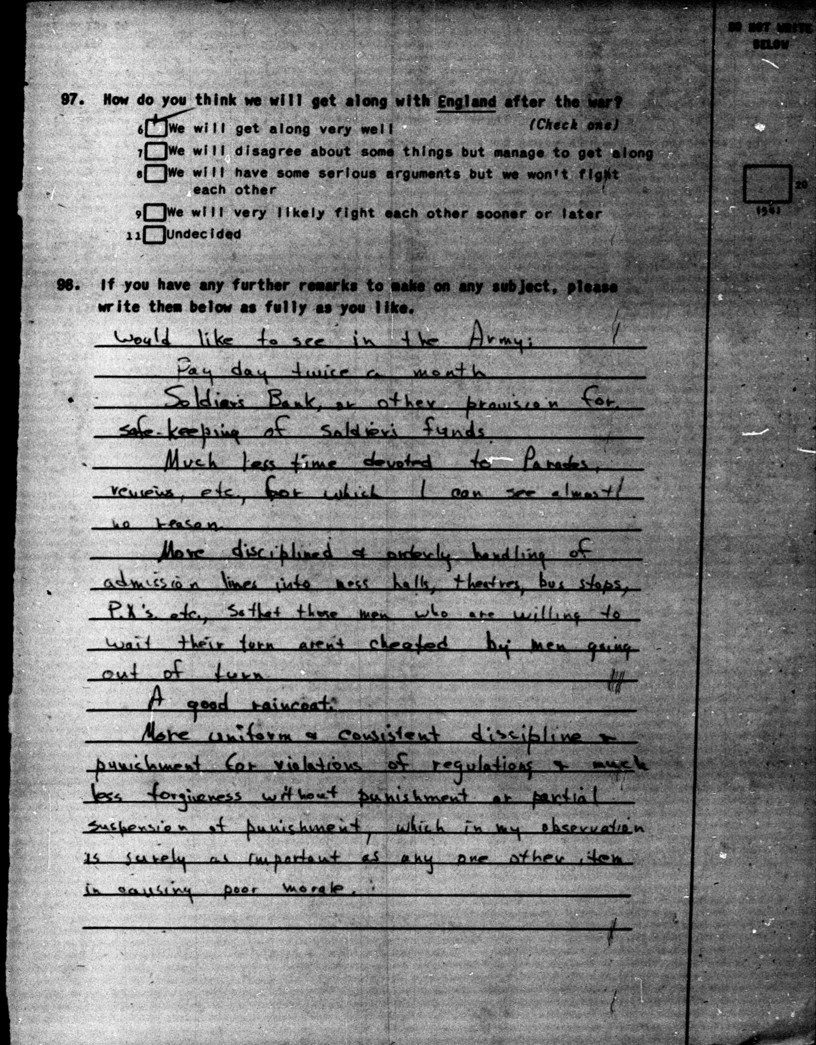
Document E, Survey 63, July-Sept, 1943,15-0658:
Would like to see in the Army:
-Pay day twice a month
-Soldiers Bank, or other provision for safe-keeping of soldiers funds.
-Much less time devoted to Parades, reviews, etc, for which I can see almost no reason.
-More disciplined & orderly handling of admission lines into mess halls, theatres, bus stops, P.X's, etc., so that those men who are willing to wait their turn aren't cheated by men going out of turn.
-A good raincoat.
-More uniform & consistent discipline & punishment for violations of regulations & much less forgiveness without punishment or partial suspension of punishment, which in my observation is surely as important as any one other item in causing poor morale.

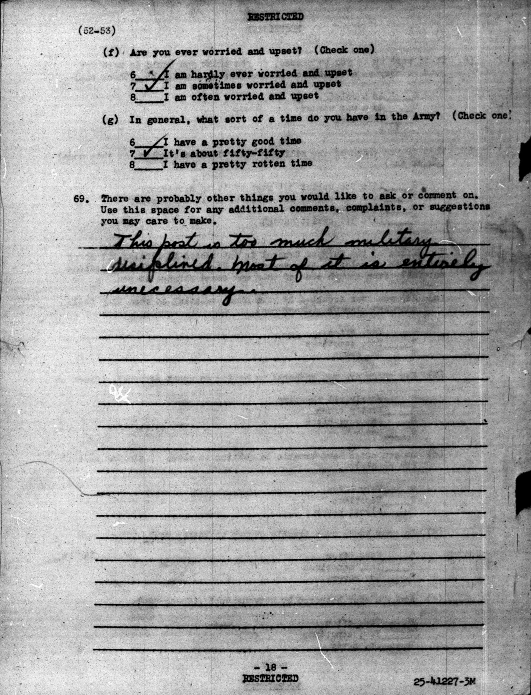
Document F, Survey 205, May 1945, 42-0307:
This post is too much military disciplined. Most of it is entirely unnecessary.

